Mt. San Antonio College
Learning Communities
There are many different types of Learning Communities available to Mt. SAC students all year round.
The existing Learning Communities include the Summer Bridge Program, Pre-Nursing/Health Bridge, General Education learning communities, Transfer Bridge, English Bridge, Math Bridge, and Reading Bridge.

Summer Bridge 2009
- 982 students applied
- 332 students enrolled in the Summer Bridge program (most in history)
- We have 63 more students participating this year than last year (269); which is about a 20% increase
- 30 instructors/faculty
- 14 supplemental instructors (tutors)
- 14 peer advisors
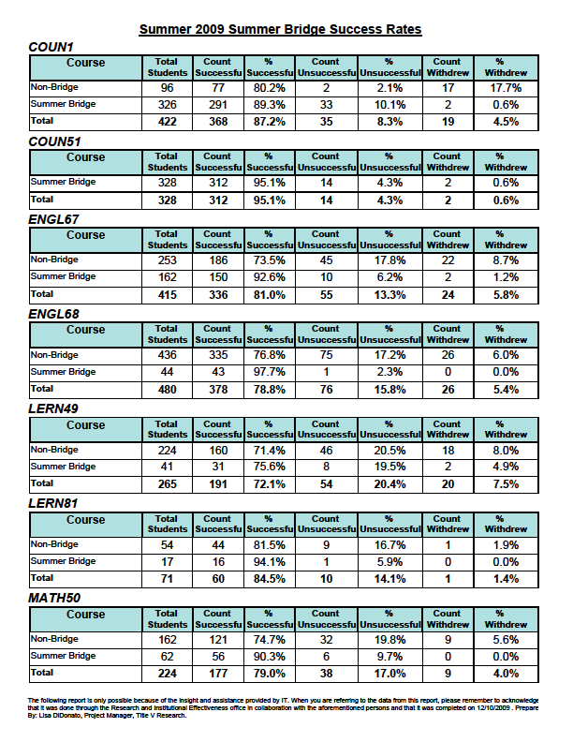

Learning Communities Fall 2009
- For fall semester 2010, the Bridge Program has been able to support a total of 21 learning communities.
- Within those 21 learning communities, there were a total of 609 students enrolled.
- There are several different variations of the learning communities this semester ranging from accelerated (short-term), to non- accelerated (full semester long).
- Some of the learning communities are linked with only one other class or up to four classes.
- Within the accelerated learning communities there has been some great student success thus far!

Cluster 1-Link 1: 100% pass rate!
English 67 (1st 8 weeks) Paul Frahs
English 68 (2nd 8 weeks) Paul Frahs
Read 90 Ema Burman
Counseling 2 Lyssette Trejo-Espinoza

Cluster 1-Link 2: 87% pass rate!
English 67 (1st 8 weeks) Paul Frahs
English 68 (2nd 8 weeks) Paul Frahs
Read 90 Michelle Sampat
Counseling 2 Lyssette Trejo-Espinoza

Cluster 3-Link 1: 69% pass rate!
Math 51 (1st 8 weeks) Candice Kim
Math 71 (2nd 8 weeks) Candice Kim
Counseling 2 Bernadette Flameno

Cluster 3-Link 2: 86% pass rate!
Math 51 (1st 8 weeks) Jeff Wakefield
Math 71 (2nd 8 weeks) Jeff Wakefield
Counseling 5 Andrea Torres

Cluster 4-Link 1: 78% pass rate!
English 68 (1st 8 weeks) Tammy Karn
English 1A (2nd 8 weeks) Tammy Karn
Counseling 2 Patricia Maestro
Library 1A (2nd 8 weeks) Pauline Swartz

Cluster 4-Link 1: 84% pass rate!
English 68 (1st 8 weeks) Tammy Karn
English 1A (2nd 8 weeks) Tammy Karn
Counseling 2 Patricia Maestro
Library 1A (2nd 8 weeks) Pauline Swartz

