





MT. SAN ANTONIO COMMUNITY COLLEGE
DISTRICT

EDUCATIONAL
MASTER PLAN
2008-2009

EDUCATIONAL MASTER PLAN CONSULTANTS
Lead Project Consultant Dr. Grace N. Mitchell, with
Dr. Ernest Berg, Robert Evans, Valerie Evans, Christopher D. Mitchell and Charlotte Alexander
for PPL, Professional Personnel Leasing, Inc.

MT. SAN ANTONIO COMMUNITY COLLEGE DISTRICT EDUCATIONAL MASTER PLAN - Page ii

MT. SAN ANTONIO COMMUNITY COLLEGE DISTRICT ADMINISTRATION
President/CEO John S. Nixon
Instruction Vice President Dr. Virginia Burley
Student Services Vice President Dr. Audrey Yamagata-Noji
Administrative Services Vice President Michael Gregoryk
Human Resources Interim Vice President Dr. Jack Miyamoto

ACKNOWLEDGEMENTS
The President, his Cabinet Members, and:
► Linda Potter, Barbara McNeice Stallard, Donna Burns, Sheryl Hullings, Diana Casteel, Liz Callahan ◄
Fawaz Al-Malood, Joseph Ammirato, Richard Anderson, Barry Andrews, Madelyn Arballo, Juan Carlos Astorga,
Jerry Austin, Linda Baldwin, Liza Becker, Vic Belinski, Deborah Blackmore, Jemma Blake-Judd, John Blyzka,
Debbie Boroch, Patricia Bower, George Bradshaw, Lane Braver, Julie Bray-Ali, C.B. Brown,
Bob Burton, Silver Calzada, Manuel Castillejos, Deborah Cavion, Neil Chapman, Meghan Chen, Susie Chen,
Jason Chevalier, Bev Crespo, Sarah Daum, Gary Davis, Jay Devers, Melanie Diederichs, Eileen DiMauro,
Amrik Dua, William Eastham, Paulette Engisch, Gary Enke, Michael Falzone, Terri Faraone, Dyrell Foster,
Wanda Fulbright-Dennis, Dan Garcia, John Gardner, Mike Goff, Michelle Grimes-Hillman, Grace Hanson,
John Heneise, Irene Herrera, Evelyn Hill-Enriquez, Trinda Hoxie, Jonathan Hymer, Ralph Jagodka,
Jim Jenkins, Joe Jennum, Susan Jones, Mathew Judd, Gary Kay, Carolyn Keys, Dafna Kohn, Terry Krider, Mary-Rose Lange, Heidi Lockhart, Sue Long, Audra Lopez, Virginia Macias, Patricia Maestro, Americo Marano, Tom Mauch, Daniel McGeough, David McLaughlin, David Medina, David Miman, Daniel Morales, Richard Morley, Amy Nakamura, Gary Nellesen, James Ocampo, Jeff Parker, Richard Patterson, Anabel Perez, Robert Perkins,
Rosa Preciado, Adrienne Price, Larry L. Redinger, Audrey Reille, Liesel Reinhart, Raul Rodriguez,
Linda Rogus, Robert Rogus, Stephen Runnebohm, Karen Saldana, Sandy Samples, Dave Schmidt,
Karen Schnurbusch, Don Sciore, Brian Scott, Paul Sharpe, Stephen Shull, Daniel Smith, John Smith,
Ralph Spaulding, Bob Stuard, Lyssette Trejo, Tammy Trujillo, Tyler Trull, Tom Vela,
Mary-Rose Weisner, Lance Wilcher, Lorraine Williams, Debbie Williams, Phil Wolf, Emily Woolery,
Margaret S. Young, Vic Zamora

MT. SAN ANTONIO COMMUNITY COLLEGE DISTRICT
BOARD OF TRUSTEES
Dr. Manuel Baca
Rosanne Bader
Fred Chyr
Judy Chen Haggerty
David K. Hall
Cheryl D. Jamison

MT. SAN ANTONIO COMMUNITY COLLEGE DISTRICT EDUCATIONAL MASTER PLAN - Page iii

MT. SAN ANTONIO COMMUNITY COLLEGE DISTRICT EDUCATIONAL MASTER PLAN - Page iv

TABLE OF CONTENTS

LIST OF MAPS, TABLES AND FIGURES ... .. ix
CHAPTER 1: Introduction and Background ... ... 1
CHAPTER 2: The District and the College ... .. 9
CHAPTER 3: Programs and Services ... . 49
Introduction and Methodology ... .. 50
Services ... ... 55
President’s Office ... .. 57
Foundation ... . 58
Marketing & Communications ... .. 59
Human Resources ... . 61
Administrative Services ... .. 65
Auxiliary Services ... .. 67
Facilities Planning & Management ... . 68
Fiscal Services ... ... 69
Information Technology ... .. 70
Public Safety ... . 72
Purchasing ... . 74
Safety, Health Benefits & Risk Management ... ... 77
Technical Services... . 78
Student Services ... ... 79
Admissions and Records / Enrollment Management ... ... 82
Assessment and Matriculation ... . 83
Bridge Program ... .. 84
Career and Transfer Services ... .. 86
Counseling ... . 88
Disabled Student Programs and Services (DSPS) ... ... 91
EOPS, CARE & CalWORKs ... . 95
Financial Aid / Scholarships / Veterans ... .. 97
Health Services ... .. 99
High School Outreach ... ... 100
International Student Programs ... ... 101
Student Life ... ... 102
Upward Bound ... .. 103
Summary of Space Needs ... ... 104
Instruction ... . 107
Offices of the Vice President and Dean ... . 109
Center of Excellence ... .. 111
Grants Office ... . 112
New Faculty Seminar ... . 113

MT. SAN ANTONIO COMMUNITY COLLEGE DISTRICT EDUCATIONAL MASTER PLAN - Page v

Offices of the Vice President and Dean (continued)
Research and Institutional Effectiveness ... 114
Small Business Development Center (SBDC) ... 115
Arts Division ... 117
Animation/Advertising Design ... 119
Computer Graphics... 122
Music ... 124
Photography ... 126
Radio and Television ... 128
Studio Art ... 131
Theatre ... 136
Business and Economic Development Division ... 139
Accounting ... 141
Business Law ... 144
Business Management ... 146
Child Development ... 149
Computer Information Systems (CIS) ... 151
Consumer Services / Life Management ... 154
Economics ... 156
Fashion Merchandising and Design Technology ... 158
Hospitality and Restaurant Management ... 162
Interior Design ... 166
Marketing ... 168
Nutrition and Foods ... 170
Office Technology ... 172
Paralegal ... 174
Real Estate ... 176
Humanities and Social Sciences Division ... 179
American Language... 181
Communication ... 184
Education ... 186
English ... 188
Ethnic Studies ... 193
Foreign Languages ... 195
Geography ... 202
History ... 204
Journalism ... 206
Philosophy ... 209
Political Science ... 211
Psychology ... 213
Sign Language / Interpreting ... 216
Social Sciences ... 218
Sociology ... 220
Library & Media Services Division ... 223
Distance Learning ... 226
Learning Assistance Center (LAC) ... 227

MT. SAN ANTONIO COMMUNITY COLLEGE DISTRICT EDUCATIONAL MASTER PLAN - Page vi

Natural Sciences Division ... 233
Agricultural Sciences ... 235
Anatomy and Physiology ... 242
Animal Science ... 246
Anthropology ... 253
Biology ... 255
Botany ... 258
Chemistry ... 260
Earth Sciences and Astronomy ... 263
Engineering ... 270
Histotechnology ... 272
Mathematics and Computer Science ... 274
Microbiology ... 278
Physical Science ... 281
Physics ... 283
Surveying ... 285
Physical Education Division ... 287
Athletics ... 289
Dance ... 291
Physical Education ... 293
Technology and Health Division ... 299
Aeronautics & Transportation ... 301
Air Conditioning & Refrigeration... 304
Aircraft Maintenance Technology ... 306
Architectural & Engineering Design Technology ... 309
Electronics & Computer Engineering Technology ... 313
Fire Technology ... 317
Manufacturing Technology ... 320
Medical Services ... 321
Mental Health / Psychiatric Technology ... 325
Nursing ... 327
Public Services ... 329
Radiologic Technology ... 332
Respiratory Therapy ... 334
Water Technology ... 336
Welding ... 338
Continuing Education / Non-Credit Division ... 341
Introduction and Methodology ... 342
Continuing Education ... 343
Community Education ... 345
Adult Basic Education Center ... 346
Non-Credit English as a Second Language ... 347
Older Adult Program ... 349
Non-Credit Combined, Short-Term Vocational and Other ... 351
Conclusions and Recommendations ... 353

MT. SAN ANTONIO COMMUNITY COLLEGE DISTRICT EDUCATIONAL MASTER PLAN - Page vii

CHAPTER 4: The Linkage Between Educational and Facilities Master Plans ... . 361

APPENDICES - SCENARIO 1
Appendix A: Credit Summary and Projections by TOP Code and Discipline
Appendix B-1: Continuing Education Summary and Projections by Program and TOP Code Appendix B-2: Continuing Education Summary and Projections by FTES, Income and Cost Appendix C: District Summary and Projections
Appendix D: Non-Teaching FTEF - Summary and Projections 2007 to 2020

MT. SAN ANTONIO COMMUNITY COLLEGE DISTRICT EDUCATIONAL MASTER PLAN - Page viii

LIST OF MAPS, TABLES AND FIGURES

MAPS
1-1 Mt. San Antonio Community College District ... .. 2
2-1 MSACCD Inflow and Outflow ... ... 36
TABLES
2-1 MSACCD Population by City ... ... 11
2-2 MSACCD Adult Population by City ... ... 12
2-3 San Gabriel Valley Employment ... . 29
2-4 District Unemployment Rate by City ... . 30
2-5 Educational Attainment of District Population 25+ by City ... . 33
2-6 MSACCD Outflow ... .. 34
2-7 MSACCD Inflow from Selected Cities ... .. 35
2-8 Participation Rates by City ... . 38
2-9 MSACCD Summary and Projections ... ... 40
2-10 Adult Population ... .. 42
2-11 Out-of-District Enrollment ... ... 43
2-12 In-District Enrollment ... . 44
2-13 Unduplicated Enrollment ... . 45
2-14 Credit WSCH & FTES ... .. 46
4-1 Room Needs Projections - Adult Basic Education Program ... .. 364
4-2 Room Needs Projections - English as a Second Language Program ... ... 365
FIGURES
1-1 Example of a Comprehensive Planning Process ... 5
2-1 Los Angeles County Ethnicity ... .. 13
2-2 Population by Ethnicity and City ... . 14
2-3 Percent of African Americans by City and MSACCD Enrollment ... ... 15
2-4 Percent of Asians by City and MSACCD Enrollment ... ... 16
2-5 Percent of Filipinos by City and MSACCD Enrollment ... . 17
2-6 Percent of Hispanics by City and MSACCD Enrollment ... . 18
2-7 Percent of Caucasians (Non-Hispanic) by City and MSACCD Enrollment ... ... 19
2-8 Los Angeles County Population Projections by Age Group ... .. 20
2-9 Population by Age and City ... ... 21
2-10 Percent of Population Age 18-20 by City and MSACCD Enrollment ... . 22
2-11 Percent of Population Age 21-25 by City and MSACCD Enrollment ... . 23
2-12 Percent of Population Age 26-30 by City and MSACCD Enrollment ... . 24
2-13 Percent of Population Age 31-40 by City and MSACCD Enrollment ... . 25
2-14 Percent of Population Age 41-50 by City and MSACCD Enrollment ... . 26
2-15 Percent of Population Age 51+ by City and MSACCD Enrollment ... . 27
2-16 MSACCD Enrollment by Age and City ... . 28
2-17 District Population by Age and City ... ... 28
2-18 Comparison of District Unemployment Rates and Bachelor’s Degree Attainment ... . 30
2-19 Comparison of Income and Educational Attainment ... . 31
2-20 Educational Attainment of District Population 25+ by City ... . 32
2-21 Full Time Equivalent Students by College ... . 37
2-22 Participation Rates by City and Credit Type ... . 39
2-23 Potential Participation Including Outflow ... . 40

MT. SAN ANTONIO COMMUNITY COLLEGE DISTRICT EDUCATIONAL MASTER PLAN - Page ix

MT. SAN ANTONIO COMMUNITY COLLEGE DISTRICT EDUCATIONAL MASTER PLAN - Page x

CHAPTER 1 - INTRODUCTION AND BACKGROUND

CHAPTER 1

INTRODUCTION AND
BACKGROUND

MT. SAN ANTONIO COMMUNITY COLLEGE DISTRICT EDUCATIONAL MASTER PLAN - Page 1
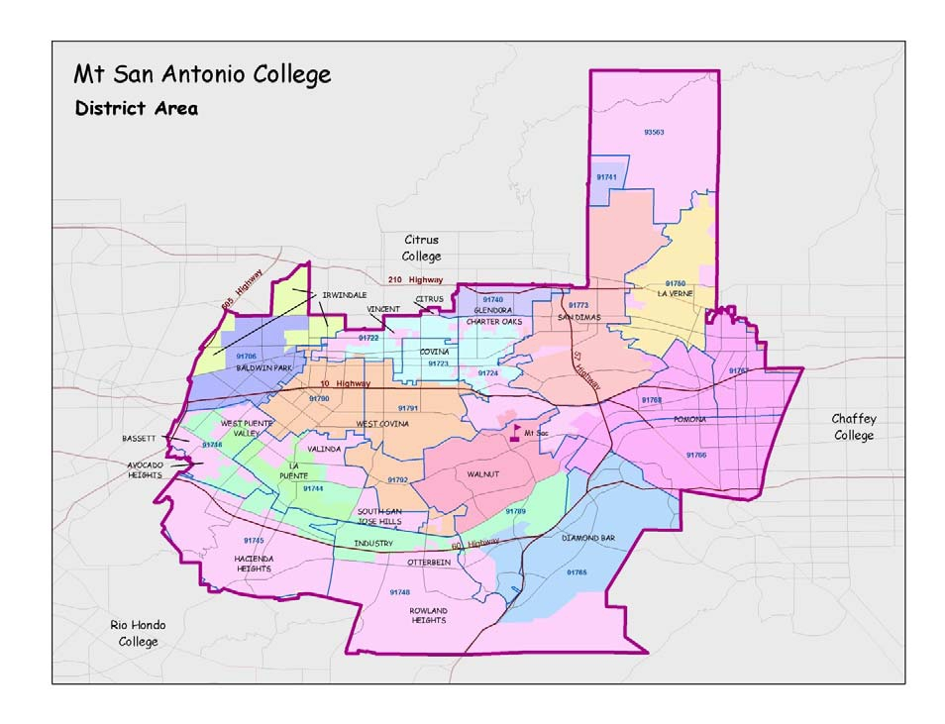

CHAPTER 1 - INTRODUCTION AND BACKGROUND

INTRODUCTION AND BACKGROUND

THE DISTRICT
Made up of approximately 180 square miles, the Mt. San Antonio Community College District (see Map 1-1)was
formed by local citizens at the end of 1945 and began service to the residents of the District in 1946. The District
serves approximately 20 communities in the San Gabriel Valley, 25 miles east of Los Angeles. The 420-acre main
campus is located in Walnut, California. In addition, a large number of non-credit classes are offered at off-campus
sites.

Map 1-1: Mt. San Antonio Community College District

Each semester, the College serves approximately 40,000 students, ranging in age from pre-teens to those nearly 100 years of age. Like most community colleges, intended to serve the continuing education needs of all the
residents of the communities they serve, the average student age is approximately 25, with two-thirds of the
students ranging in age from 18 to 25 years. Students at Mt. SAC are representative of the diversity of the residents of the communities in the District; more than 40 percent are of Latino origin, more than 20 percent are Asian or Pacific Islander, and nearly 20 percent are Caucasian.

MT. SAN ANTONIO COMMUNITY COLLEGE DISTRICT EDUCATIONAL MASTER PLAN - Page 2

CHAPTER 1 - INTRODUCTION AND BACKGROUND

The District develops and maintains many partnerships with the community, thus enhancing its educational
programs and opportunities for District residents. In addition, Mt. SAC is known statewide as a college with high
standards, excellent faculty and staff, and many highly successful programs. An excellent review of its most recent
accomplishments is contained in the 2007-2008 Mt. San Antonio College Annual Report, available from the
College’s web site, www.mtsac.edu.

HISTORY OF THE COLLEGE (1)
With World War II coming to an end in 1945, citizens of four school districts in eastern Los Angeles County
(Pomona, Covina, Puente, and Bonita) recognized the need for a broader and more comprehensive junior college in their area. Pomona Jr. College had been organized on the Pomona High School Campus in 1917. It was not considered adequate to meet the needs of the many returning servicemen and women.
In December of 1945, voters in these school districts approved the establishment of the new East Los Angeles County Jr. College District. Within a year, the new college was given its current name, Mt. San Antonio College. The new college was named after the most visible peak in the nearby mountains.
The physical location of the College was settled in 1946 when the College Board leased the site of a U.S. Naval Hospital in what is now Walnut. The 445-acre site was at the geographic center of the new district and had some facilities already as a result of its previous use. Site selection was made permanent a year later when the College agreed to buy the leased facility from the State of California.
The early success of Mt. SAC was due in no small part to the quality and dedication of the original Board and
administration. The first three presidents - George Bell, Oscar Edinger, and Marie Mills, spanning the years 1946-
1972 - were all members of the original administrative staff. Three of the early Board members - Fred Harmsen,
A. T. Richardson, and Lance Smith - served more than 20 years. The leadership of the first 25 years set the tone for a stable, well-run college, well equipped to meet the needs of a rapidly growing student population.
The last quarter of the 20th Century presented new and difficult challenges to the leadership of Mt. San Antonio
College. The fifth president, Dr. John Randall, had to deal immediately with the changing face of community college education at his appointment in 1977. Collective bargaining and shared governance both came to be sanctioned by state law. Under Dr. Randall’s leadership, Mt. SAC developed policy and structure that provided successful models not only for Mt. SAC but also for many other community colleges in the state.
This era also saw the passage of Proposition 13 (1978) and the resulting losses to community college finances.
Mt. San Antonio College suffered an immediate reduction in State funding. One of the accomplishments that Dr.
Randall “. . . was most proud [of] was the fiscal management of the College during these very difficult times, still
allowing the instructional program to flourish, staff to be competitively compensated and facilities to improve.”
The last decade of the 20th Century was dedicated to the vision of “making a good college better.” This was made
more difficult by California’s continuing fiscal crisis. The years 1991-1995 were the worst fiscal years in the 80-year
history of the California Community Colleges. Despite economic constraints in 1993-1994, the College had its
biggest construction year in a quarter of a century. In 1994, the 50,908-square-foot Student Services Center was
completed and construction of the 66,770-square-foot Performing Arts Center was begun. Much of the credit for
progress made during this time was due to the careful planning of then-President Dr. Bill Feddersen.
A defining characteristic of Mt. San Antonio College over the years is its burgeoning student population and that
these students are served on one large campus. The College was originally designed to meet the needs of no more
than 1,500 students. The first class to register in Fall 1946 consisted of 682 members. By the mid 1950s,
predictions were for a college of 10,000-20,000 students. As a result of the population boom of the 1960s, by 1972
the student body included 17,000 students. In 1991, Mt. San Antonio College was recognized as the largest single-

MT. SAN ANTONIO COMMUNITY COLLEGE DISTRICT EDUCATIONAL MASTER PLAN - Page 3

CHAPTER 1 - INTRODUCTION AND BACKGROUND

campus community college district in the State, with more than 41,000 students and over 1,200 employees. The College continues to hold this distinction today.
Toward the completion of the first decade of the 21st Century, Mt. SAC is well positioned to meet new challenges in the future. This is a college in the forefront of the California Community Colleges with dynamic, innovative programs and a talented, dedicated staff of classified workers, teachers, and administrators. Mt. SAC also has a large and diverse student population. In a normal year, the student body represents over 100 countries as well as most of the states in this country. There are many reasons to believe that Mt. SAC will retain its position as one of the most respected institutions of higher learning in California.

ECONOMIC CONTRIBUTION OF THE COLLEGE
Mt. San Antonio College contributes in several ways to the economic growth and health of the communities it serves as well as the State economy. A study completed by CCbenefits, Inc. in 2007(2) indicates that there is a benefit to the local economy through the college’s expenditures and through the development of human capital resulting from the increase in skills in the local population. Additional benefit results from students trained by the college earning increased income resulting in increased spending in the community.
From the student perspective, the study shows that students earn a 17 percent return on their investment in
education, based on the higher earnings of students completing years of higher education. As a group, students
having studied at Mt. San Antonio College contribute a total of $2.7 billion in regional labor and non-labor income to the College’s service region economy each year.
State and local governments also benefit from the products of Mt. San Antonio College’s work. The benefit/cost
ratio is heavily weighted on the benefit side of the equation. Governments spend approximately $130 million each
year in support of Mt. SAC. A study of results from higher education, including improved health, reduced crime,
reduced welfare and unemployment, increased taxes from higher lifetime earnings show, a benefit/cost ratio of 3.1.

PLANNING AT MT. SAN ANTONIO COLLEGE
During its more than 60-year history, Mt. San Antonio College has been guided by citizens and staff who were wise and forward-thinking in planning the future of the College. Like the leadership of many junior colleges in the 1940s, 1950s and 1960s, their major concerns were very different during those decades from what they are today. Leaders were occupied with planning buildings to house the rapidly increasing numbers of students taking advantage of the opportunities provided by the new institution of higher education. With boards able to develop local taxes and bond measures for the benefit of the colleges, these decades of growth were marked by facilities planning to house the traditional missions of the community college: transfer and vocational education.
With the advent of Proposition 13 in the late 1970s, and the tide of community college finance shifting in the
direction of Sacramento, a period of major change was experienced by community colleges throughout the State.
Funding for building and programs was now directed and managed by the legislature with input from the
Chancellor’s Office. Colleges were required more and more to justify their needs through documentation and
competition with other colleges. Their requests were required to be based on State standards and, at the very least,
more information.
At Mt. San Antonio College, the first building funds, known as Building Plan “M” in 1947, totaled $1,766,294.59 in
funds expended or encumbered. The amount required to complete the plant as originally planned was listed as
$1,145,000.00. With this amount, the campus would be built to house 1,500 full-time day students.(3) There is little

MT. SAN ANTONIO COMMUNITY COLLEGE DISTRICT EDUCATIONAL MASTER PLAN - Page 4

CHAPTER 1 - INTRODUCTION AND BACKGROUND

information about formal planning efforts, although the District obviously continued its facilities development plans over the next 30 years.
History does note that by 1959, remodeling of the early buildings had already begun, and several new buildings were dedicated in the first half of the 1960s. Only one paragraph in Mt. San Antonio College - The First Fifty Years is devoted to building at the College from 1953 to 1990.
The 1990s were a period of extensive additional building at the College, all of which was funded by State dollars. During this period, the College also engaged in many planning efforts. In May 1993 what was described as a new Educational and Facilities Master Plan, Vision 2007, was developed. The District continued its success in obtaining State funding for campus development as the student body grew to over 30,000.
In the years 2000 and 2001, Mt. San Antonio College developed three documents meant to direct its planning for
some years: first, an Environmental Simulation and Planning Environmental Scan by Dr. Charles McIntyre,
then 2020 Vision - Strategic Plan - Goals and Initiatives, followed by a Facilities Action Plan based on the
scenarios for growth in the McIntyre study. This appears to be the first attempt to connect educational and facilities
planning.
Based on the planning completed in the early 2000s, the College was able to pass a $221 million local bond
measure (Measure R) in 2001. These funds are being used to modernize and replace many buildings and to add much-needed classrooms and service areas. Local bonds have become essential if colleges wish to obtain State funding, and as important, the bonds are now the source of funds for much building without State support. The burden of development has come full circle and returned to local districts.
In 2005, the leadership at Mt. San Antonio College engaged the services of an architectural firm to develop the Mt. SAC Master Plan Update, a renewal and revision of previous facilities master plans. The College is currently alive with building projects funded both through local bonds and with State-supported funding.

NEW LEADERSHIP - A NEW PLANNING PROCESS
In 2007-2008, a market analysis conducted by the Clarus Corporation meant to improve marketing and
communication to the residents and potential students of the District was initiated. A summary presentation of the study result was shown to the campus in July 2007. More detailed results were released during 2008. The
relationship of this study, commissioned by the College Marketing Department, to the overall planning processes of the College is not clear. It could be used, in coordination with the demographic research in this Educational Master Plan (EMP), to guide program planning and location.
In fall of 2008, Measure RR, a $353 million extension of Measure R, was resoundingly approved by the voters in the District. These bonds will usher in a continuation of needed development for this growing college.
In 2008, newly appointed Superintendent/President Dr. John Nixon noted that facilities planning at the College had been thorough and ongoing, but not well connected to educational master planning. He requested that action be taken to implement a planning process that would provide strategic direction for the institution as well as
educational planning that could direct facilities planning.
Dr. Nixon named a new Institutional Effectiveness Committee to lead the efforts to develop a Strategic Plan. In
addition, he engaged the services of Dr. Grace N. Mitchell with PPL, Inc., to assist the college in developing a new EMP; the results of the EMP, including projections of space needs into the academic year 2020 for both academic programs and college services, will guide the development of facilities.
This EMP provides the information needed to lead seamlessly to a Facilities Master Plan and to work with State
standards for space qualification. With these new initiatives, the College is on its way to adopting a comprehensive

MT. SAN ANTONIO COMMUNITY COLLEGE DISTRICT EDUCATIONAL MASTER PLAN - Page 5
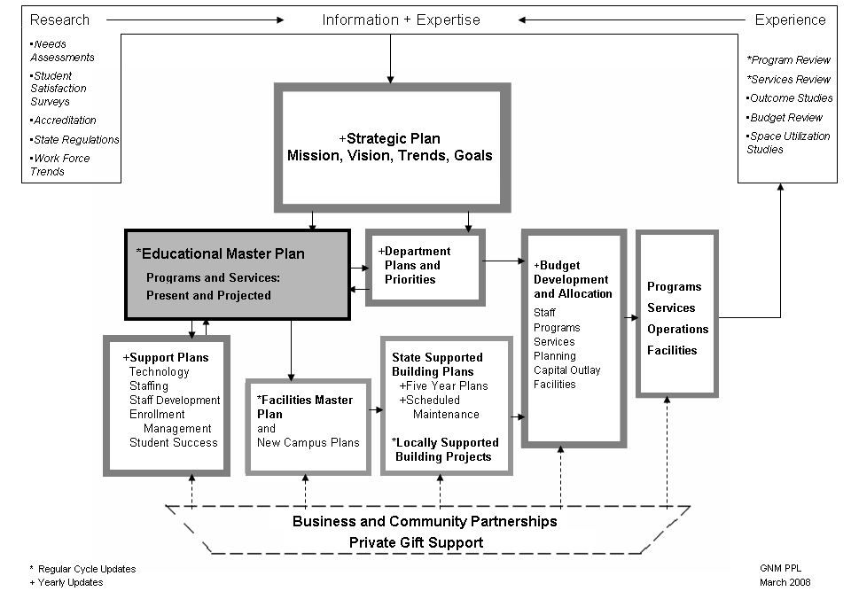

CHAPTER 1 - INTRODUCTION AND BACKGROUND

planning process that encompasses all aspects of planning, development, implementation and evaluation. One possible planning process that might be adopted is illustrated in Figure 1-1.

Figure 1-1: Example of a Comprehensive Planning Process

A Strategic Plan should provide the overall vision for a College. The role of the EMP is central to a college’s
planning process and works together with or leads to more specific planning for departments, budgets, and
facilities. The EMP should be supported by and coordinated with other plans covering various college operations
such as technology, staffing, staff development, enrollment management, and student outcomes. To render the
planning process effective, it should be initiated and constantly examined and revised by the use of research and
information in order to improve the college’s programs and services. The outcome of an effective planning process
can also be an invaluable tool in gaining the support of local and state organizations and individuals.

RESEARCH AND DATA FOR PLANNING
Mt. San Antonio College has strong research capability and produces regular reports to assist its managers in daily operations and in planning. Currently, the college is undergoing a transition from one data system to another, a process which will take several years. This change can provide an opportunity to organize data that are appropriate, standardized and available for planning.
What appears to be needed with regard to the use of data is a clear connection between research and planning. Also needed are data that are accepted college-wide as a standard, and as standards to be used in describing College results and in projecting College needs.

MT. SAN ANTONIO COMMUNITY COLLEGE DISTRICT EDUCATIONAL MASTER PLAN - Page 6

CHAPTER 1 - INTRODUCTION AND BACKGROUND

At present, in addition to the reports required by the State of California, there seem to be multiple reports being
produced as requested by various departments, and records of College-wide statistics (e.g. enrollment) being kept in multiple offices. This can lead to confusion, at best, and results in the absence of a coordinated College planning process. An effort to outline a plan for the use of data and to tie that plan to the College’s planning processes and operations would make all research efforts more effective and efficient. A coordinated plan would most likely call for fewer reports generated for staff use and open, clear communication channels relative to planning among the
various departments of the College. Agreement on which data are to be used for marketing and publication
purposes would also present a better picture of the College to the public.(4)

PLANNING: THE COLLEGE AND THE STATE OF CALIFORNIA
Perhaps the most daunting challenge in facilities planning and development, and sometimes the least visible, is the
fact that the State of California is the final arbiter in the planning process, no matter the source of funding. Building
and renovations are controlled by State Code and regulated by the Board of Governors of the California Community
Colleges. Whether or not districts employ locally approved bond dollars to support development, these regulations
must be adhered to if the District wishes to receive State support for operations, staffing, or future projects.
A complex set of standards governs the amount of space for various types of activities to be allocated to community
colleges based on student contact hours and other factors. Every district must maintain a current space inventory
related to these categories of space and submit a Five Year Plan to the State each year updating both utilization
information as well as request for dollars from State building funds. Facilities plans must be related to facilities use;
if space is underutilized according to State standards, a district will not be eligible for construction or operations
dollars for additional space.
Three governmental agencies are involved in the approval of applications for the development of new Educational
Centers: the California Community Colleges Chancellor’s Office (CCCCO), the California Postsecondary Education
Commission (CPEC), and the Demographic Unit of the State Department of Finance (DoF). Regulations regarding
the development of new centers have recently been amended by the Board of Governors of the California
Community Colleges (BoG) on recommendation of the CCCCO. These changes are included in Section 55180 of
the Education Code, Title V, which defines “Community College” and “Educational Center.” The definition for an
Educational Center includes one of the most important changes and is tied to the enrollment of the new center.
The approval process for a Center is lengthy and can easily take up to two years to complete. It involves three
stages and takes the process through all three agencies for close scrutiny and hearings. The three stages include a preliminary letter, a formal Letter of Intent, and a Needs Study - a document similar to a Master Plan describing the need for the new center. Guidelines for this process are available from CPEC in a document entitled Guidelines for Review of Proposed University Campuses, Community Colleges, and Educational and Joint-Use Centers. Centers developed without approval at the State level (e.g. with local dollars) do not, as mentioned previously,
qualify for state support for operations or building projects.

THE EDUCATIONAL MASTER PLAN: PURPOSE AND PROCESS
An Educational Master Plan is part of a complete planning process and can be used as the foundation for much of an institution’s other planning activities. It can lead to department plans that are used in budget development, to
program review, to foster or create more detailed plans for special activities (such as technology or staff
development), and to the creation and maintenance of facilities plans to provide infrastructure for the programs and services needed for students.

MT. SAN ANTONIO COMMUNITY COLLEGE DISTRICT EDUCATIONAL MASTER PLAN - Page 7

CHAPTER 1 - INTRODUCTION AND BACKGROUND

This Educational Master Plan is being developed for the purpose of projecting the College’s program and services needs from the present to the year 2020. Based on the data gathered and the expert information provided by
College faculty and staff, the Plan projects enrollment, weekly student contact hours, and service needs, and makes recommendations regarding programs and services for the District.
The results of the Plan will be tied directly to qualification for space, related to the State of California’s regulations for community colleges. College staff can use the projections in the Plan and its yearly review and revision to develop facilities for years into the future.
The processes used to develop the Educational Master Plan are described in more detail in other sections of this
document. They include a thorough environmental scan and the gathering of information about the College,
including enrollment, programs and services. These sources are then used to project enrollment some years into
the future in order to plan adequate and well-located facilities for the programs needed to serve the future residents
of the District. In addition, these projections help to gain State support for facilities development and to support local
building efforts.

CONTENTS OF THE EDUCATIONAL MASTER PLAN
The purpose of this Educational Master Plan is to provide a foundation for future planning of programs and services for the residents of the District. While it is recognized that the content of the Plan represents a snapshot in time, it is important that projections anticipate the needs of future students and residents of the District. Constant vigilance in revising the information and assumptions contained in the Plan is needed to maintain currency.
Chapter 1 introduces important background information, and provides a description of the state of planning in the District. The District and College are described in Chapter 2 using population, enrollment, and demographic data from which population and enrollment projections are derived. Recommendations are made about programs and services based on the demographic projections.
In Chapter 3, the current educational programs and services of the College are described from both quantitative
and qualitative perspectives. This Chapter also projects the future of those programs and services, using data
projections as well as the expertise of the program providers - faculty and staff. Each College department is
described separately and projected to the year 2020. At the end of the Chapter are observations, recommendations
and conclusions.
Chapter 4 of the Educational Master Plan serves as the link between educational programs and services and facilities planning. Based on program enrollment projections, Master Tables display each department by TOP (Taxonomy of Programs) Codes from the years 2005 to 2020. Credit and non-credit are displayed in separate Master Tables. These enrollment projections can then be “translated” into space qualifications using State standards for community colleges.

⁽¹⁾ Mt. San Antonio College - The First Fifty Years, compiled by Barbara Ann Hall and Odelle Marie Pietzsch, 1996.
⁽²⁾ Economic Contribution of Mt. San Antonio College: Analysis of Investment Effectiveness and Economic Growth, CCbenefits, 2007.
(3) Mt. San Antonio College - The First Fifty Years, compiled by Barbara Ann Hall and Odelle Marie Pietzsch, 1996, page 31.
⁽⁴⁾ How May We Count Enrollment?, Sheryl Hullings, Barbara McNeice-Stallard and Virginia Burley.

MT. SAN ANTONIO COMMUNITY COLLEGE DISTRICT EDUCATIONAL MASTER PLAN - Page 8

CHAPTER 2 - THE DISTRICT AND THE COLLEGE

CHAPTER 2
THE DISTRICT AND
THE COLLEGE

MT. SAN ANTONIO COMMUNITY COLLEGE DISTRICT EDUCATIONAL MASTER PLAN - Page 9

CHAPTER 2 - THE DISTRICT AND THE COLLEGE

THE DISTRICT AND THE COLLEGE

INTRODUCTION
The Mt. San Antonio Community College District (MSACCD) is situated in southern Los Angeles County in the San Gabriel Valley. The District lies at about the 34th degree of north latitude.
The southern boundary of the District is contiguous with the northern boundary of Orange County. The District includes the incorporated and unincorporated areas of Baldwin Park/Irwindale, Covina, Diamond Bar, Glendora South, Hacienda Heights, City of Industry, La Puente/Valinda, La Verne, Pomona, Rowland Heights, San Dimas, Walnut, and West Covina.
During the period 1990 to 2000, the cities of Irwindale, La Puente, and City of Industry were recognized as the
fastest growing cities in Los Angeles County. Growth has slowed considerably since that time. During the period
since 2005, the population of the District has increased less than 1.0 percent per year. By the year 2035, population
growth is predicted to slow to 0.7 percent. The 2007 population of Pomona, the largest city in the District, was
projected to be 164,603. By the year 2020, the population is projected to increase to 189,551. This diminishing
population growth can be attributed in part to changing economic conditions and business needs, lack of skilled
workforce and limited capacity for residential and business real property growth. Baldwin Park/Irwindale, La Puente
and Pomona, for example, suffer from depressed economic conditions with high rates of unemployment.
The College is located in the city of Walnut, which has an estimated 2007 population of 32,098. The population is estimated to increase to 34,407 by the year 2020. Walnut has a low rate of unemployment, the median household income is one of the highest in the District, and the educational attainment is also one of the highest in the District. Walnut is the only city in the District in which the Asian population is the majority group.
The District is a mixture of higher cost neighborhoods, such as Walnut, Hacienda Heights, Rowland Heights, and La Verne, and lower cost neighborhoods such as those found in La Puente/Valinda and Baldwin Park. The student
body of the College reflects a wide diversity of students from homes of varying income levels, ethnicities and
educational backgrounds.
The District and the surrounding area experience a typical southern California inland climate with very mild winters. At other times of the year, temperatures may reach into the 80s and 90s. The summer season extends from June through August. The approximate average annual rainfall is 17 inches.
Mt. San Antonio College is located in a scenic area with outstanding views of Mt. San Antonio and the other
mountain peaks of its range. The campus is very attractive with many newer buildings which are beautifully
designed and very functional. Several older buildings that date back to the College’s beginning as a hospital are
scheduled to be replaced. The College has an ambitious building program that includes several remodeled or newly constructed buildings. Mt. San Antonio College, commonly known as Mt. SAC, has long been recognized as a very high-quality college with an outstanding, comprehensive educational program that includes many fields of studies not offered by other community colleges.
Three well-developed community colleges in other districts are in close proximity to Mt. SAC. At the present time, the College is losing approximately 12,000 District residents who are enrolled in these nearby colleges (this is
known as “outflow”). Fortunately, the inflow of students from other districts into Mt. SAC is even larger, amounting to approximately 15,000 students at the present time. It is projected that the enrollment of Mt. San Antonio College will reach over 50,000 in the year 2020. More detail regarding the demographics of the MSACCD will be found in the “Demographic Factors” section of this chapter.

MT. SAN ANTONIO COMMUNITY COLLEGE DISTRICT EDUCATIONAL MASTER PLAN - Page 10
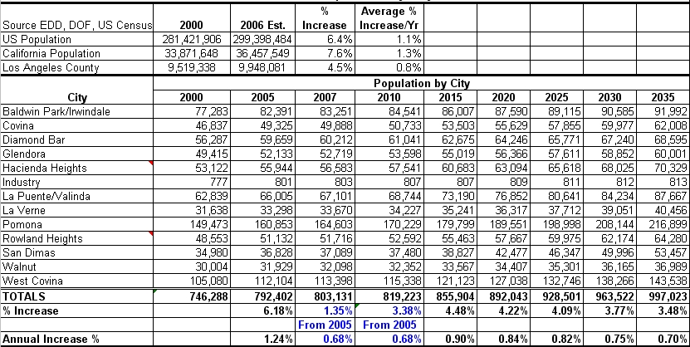

CHAPTER 2 - THE DISTRICT AND THE COLLEGE

POPULATION
The population of the Mt. San Antonio Community College District is shown in Table 2-1. The population growth
projections closely follow estimates and projections produced by the State Department of Finance Research Unit on Los Angeles County.
Table 2-1 shows that the 2005 population of the District was estimated to be 792,402. By 2020, the population is projected to reach 892,043. By 2035, the population will reach slightly less than one million persons. These
population numbers show that the District population from 2005 through 2035 will increase at an average of less than 1.0 percent per year. The rate of increase declines from 2010 to 2035.
These population numbers have already taken into consideration factors such as the ratio between birth rates and
death rates and the aging populations in the District. There is the possibility that the number of persons per
household will increase and that many single-family homes will be removed and replaced by multi-family dwellings.
Other studies have shown that the birth rate in some Hispanic families and communities is larger than in other
ethnic groups. As a result, the number of Hispanics in the younger age groups will increase more quickly in
proportion to other ethnic groups. It has also been shown that the college-going rates for young Hispanics is much
lower than in other ethnic groups, and the drop-out rate is higher. This indicates that the College should engage in
an active marketing and recruitment campaign to attract young Hispanics to the College. In addition, continuing the
College’s research in the many aspects of the teaching/learning experience that contribute to the success of
Hispanic students, and reviewing its curriculum for possible changes, would be very important.

Table 2-1: MSACCD Population by City
Source: The Southern California Association of Governments, 2006

MT. SAN ANTONIO COMMUNITY COLLEGE DISTRICT EDUCATIONAL MASTER PLAN - Page 11
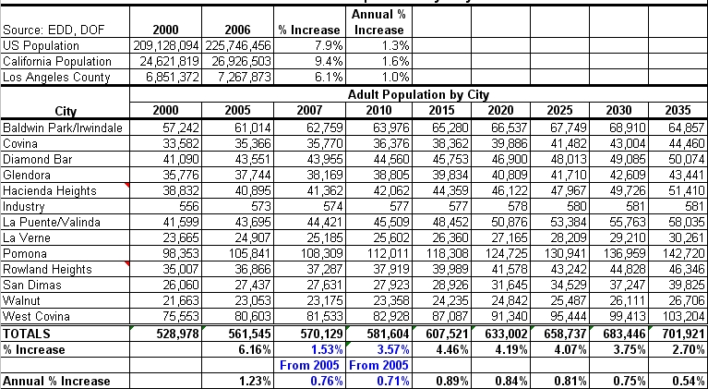

CHAPTER 2 - THE DISTRICT AND THE COLLEGE

Table 2-2 shows the Adult Population in the District between the years 2000 and 2035. The Adult Population
includes all residents of the District 18 years of age and older. In this projection, adult population proportions are
based upon 2000 census data and grown at the same rates as the total population projections. As will be shown in
the age study in the “Demographic Factors” section of this chapter, the population in the District is aging. Therefore
a slightly lower adult population may have been projected. The college-going age groups include all students from
18 to over 80 because the community colleges have become increasingly diverse, both in terms of ethnic groups
and age groups. Seventeen-year-olds should be included because they frequently enroll in community colleges, but
few studies include them in the potential college-going group. Students younger than 18 enroll in community
colleges in advance placement classes, special outreach and other programs. As a result of this changing
demographic, community colleges are faced with the necessity and the opportunity to serve all age groups in their
educational programs.

Table 2-2: MSACCD Adult Population by City
Source: The Southern California Association of Governments, 2006

It is important to determine the Adult Population since that population is used in the calculation of participation rates that measure how well community colleges are meeting the needs of their communities. Participation rates will be reviewed later in this chapter.

DEMOGRAPHIC FACTORS
One very important change that has occurred in community colleges is the expansion of inclusiveness in terms of age, gender and ethnicity. Community colleges now offer programs in English language development, skills
training, skills upgrading, retraining, women’s studies, ethnic studies and, of course, the traditional academic and technical programs. These comprehensive programs serve a wide range of students.

MT. SAN ANTONIO COMMUNITY COLLEGE DISTRICT EDUCATIONAL MASTER PLAN - Page 12

CHAPTER 2 - THE DISTRICT AND THE COLLEGE

Because many external factors have an effect on community college enrollments, it is important for community
colleges to conduct regular studies of potential student demographics to determine whether the needs of their
diverse communities are being addressed. For example, poor economic conditions cause many in search of
employment to enroll in college to retrain or upgrade their skills. Experience has shown that community college
enrollment is counter-cyclical; that is, downturns in business often result in increases in college enrollments.
Aging populations will also have an effect on community needs; seniors seeking new intellectual, cultural and
recreational outlets will depend upon the community college for continuing education. The increasing needs in
health care have already had an impact on demand for community college programs, and with the possible advent
of more widespread health care services, there will be an increased need for retraining for many future students.
Ethnicity
Figure 2-1 depicts the California Department of Finance (DoF) ethnicity projections through the year 2020 in five year increments for Los Angeles County as a whole. The DoF data are based upon 2000 census data and 2006 baseline estimates from the DoF. The following are significant highlights from these projections:
• The Hispanic population is expected to increase from 44.6 percent to 52.7 percent.
• The White population is expected to drop from 31.8 percent to 23.4 percent.
• The Black population is expected to drop 2.2 percent to 7.3 percent.
• The Asian population is expected to grow 1.9 percent to 14.1 percent.

Figure 2-1: Los Angeles County Ethnicity
Source: California Department of Finance

60.0%

50.0%

40.0%

30.0%
White
Hispanic
20.0% Asian
Pacific Islander
Black
10.0% American Indian
Multirace

0.0%
2000 2005 2010 2015 2020
White 31.8% 29.7% 27.7% 25.5% 23.4%
Hispanic 44.6% 46.4% 48.3% 50.4% 52.7%
Asian 12.2% 12.7% 13.3% 13.8% 14.1%
Pacific Islander 0.3% 0.3% 0.3% 0.3% 0.3%
Black 9.5% 8.9% 8.3% 7.9% 7.3%
American Indian 0.3% 0.3% 0.3% 0.3% 0.3%
Multirace 1.4% 1.7% 1.8% 1.8% 1.9%

MT. SAN ANTONIO COMMUNITY COLLEGE DISTRICT EDUCATIONAL MASTER PLAN - Page 13
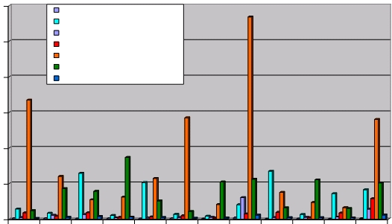

CHAPTER 2 - THE DISTRICT AND THE COLLEGE

For the District to maintain programs which are responsive to the needs of the community, it is helpful to examine how well the College currently attracts enrollment from among ethnic groups. Using the District’s 2007 enrollment numbers and 2005 estimates of ethnicity by city, this section will examine the enrollment of Filipino, Black, White, Hispanic, and Asian students. To help judge the import and location of opportunities to better serve certain ethnic groups in the District, Figure 2-2 depicts the population by number rather than percent in each city by ethnicity. The figure highlights the following key points:
• Baldwin Park/Irwindale, La Puente/Valinda, Pomona and West Covina have the largest Hispanic population
centers in the District;
• Diamond Bar, Hacienda Heights, Rowland Heights, Walnut and West Covina have the largest Asian
population centers in the District;
• Glendora, La Verne, Pomona and San Dimas have the largest White population centers in the District.
• Pomona and West Covina have the most significant Black/African American populations in the District.
• Baldwin Park/Irwindale, Diamond Bar, Pomona, Rowland Heights, Walnut and West Covina have the
largest Filipino population centers.

Figure 2-2: Population by Ethnicity and City
Source: California Department of Finance

120000

100000

80000

60000

40000

20000

0

American Indian /Alaska Native
Asian
Black /African American
Filipino
Hispanic
White /Caucasian (Non-Hispanic)
Other (Non-White)

MT. SAN ANTONIO COMMUNITY COLLEGE DISTRICT EDUCATIONAL MASTER PLAN - Page 14
Baldwin Park/Irwindale
Covina
Diamond Bar
Glendora
Hacienda Heights
La Puente/Valinda
La Verne
Pomona
Rowland Heights
San Dimas
Walnut
West Covina

CHAPTER 2 - THE DISTRICT AND THE COLLEGE

Figures 2-3 through 2-7 each present one major ethnic group both as a percent of the enrolled students from that city and as a percent of city population in Fall 2007. These tables use Fall first census figures from the District and population by ethnicity and city from 2007 estimates. The 2007 estimates were based on 2000 census data by city and California Department of Finance projections on ethnicity for Los Angeles County.
When examining how well the District is serving the ethnic groups in its population, several factors must be taken
into account. First, the figures used for both city and District enrolled percentages include under-18 populations. For the District this may skew the numbers from certain cities which are more involved in the College’s early outreach
programs, making it harder to examine the under-18 population. For example, Baldwin Park/Irwindale, Hacienda
Heights and La Puente all have under-18 enrollments in the District which represent more than 40 percent of
students enrolled from those cities at first census. Second, educational attainment may affect enrollment differences among ethnic groups. Both those residents with college degrees and those who have not completed high school
may provide opportunities to change enrollment behaviors in the District. Last, it is important to weigh the
magnitude of these opportunities by city based upon the population distribution in the District as depicted in Figure 2-2. Focusing on gains in larger ethnic population centers may provide a better return on the District’s efforts, as
long as the offerings fit the needs of that population.
Figure 2-3 depicts the African American ethnic group by city and enrolled students. This ethnic group appears to be
well served by the District. The largest population center for African Americans is Pomona, which also shows strong
numbers in the enrolled population. West Covina, the second largest population center for this ethnic group, and its
neighbor Covina show possible opportunities for increasing the enrollment of African Americans at the College.

Figure 2-3: Percent of African Americans by City and MSACCD Enrollment
Source: California Department of Finance and MSACCD

9.0%

8.0%

7.0%

6.0%

5.0%

4.0%
City
3.0% Enrolled

2.0%

1.0%

0.0%

MT. SAN ANTONIO COMMUNITY COLLEGE DISTRICT EDUCATIONAL MASTER PLAN - Page 15
Baldwin
Park/Irwindale
Covina
Diamond Bar
Glendora
Hacienda Heights
La
Puente/Valinda
La Verne
Pomona
Rowland Heights
San Dimas
Walnut
West Covina

CHAPTER 2 - THE DISTRICT AND THE COLLEGE

Figure 2-4 depicts the percentage of Asians by city and enrolled students. Every population center for this ethnic group is well served by the District. An analysis of which programs Asian students are enrolled in will help define ways to continue this strong performance by the district. An analysis of the ages, educational attainment and residence will aid in this pursuit.

Figure 2-4: Percent of Asians by City and MSACCD Enrollment
Source: California Department of Finance and MSACCD

60.0%

50.0%

40.0%

30.0%

20.0%

10.0%

0.0%

City
Enrolled

Figure 2-5 depicts the percentage of Filipinos by city and enrolled students. Diamond Bar, Rowland Heights,
Walnut and West Covina stand out as being underserved population centers for this ethnic group in the District.
Again, educational attainment, participation rates from these cities, age, unemployment and cultural information will help to further define opportunities to serve this ethnic group.

MT. SAN ANTONIO COMMUNITY COLLEGE DISTRICT EDUCATIONAL MASTER PLAN - Page 16
Baldwin
Park/Irwindale
Covina
Diamond Bar
Glendora
Hacienda Heights
La
Puente/Valinda
La Verne
Pomona
Rowland Heights
San Dimas
Walnut
West Covina

CHAPTER 2 - THE DISTRICT AND THE COLLEGE

Figure 2-5: Percent of Filipinos by City and MSACCD Enrollment
Source: California Department of Finance and MSACCD

12.0%
s

10.0%

8.0%

6.0%

City
4.0% Enrolled

2.0%

0.0%

Figure 2-6 depicts the percentage of Hispanics by city and the percentage of enrolled students from each city.
State Department of Finance and census numbers suggest that Hispanics make up the youngest ethnic group. This
fact has two effects. First, this group may appear underserved because of the large under-18 sector of this
population. Second, this group presents a significant opportunity for the District, as over 60 percent of all students
first entering post secondary education in the Los Angeles County area will be Hispanic for the foreseeable future.
Baldwin Park/Irwindale, Covina, La Puente/Valinda and West Covina, which all have larger Hispanic populations, also show the most significant gaps between the cities’ populations and the College’s enrollment. Pomona, the largest Hispanic population center in the District, shows less of a gap. This smaller gap may be explained in part by local under-18 outreach programs.
The Hispanic ethnic group is the largest in the District, the youngest in the District, and has the most impact on District enrollment numbers. Ongoing needs studies among these residents will be essential to the continued success of the District.

MT. SAN ANTONIO COMMUNITY COLLEGE DISTRICT EDUCATIONAL MASTER PLAN - Page 17
Baldwin
Park/Irwindale
Covina
Diamond Bar
Glendora
Hacienda Heights
La
Puente/Valinda
La Verne
Pomona
Rowland Heights
San Dimas
Walnut
West Covina

CHAPTER 2 - THE DISTRICT AND THE COLLEGE

Figure 2-6: Percent of Hispanics by City and MSACCD Enrollment
Source: California Department of Finance and MSACCD

90.0%

80.0%

70.0%

60.0%

50.0%
City

40.0%

30.0%

20.0%

10.0%

0.0%
Enrolled

Figure 2-7 depicts the percentage of the Non-Hispanic White/Caucasian population by city and enrolled students. This shrinking ethnic group has population centers in Glendora, La Verne and San Dimas. This population is the oldest among ethnic groups in Los Angeles County. The numbers in these population centers suggest opportunities for upgrading, retraining and adult education. In the section on Age that follows, it will be shown that many more opportunities exist for seniors to be served by the District.

MT. SAN ANTONIO COMMUNITY COLLEGE DISTRICT EDUCATIONAL MASTER PLAN - Page 18
Baldwin
Park/Irwindale
Covina
Diamond Bar
Glendora
Hacienda Heights
La
Puente/Valinda
La Verne
Pomona
Rowland Heights
San Dimas
Walnut
West Covina

CHAPTER 2 - THE DISTRICT AND THE COLLEGE

Figure 2-7: Percent of Caucasians (Non-Hispanic) by City and MSACCD Enrollment
Source: California Department of Finance and MSACCD

70.0%

60.0%

50.0%

40.0%

30.0%
City
Enrolled
20.0%

10.0%

0.0%

Age
The age demographic is an important measure of how well the District is serving its populations.
Figure 2-8 shows the California Department of Finance (DoF) projections of changes in age groups in Los Angeles County through the year 2020. Age groupings were drawn to match those used by the District. The size of the data sets is not as significant as the change presented over time, as the under-18 population is a disproportionately large age group when compared with other age groups.
Los Angeles County is expected to have a decreasing birth rate through 2050. For the under-18 group in 2020,
Figure 2-8 shows a small bump in the decline shown by DoF numbers to 2050, not a turnaround in births. Birth
rates peaked in 2000 and have had one bump in 2003 similar to that projected for 2020. This peak in young people in 2000 will have passed through the first-time student age groups by 2020. The 2000 peak can be seen passing through age group 21-25 as it peaks in 2015 and begins to decrease by 2020.
Overall Figure 2-8 depicts the DoF expectation of an aging population. This can be seen by comparing the downward trend of the under-18 age group and the upward trend of the 51+ age group.

MT. SAN ANTONIO COMMUNITY COLLEGE DISTRICT EDUCATIONAL MASTER PLAN - Page 19
Baldwin
Park/Irwindale
Covina
Diamond Bar
Glendora
Hacienda Heights
La
Puente/Valinda
La Verne
Pomona
Rowland Heights
San Dimas
Walnut
West Covina

CHAPTER 2 - THE DISTRICT AND THE COLLEGE

Figure 2-8: Los Angeles County Population Projections by Age Group
Source: California Department of Finance

4,000,000

3,500,000

3,000,000

2,500,000

2,000,000

1,500,000

1,000,000

500,000

0

2005 2010 2015

2020

Under 18
18-20
21-25
26-30
31-40
41-50
51+

Figure 2-9 depicts population in numbers by age and city to give a view of actual population centers within the
district by age. Age groups should be looked at in relation to other cities and not just their size since District
groupings such as 18-20, 21-25 and 51+ differ in their numbers of years. With relative size in mind, the 51+ group’s
largest population centers are Pomona and West Covina. The 31-50 groups will all be in the 51+ by 2020. Baldwin
Park, Diamond Bar and Pomona have a larger proportion of this age group than do other cities in the district. These
three cities will therefore have larger gains in 51+ populations through 2020. The youngest cities are Baldwin Park,
La Puente and Pomona. West Covina, though its population is not as young overall, also has a large 18-30
population.

MT. SAN ANTONIO COMMUNITY COLLEGE DISTRICT EDUCATIONAL MASTER PLAN - Page 20

CHAPTER 2 - THE DISTRICT AND THE COLLEGE

Figure 2-29: Population by Age and City
Source: California Department of Finance

35,000

30,000

25,000

20,000
18-20
15,000 21-25
26-30
31-40
10,000
41-50
51+
5,000

0

Figures 2-10 through 2-15 examine six District age groups using 2007 first census enrolled students in percentages by age and city, and general population in percentages by age and city.
General population numbers are based on 2000 U.S. Census and California Department of Finance (DoF)
population 2007 projections by age and ethnicity. DoF age groups are arithmetically adjusted to match the District age groups.
As with ethnicity, when examining how the District serves its age groups, other factors should be considered as
affecting the results. Educational attainment and employment status, for example, change the needs and behaviors of these age groups in District cities. Proximity to other colleges may also affect the attendance patterns among these age groups - for example, through outflow from the District.
The under-18 age group has been removed from these comparisons. Under-18 students do participate in the
District in large numbers, but the rates vary greatly between cities. Enrollment of these under-18, outreach and
special program students appears to be related to the proximity of the offerings. In addition, the source data for the cities have all under-18 residents in one age group, 0 to 17, making segmentation of this age group for comparisons impractical and inaccurate.
Figure 2-10 depicts the 18-20 age group. This is the age group from which the highest participation rates should be expected.

MT. SAN ANTONIO COMMUNITY COLLEGE DISTRICT EDUCATIONAL MASTER PLAN - Page 21
Baldwin
Park/Irwindale
Covina
Diamond Bar
Glendora
Hacienda Heights
La Puente
La Verne
Pomona
Rowland Heights
San Dimas
Walnut
West Covina

CHAPTER 2 - THE DISTRICT AND THE COLLEGE

Here it is helpful to compare the District’s performance among cities. Baldwin Park/Irwindale, La Verne and San Dimas show the lowest participation, while Glendora and Rowland Heights show the highest. Glendora is a particular success here, as it is much closer to Citrus College.

Figure 2-10: Percent of Population Age 18-20 by City and MSACCD Enrollment
Sources: U.S. Census 2000, California Department of Finance and MSACCD
30.0%

25.0%

20.0%

15.0%

% Enrolled

10.0%

5.0%

0.0%

MT. SAN ANTONIO COMMUNITY COLLEGE DISTRICT EDUCATIONAL MASTER PLAN - Page 22
% City
Baldwin
Park/Irwindale
Covina
Diamond Bar
Glendora
Hacienda Heights
La Puente
La Verne
Pomona
Rowland Heights
San Dimas
Walnut
West Covina

CHAPTER 2 - THE DISTRICT AND THE COLLEGE

Figure 2-11 depicts the 21-25 age group. This age group, similar to the 18-20 age group, should show higher percentages than the cities.
Performance results here show similar results to the 18-20 age group. Again, the best participation rates in the District from this age group are in Glendora and Rowland Heights, while the lowest numbers come from Baldwin Park/Irwindale, La Verne and San Dimas. These three cities, though within the District, are very close to Citrus and Rio Hondo Colleges, which enjoy significant inflow from these cities.

Figure 2-11: Percent of Population Age 21-25 by City and MSACCD Enrollment
Sources: U.S. Census 2000, California Department of Finance and MSACCD

30.0%

25.0%

20.0%

15.0%

% Enrolled
10.0% % City

5.0%

0.0%

Figure 2-12 depicts the 26-30 age group. This age group shows notably proportional results when compared with the District.
Once again, the best participation rates in the District lie in Glendora and Rowland Heights, and the lowest
participation rates come from Baldwin Park/Irwindale, La Verne and San Dimas. This age group appears to be less affected by proximity, suggesting differences in means and in motivations. Glendora, once again, shows particular strength in this age group.

MT. SAN ANTONIO COMMUNITY COLLEGE DISTRICT EDUCATIONAL MASTER PLAN - Page 23
Baldwin
Park/Irwindale
Covina
Diamond Bar
Glendora
Hacienda Heights
La Puente
La Verne
Pomona
Rowland Heights
San Dimas
Walnut
West Covina

CHAPTER 2 - THE DISTRICT AND THE COLLEGE

Figure 2-12: Percent of Population Age 26-30 by City and MSACCD Enrollment
Sources: U.S. Census 2000, California Department of Finance and MSACCD

10.0%

9.0%

8.0%

7.0%

6.0%

5.0%

4.0% % Enrolled
% City
3.0%

2.0%

1.0%

0.0%

Figure 2-13 depicts the 31-40 age group. This group can be greatly affected by educational attainment and employment status.
Hacienda Heights, La Verne and San Dimas have the lowest participation in this age group, while Glendora,
Pomona and Rowland Heights have the highest participation. Some of these results appear to be directly correlated to educational attainment, detailed in the “Economic Conditions” section of this chapter.
The cities with lower participation in this age group have low unemployment and higher educational attainment. Upgrade and repair offerings which are accessible to working individuals should present the best opportunities for growth in these cities.

MT. SAN ANTONIO COMMUNITY COLLEGE DISTRICT EDUCATIONAL MASTER PLAN - Page 24
Baldwin
Park/Irwindale
Covina
Diamond Bar
Glendora
Hacienda Heights
La Puente
La Verne
Pomona
Rowland Heights
San Dimas
Walnut
West Covina

CHAPTER 2 - THE DISTRICT AND THE COLLEGE

Figure 2-13: Percent of Population Age 31-40 by City and MSACCD Enrollment
Sources: U.S. Census 2000, California Department of Finance and MSACCD

16.0%

14.0%

12.0%

10.0%

8.0%

6.0% % Enrolled
% City

4.0%

2.0%

0.0%

Figure 2-14 depicts the 41-50 age group. This age group’s behavior is also affected by educational attainment and employment status.
Baldwin Park/Irwindale, Hacienda Heights, La Verne and San Dimas have lower relative participation. Covina, Diamond Bar, Rowland Heights and Walnut have the highest relative participation.
This age group was educated in an era with much less developed technology. As the economy forces adaptation in the workforce, this age group will need to repair and upgrade their marketable skill sets or acquire new skills.

MT. SAN ANTONIO COMMUNITY COLLEGE DISTRICT EDUCATIONAL MASTER PLAN - Page 25
Baldwin
Park/Irwindale
Covina
Diamond Bar
Glendora
Hacienda Heights
La Puente
La Verne
Pomona
Rowland Heights
San Dimas
Walnut
West Covina

CHAPTER 2 - THE DISTRICT AND THE COLLEGE

Figure 2-14: Percent of Population Age 41-50 by City and MSACCD Enrollment
Sources: U.S. Census 2000, California Department of Finance and MSACCD

20.0%

18.0%

16.0%

14.0%

12.0%

10.0%

8.0% % Enrolled
% City
6.0%

4.0%

2.0%

0.0%

Figure 2-15 depicts the 51+ age group. This is the senior age group in the District.
Seniors, especially retired ones, have unique attendance behaviors as a group. Seniors attend college to repair and
upgrade for the same reasons as the 31-50 age groups. Upon retirement, this population sector changes behavior.
A 2008 study by C. Stallard, “Community College Offerings to Seniors,” shows that seniors 55 and over attend enrichment programs partly based upon proximity of the class locations. This study also suggests that a District realignment of class locations to serve the denser population centers of Baldwin Park/Irwindale, West Covina, La Puente and Pomona may be an opportunity to better serve this age group.
Figure 2-15 shows that better participation is coming from Glendora, La Verne, San Dimas and Walnut, where many off-campus classes are offered.

MT. SAN ANTONIO COMMUNITY COLLEGE DISTRICT EDUCATIONAL MASTER PLAN - Page 26
Baldwin
Park/Irwindale
Covina
Diamond Bar
Glendora
Hacienda Heights
La Puente
La Verne
Pomona
Rowland Heights
San Dimas
Walnut
West Covina

CHAPTER 2 - THE DISTRICT AND THE COLLEGE

Figure 2-15: Percent of Population Age 51+ by City and MSACCD Enrollment
Sources: U.S. Census 2000, California Department of Finance and MSACCD

35.0%

30.0%

25.0%

20.0%

15.0%
% Enrolled
% City
10.0%

5.0%

0.0%

Figures 2-16 and 2-17 present a more global view of the ages of enrolled students and the District in 2007.
Figure 2-16 shows that the largest proportion of enrolled students is in the 18-25 age range. Next in size is the 51 and over age group. Here the correlation between proximity and participation can be seen. The 51 and over age group has the largest spread in participation, from as low as 2.1 percent in Baldwin Park/Irwindale up to 15.9 percent in San Dimas. San Dimas, La Verne, Walnut, Covina, Diamond Bar and Glendora are the top six
respectively, and all are in close proximity to the College and off-campus offerings.
Figure 2-17 shows the age distribution of the cities in the District. The age distributions are tightly bunched in the 18-40 age groups. The large spread in the 51+ age group between cities highlights the much younger populations in Baldwin Park/Irwindale, La Puente and Pomona. Some of the spread in senior participation is explained by these younger populations with fewer 51+ residents. Yet there remains a significant gap between enrolled students and cities in their proportions of this growing age group. Opportunities to improve the District’s services to the 51+ age group may be found in several places. Offerings in the population centers in the southern half of the District seem promising, and should be examined. Needs studies related to educational attainment and employment status within this age group may also offer direction in the types of programs to offer.

MT. SAN ANTONIO COMMUNITY COLLEGE DISTRICT EDUCATIONAL MASTER PLAN - Page 27
Baldwin
Park/Irwindale
Covina
Diamond Bar
Glendora
Hacienda Heights
La Puente
La Verne
Pomona
Rowland Heights
San Dimas
Walnut
West Covina

CHAPTER 2 - THE DISTRICT AND THE COLLEGE

Figure 2-16: MSACCD Enrollment by Age and City
Source: MSACCD

30.0%

25.0%

Baldwin Park
20.0% Covina
Diamond Bar
Glendora
Hacienda Heights
15.0% La Puente
La Verne
Pomona
Rowland Heights
San Dimas
10.0% Walnut
West Covina

5.0%

0.0%
18-20 21-25 26-30 31-40 41-50 51+

Figure 2-17: District Population by Age and City
Sources: U.S. Census 2000 and California Department of Finance

35.0%

30.0%

25.0% Baldwin Park/Irwindale
Covina
Diamond Bar
Glendora
20.0% Hacienda Heights
La Puente
La Verne
15.0% Pomona
Rowland Heights
San Dimas
Walnut
10.0% West Covina

5.0%

0.0%
18-20 21-25 26-30 31-40 41-50 51+

MT. SAN ANTONIO COMMUNITY COLLEGE DISTRICT EDUCATIONAL MASTER PLAN - Page 28
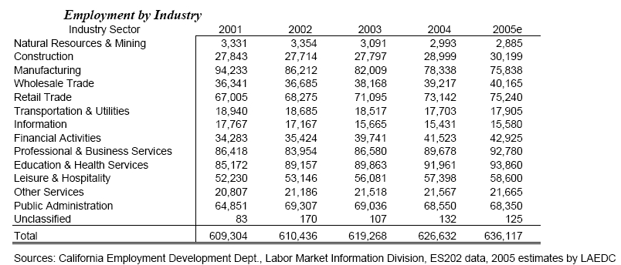

CHAPTER 2 - THE DISTRICT AND THE COLLEGE

ECONOMIC CONDITIONS
As this Plan is being written the United States appears to be entering a recession and the Presidential election
cycle promises to bring the country to an economic fork in the road. For these reasons it is difficult to forecast
economic conditions. Fuel prices are rapidly increasing, with a significant effect throughout the economy.
Unemployment is rising, as outsourcing, fuel prices and a looming recession continue to take jobs in many sectors. Though the country may be relieved of some of these economic pressures, it is clear that vigilant adaptation will be necessary in this changing economy.
Southern California follows the country in a precipitous increase in home foreclosures. The number of foreclosures, which reached a 10-year low in 2005 after eight years of steady decreases, is now at record high levels. This
mortgage crisis, large housing inventories, land scarcity and high land prices in the San Gabriel Valley have
affected new construction and its economic partners.
In the San Gabriel Valley there has been a trend toward technology start-ups migrating out of the area due to land scarcity and unfulfilled labor needs. Since 2001 manufacturing has gone from the largest employment sector in the San Gabriel Valley to third position (Table 2-3). Manufacturing jobs are being replaced by jobs in education and health services, professional and business services, hospitality, as well as retail and wholesale trade.

Table 2-3: San Gabriel Valley Employment
Source: San Gabriel Valley Economic Partnership’s 2006 Economic Overview and Forecast

Table 2-4 depicts the current unemployment in the District according to the Employment Development Department
as of April 2008. The San Gabriel Valley and the District, with their diversified and adaptive employment base,
appear to be more resilient than Los Angeles County and California to the recent increases in unemployment. The
District is at 4.9 percent unemployment, while Los Angeles is at 5.7 percent, California is at 6.1 percent and the
United States is at 4.8 percent unemployment. The lack of large firms in the San Gabriel Valley contributes to the
District’s resiliency, as do the large numbers of jobs in education and health services and public administration.
Baldwin Park/Irwindale, La Puente/Valinda and Pomona are large population centers within the District that have
significantly higher unemployment. Eight of the 13 cities have unemployment at or below 4.0 percent.

MT. SAN ANTONIO COMMUNITY COLLEGE DISTRICT EDUCATIONAL MASTER PLAN - Page 29

CHAPTER 2 - THE DISTRICT AND THE COLLEGE

Table 2-4: District Unemployment Rate by City
Source: Employment Development Department April 2008

City Rate Population
Baldwin Park/Irwindale 7.2% 62,759
Covina 4.0% 35,770
Diamond Bar 4.0% 43,955
Glendora 2.9% 38,169
Hacienda Heights 3.9% 41,362
Industry 9.8% 574
La Puente/Valinda 6.8% 44,421
La Verne 3.2% 25,185
Pomona 6.4% 108,309
Rowland Heights 3.6% 37,287
San Dimas 3.3% 27,631
Walnut 2.7% 23,175
West Covina 5.0% 81,533
MSACCD (weighted) 4.9% 570,129
Los Angeles County 5.7% 7,490,000
California 6.1% 27,975,000
United States 4.8% 233,405,000

Figure 2-18 suggests an inverse relationship between educational attainment (in this case a bachelor’s degree)
and unemployment. Blue collar jobs are decreasing in the San Gabriel Valley. And employers are requiring more
education and wider skill sets from applicants as fewer employees are asked to take on more duties. This suggests
a gap between the needs of the employers and the education of the residents in Baldwin Park/Irwindale, La Puente
and Pomona.

Figure 2-18: Comparison of District Unemployment Rates and Bachelor’s Degree Attainment
Source: Employment Development Department and California Department of Finance

45.0%

40.0%

35.0%

30.0%

25.0%

20.0%

15.0%

10.0%

5.0%

0.0%

Unemployment Bachelor's Degree

MT. SAN ANTONIO COMMUNITY COLLEGE DISTRICT EDUCATIONAL MASTER PLAN - Page 30
Baldwin
Park/Irwindale
Covina
Diamond Bar
Glendora
Hacienda Heights
Industry
La Puente/Valinda
La Verne
Pomona
Rowland Heights
San Dimas
Walnut
West Covina
District (weighted)

CHAPTER 2 - THE DISTRICT AND THE COLLEGE

Energy prices may affect enrollment both negatively and positively. Unemployment caused by the energy crisis can cause an increase in enrollment. On the other hand, energy costs may have the opposite effect. The current energy crisis appears to have no short-term solution. Gasoline prices will continue to pressure the economic decisions of
individuals. Out-of-District students may begin to reconsider traveling to the District for their education. High traffic congestion in the Valley will serve to intensify this focus on reduced travel. And though Los Angeles County MTA
offers a $36/month college discount pass, public transportation remains impractical in the busy lives of many. The same effect may be seen in students who leave the District as they become less willing to travel and look to their
local community college to fulfill their needs.
The costs of higher education have a more certain effect on enrollment. In this economy, the cost of attending a four-year institution is becoming more and more inaccessible. Community colleges will likely see an increase in enrollment from the growing 18-20 age group due to this economic pressure. Retraining and upgrading students in the 25+ age groups will be increasing due to employment sector migrations away from manufacturing and
construction in the District. Along with employment sector migrations, ever-increasing demand for technology skills and the demand for employees with wider skill sets in an effort to decrease labor costs will also translate to
retraining and upgrading opportunities for community colleges.
The District may also anticipate greater enrollment gains from the middle- and lower-income cities of the District
due to the recession, job migration and the correlation between income and educational attainment clearly shown in
Figure 2-19. This can be seen in the direct correlation between bachelor’s degree attainment and median income.
Ironically, revenue cuts often accompany these enrollment demands found during a recession, adding another challenge for community colleges. To adapt as a community college in such an environment will require close monitoring of job sectors, strong relationships with local businesses, and a focus on cost-effective programs that meet the changing needs of the District.

Figure 2-19: Comparison of Income and Educational Attainment
Source: California Department of Finance

100%
90%
80%
70%
60%
50%
40%
30%
20%
10%

0%

High School Bachelor's Degree Higher Degree Med. Income/100,000

MT. SAN ANTONIO COMMUNITY COLLEGE DISTRICT EDUCATIONAL MASTER PLAN - Page 31
Baldwin Park
City of Industry
Covina
Diamond Bar
Glendora
Hacienda Heights
Irwindale
La Puente
La Verne
Pomona
Rowland Heights
San Dimas
Valinda
Walnut
West Covina
Average
(Unweighted)

CHAPTER 2 - THE DISTRICT AND THE COLLEGE

EDUCATIONAL ATTAINMENT
Figure 2-20 and Table 2-5 depict the educational attainment of the 25-and-over population in the District by city.

Percentages represent the number of people in this population who have attained that level of education. Cities with no higher degree attainment showing in Figures 1-24a and 1-24b have chosen to combine bachelor’s degrees and higher degrees in one group. In these cases, bachelor’s degree attainment represents a total of residents with
bachelor’s degrees or higher.

Figure 2-20: Educational Attainment of District Population 25+ by City
Source: California Department of Finance

100.0%

90.0%

80.0%

70.0%

60.0%

50.0%

40.0%

30.0%

20.0%

10.0%

0.0%

High School Diploma Bachelor's Degree Higher Degree

Less than 50 percent of the population of Baldwin Park and La Puente has a high school diploma. The City of
Industry, Irwindale, Pomona and Valinda have 12 percent or less with a bachelor’s degree. Diamond Bar, Hacienda Heights, La Verne, Rowland Heights and Walnut all have bachelor’s degree attainment above 30 percent.
The District has a weighted average of less than 22 percent for attainment of bachelor’s degrees. This average is
compared with 25 percent for Los Angeles County and 27 percent for California. These numbers suggest that the
District could facilitate growth in enrollment in the near future from certain sectors of their population. If properly

MT. SAN ANTONIO COMMUNITY COLLEGE DISTRICT EDUCATIONAL MASTER PLAN - Page 32
Baldwin Park
City of Industry
Covina
Diamond Bar
Glendora
Hacienda Heights
Irwindale
La Puente
La Verne
Pomona
Rowland Heights
San Dimas
Valinda
Walnut
West Covina

CHAPTER 2 - THE DISTRICT AND THE COLLEGE

targeted, the enrollment gains discussed here should show an inverse relationship to the educational attainment levels in each city.

Table 2-5: Educational Attainment of District Population 25+ by City
Source: California Department of Finance

City High School Bachelor's Degree Higher Degree
Baldwin Park 47.5% 9.0% 1.6%
City of Industry 66.6% 12.0% n/a
Covina 81.9% 18.8% 5.5%
Diamond Bar 90.7% 42.3% 13.4%
Glendora 87.1% 25.7% 9.1%
Hacienda Heights 81.6% 30.7% 10.0%
Irwindale 60.0% 7.3% 2.4%
La Puente 49.7% 7.8% 2.1%
La Verne 88.7% 31.6% 12.2%
Pomona 60.3% 11.8% n/a
Rowland Heights 82.1% 33.3% 10.9%
San Dimas 87.3% 28.4% n/a
Valinda 57.9% 8.4% n/a
Walnut 88.8% 41.9% n/a
West Covina 78.2% 21.9% 5.7%
Average (Unweighted) 73.9% 22.1% 7.3%

These educational attainment statistics for the District point strongly to the need for post-secondary education
opportunities that follow the changing job market. Table 2-5 suggests a reasonable starting point for investigation of how to best serve the District with these opportunities.

FREE FLOW
California law allows a student to attend any of the more than 100 community colleges in the State, irrespective of the student’s district of residence; this is called free flow. Students, then, are provided with a very wide selection of locations and educational programs.
Table 2-6 (outflow) and Table 2-7 (inflow) taken together present a snapshot of the free flow for the Mt. San
Antonio Community College District. Information for outflow includes 2006 enrollment of students from zip codes in the District at Chaffey, Citrus and Rio Hondo Colleges. This information is shared by the college of attendance and shared among institutions in the San Gabriel Valley. The information has multiple sources, with multiple formats; blanks indicate no data from that college.
Inflow data from the District show students enrolled from selected cities outside the District, and the grand totals of inflow from all locations outside the District.

MT. SAN ANTONIO COMMUNITY COLLEGE DISTRICT EDUCATIONAL MASTER PLAN - Page 33

CHAPTER 2 - THE DISTRICT AND THE COLLEGE

Table 2-6: MSACCD Outflow
Source: MSACCD, Chaffey, Citrus and Rio Hondo

City Zip Code Chaffey Citrus Rio Hondo Totals
Baldwin Park/Irwindale 91706 12 580 409 1001
Industry 91714 0 1 1 2
Industry 91715 2 2 4 8
Industry 91716 0 3 0 3
Covina 91722 14 832 83 929
Covina 91723 7 409 35 451
Covina 91724 21 613 46 680
Diamond Bar 91765 33 117 83 233
Glendora 91741 17 1442 63 1522
Hacienda Heights 91745 8 84 601 693
La Puente 91744 10 265 502 777
La Puente 91746 6 66 342 414
La Puente 91747 0 3 4 7
La Puente 91749 0 2 1 3
La Verne 91750 115 595 47 757
Pomona 91766 175 191 84 450
Pomona 91767 158 272 45 475
Pomona 91768 85 128 36 249
Pomona 91769 5 3 2 10
Rowland Heights 91748 9 62 152 223
San Dimas 91773 47 704 32 783
Walnut 91788 0 4 3 7
Walnut 91789 13 126 68 207
Walnut 91795 0 0 0 0
West Covina 91790 11 575 197 783
West Covina 91791 13 428 79 520
West Covina 91792 11 127 107 245
West Covina 91793 0 9 1 10
Total 772 7643 3027 11442

Table 2-6 reveals several significant facts.
Two-thirds of students who leave the District are enrolled at Citrus. Cities that stand out as feeders of Citrus include Baldwin Park/Irwindale, Covina, Glendora, La Verne, Pomona, San Dimas and West Covina. This outflow affects participation in these cities and shows up in the age and ethnicity comparisons previously presented.
Enrollment at Rio Hondo by students in the District makes up 26 percent of the outflow. Cities that stand out as feeders of Rio Hondo include Baldwin Park/Irwindale, Hacienda Heights, La Puente and West Covina.
Table 2-7 shows the grand total of students from outside the District who are enrolled at MSACCD totals 15,024. This represents about 40 percent of the College’s total enrollment. Cities listed here do not represent an exhaustive list of all sources of inflow, but only those cities with large enough numbers to be considered significant.
Students choose to enroll in schools outside the District in which they live for a variety of reasons. Students will
deliberately drive by a less attractive campus to attend a more attractive campus even though the distance is
center, a cafeteria, and a full range of student services. High school counselors will sometimes encourage a student to attend a more well-developed college. Also significant to free flow are the differences in programs offered and accessibility to those programs as they relate to student needs and perceived needs.

MT. SAN ANTONIO COMMUNITY COLLEGE DISTRICT EDUCATIONAL MASTER PLAN - Page 34

CHAPTER 2 - THE DISTRICT AND THE COLLEGE

Table 2-7: MSACCD Inflow from Selected Cities
Source: MSACCD Fall 2007 Enrollment Data

City Credit Only Non-Credit Only Credit & Non-Credit City Totals
Alhambra 79 18 46 143
Alta Loma 135 30 58 223
Anaheim 48 4 7 59
Arcadia 110 19 40 169
Azusa 261 98 121 480
Brea 106 1 54 161
Chino Hills 1,184 269 624 2,077
Chino 824 137 397 1,358
Claremont 225 156 113 494
Corona 217 31 134 382
Duarte 67 20 32 119
El Monte 275 55 174 504
Fontana 305 63 166 534
Fullerton 84 8 36 128
Glendora-North 169 52 81 302
La Habra Hts 86 19 51 156
Los Angeles 144 30 67 241
Monrovia 68 17 33 118
Montclair 336 93 168 597
Ontario 959 206 523 1,688
Pasadena 69 29 20 118
Pico River 49 3 23 75
Rosemead 124 23 82 229
Rancho Cucamonga 389 91 192 672
Rialto 69 13 46 128
Riverside 117 9 46 172
San Gabriel 64 28 65 157
South El Monte 103 23 57 183
Temple City 61 16 31 108
Upland 516 141 269 926
Whittier 185 43 104 332
Yorba Linda 51 4 13 68
Sub-Total of
Selected Cities 7,479 1,749 3,873 13,101
Grand Totals All Cities
Credit and Non-
Credit-Only Non-Credit Only Credit Grand Total Inflow
8,611 1,971 4,442 15,024

The geographic proximity of Rio Hondo and Citrus colleges to cities in the District, as well as transportation
infrastructure, are significant factors in outflow. Map 2-1 shows how outflow is related to these factors. Map 2-1 is meant to show the significant spheres of influence exerted by these colleges. Chaffey College outflow is not
included because numbers for Chaffey were only significant in one city, Pomona.
In Map 2-1 the cities within the District with significant outflow are colored according to the recipient college. Marked in blue, Glendora, La Verne, San Dimas and Covina all have significant outflow to Citrus College, marked with a larger blue balloon. Marked in magenta, La Puente, Hacienda Heights and Rowland Heights all have significant outflow to Rio Hondo College, marked with a larger magenta balloon. Baldwin Park is marked in blue and magenta, as it has significant outflow to both Citrus and Rio Hondo.

MT. SAN ANTONIO COMMUNITY COLLEGE DISTRICT EDUCATIONAL MASTER PLAN - Page 35
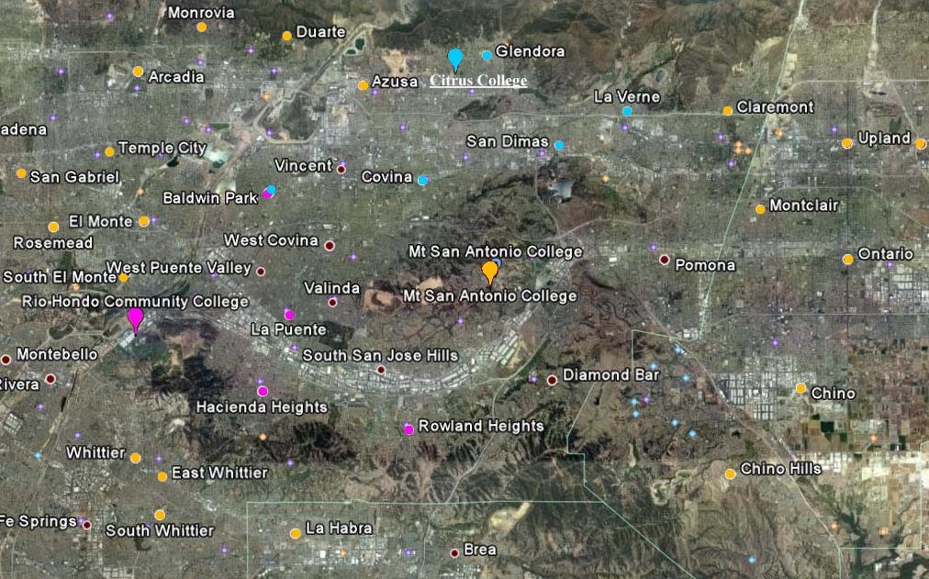

CHAPTER 2 - THE DISTRICT AND THE COLLEGE

From this map it is clear that geographic proximity and transportation infrastructure are significantly influencing
outflow. The maroon dots with white circles are not significant to this discussion; they are simply default markers for
cities.
Map 2-1 also shows the inflow to the District from selected, significant cities. The District has an inflow comparable to the total enrollment at Chaffey, Citrus or Rio Hondo colleges, and Figure 2-21 is included here to help
demonstrate the relative size of the colleges examined in this section. Figure 2-21 shows the full time equivalent students (FTES) at each institution, providing an accurate measure of the relative size of each college’s
enrollments. Inflow to the District is much greater, and from much farther away.
If one connects the similarly colored dots in Map 2-1, the relative magnitude of Mt. San Antonio Community College District’s sphere of influence becomes clear. This indicates strengths in programs and services as well as off-
campus offerings, compared with the smaller colleges in the area. Opportunities to further leverage these strengths and differences may also exist. An examination of the enrollment behaviors of both inflow and outflow students should more clearly define these opportunities.

Map 2-1: MSACCD Inflow and Outflow
Used by permission of Google Earth

MT. SAN ANTONIO COMMUNITY COLLEGE DISTRICT EDUCATIONAL MASTER PLAN - Page 36

CHAPTER 2 - THE DISTRICT AND THE COLLEGE

Figure 2-21: Full Time Equivalent Students by College
Source: CCCCO FTES Query Engine 2006

1824

254 528

562

9688

5959 5495
4450

Chaffey Citrus Rio Hondo Mt San Antonio

2006 Credit FTES 2006 Non-Credit FTES

In many cases geographic proximity to institutions outside the District in this dense part of Los Angeles County
seems to be affecting decisions to enroll across district lines. Going forward, fuel costs will certainly become a more
significant factor in these enrollment decisions. In this instance, although all four community colleges in the area of
the District are well-developed, full-service institutions with respect to programs and services offered, Mt. San
Antonio College appears to have strong advantages, as well as certain opportunities to better serve its District.
A close examination of the programs in which these inflow students are enrolled in significantly large numbers as
well as a comparison of program, service and accessibility differences among Mt. San Antonio, Citrus and Rio
Hondo colleges should reveal opportunities to attract future enrollment through attractive and innovative new
programs.

PARTICIPATION RATES
Participation rate is an accurate measure of how well a district is meeting the needs of the residents of the district. It indicates the number of students registered at the college per each 1,000 adult population.
Table 2-8 is a complete list of cities and zip codes within the Mt. San Antonio Community College District
(MSACCD) and their participation rates. For each city in the District the table shows zip code(s), adult population, enrollment by credit type and participation rates by credit type and overall. The statewide average participation rate for a community college district is 70 students per 1,000 adults in that population. The participation rate for
MSACCD is 47 in fall 2007.

MT. SAN ANTONIO COMMUNITY COLLEGE DISTRICT EDUCATIONAL MASTER PLAN - Page 37
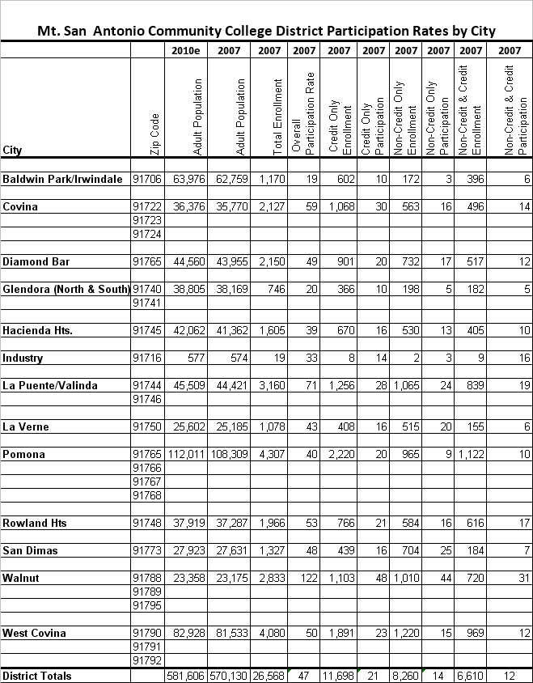

CHAPTER 2 - THE DISTRICT AND THE COLLEGE

Table 2-8: Participation Rates by City
Sources: MSACCD and California Department of Finance

When looking for growth opportunities and other information on student behaviors in a city in the District, it is helpful to see the credit status of participating students. In Figure 2-22, participation is displayed by credit status and in total for each city in the District. By examining the needs of the cities in the District compared to their credit status behavior, more targeted opportunities for growth potential can be established.
The state average of 70 as a benchmark for total participation shows opportunities for significant enrollment gains.
Only Walnut, where the College is located, has a participation rate above 70. In this District, however, the proximity

MT. SAN ANTONIO COMMUNITY COLLEGE DISTRICT EDUCATIONAL MASTER PLAN - Page 38

CHAPTER 2 - THE DISTRICT AND THE COLLEGE

of other community colleges, travel infrastructure, and districting cause significant free flow between districts as shown in Map 2-1.
Figure 2-22: Participation Rates by City and Credit Type

Sources: MSACCD and California Department of Finance

130
120
110
100
90
80
70
60
50
40
30
20
10
0

Credit Only Non-Credit Only Credit and Non-Credit Total

Figure 2-23 takes into account the fact that other institutions are also serving the needs of cities within the District. It shows what the participation rates would be if outflow to Citrus and Rio Hondo colleges are added back into the participation of each city in the District.
Ten cities in the District remain below the State district average of 70. By adding these outflow students back into participation, we can see the cities that have true potential for growth in participation regardless of which institution they are attending. Even in this view of participation, only Covina, La Puente/Valinda, San Dimas and Walnut are participating at the State district average. This indicates an opportunity for a great deal of potential growth in
enrollment through reaching out and meeting the changing needs of these cities within the District.

MT. SAN ANTONIO COMMUNITY COLLEGE DISTRICT EDUCATIONAL MASTER PLAN - Page 39
Participation Rate/1000
Baldwin
Park/Irwindale
Covina
Diamond Bar
Glendora (North
& South)
Hacienda Hts.
Industry
La
Puente/Valinda
La Verne
Pomona
Rowland Hts
San Dimas
Walnut
West Covina
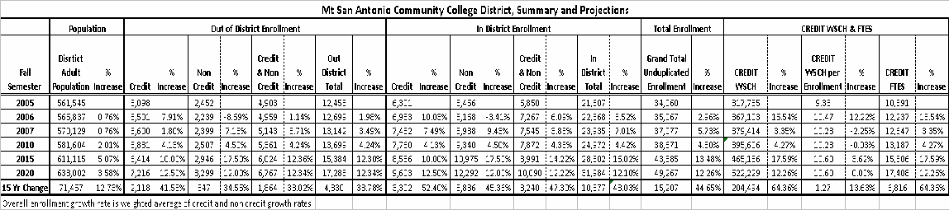

CHAPTER 2 - THE DISTRICT AND THE COLLEGE

Figure 2-23: Potential Participation Including Outflow
Sources: MSACCD, Chaffey, Citrus and Rio Hondo

130

110

90

70

50

30

10

-10

Participation\1000 Citrus Outflow\1000 Rio Hondo Outflow\1000

SUMMARY AND PROJECTIONS - SCENARIO 1
Table 2-9 depicts both a summary of existing District enrollment data and projections for growth for the years 2010,
2015 and 2020. The table is too large to discuss whole, so magnifications of each section of the table are provided
as each section is discussed below. A full size version of the District Summary Table is provided as Appendix C.

Table 2-9: MSACCD Summary and Projections

MT. SAN ANTONIO COMMUNITY COLLEGE DISTRICT EDUCATIONAL MASTER PLAN - Page 40
Baldwin
Park/Irwindale
Covina
Diamond Bar
Glendora (North &
South)
Hacienda Hts.
Industry
La Puente/Valinda
La Verne
Pomona
Rowland Hts
San Dimas
Walnut
West Covina
Totals

CHAPTER 2 - THE DISTRICT AND THE COLLEGE

Projections were presented to the District for approval. As a plan to adapt to recent state funding reductions, the
District plans to bring 2009 enrollment to 2007 levels. The District requested that the projections reflect their plan.
Since the plan would eliminate two of the three years of growth for the 2010 period, one third of the initial growth
projection for that period was used in both credit and non-credit areas. The effect of this adjustment carried through
the other periods of the projection, significantly reducing the outcome. This projection uses flat growth rates for the
District. Projections differ between credit, non-credit and combined (students taking both credit and non-credit
classes). This projection method does not take into account the differences in growth rates between departments.
A more granular projection is done for credit enrollment. Interviews and research provide guidance as to rate
adjustments of faster or slower than the district. These rate adjustments can be seen as percentage adjustments in Appendix A: Credit Summary and Projections by TOP Code and Discipline. These adjustments show in the appendix table as Xs, which come before each period’s projected weekly student contact hours (WSCH). During the review process for the Educational Master Plan, the District changed these growth rate adjustments, downward in most cases, for all periods (2010, 2015 and 2020). Much of the guidance from departmental interviews and
research are not fully reflected in the resultant adjustments.
There is a possibility that the administration’s plans to limit growth may still be averted. Many factors involved in the
decision are still moving targets. Therefore, the District has asked that both of these scenarios be documented.
Scenario 1, which appears in this Master Plan, includes the two District changes to limit growth. The ADDENDUM
presents Scenario 2. In the ADDENDUM the consultants provide all of the projections set forth in this Master Plan
before District changes. Only tables which are different from Scenario 1 are provided in the ADDENDUM.
Percentage increases in Table 2-9 are calculated from the previous year in the table; these intervals are of differing lengths, so increases should be looked at carefully. Many factors and opportunities for growth were taken into account when projecting enrollment and WSCH gains. These factors include: population projections, demographic factors such as ethnicity and age, counter-cyclical growth from the struggling economy, the possible addition of offcampus locations, targeted outreach programs to currently underserved groups, and the fact that the District
historically has grown faster than the population.
Projected population growth for the District is under 1.0 percent per year. Lack of housing and business space is limiting population growth. Repurposing of existing land for higher density housing and modern business uses will accommodate much of the future growth in the San Gabriel Valley. Therefore, population growth alone will not sustain the projected growth in enrollment. Changes in the makeup of the population in ethnicity, income, employment and age will hold many of the opportunities for growth in enrollment.
The opportunities to better serve the Hispanic residents of the District will be one key factor to sustained growth.
The 18-25 age group will be over 60 percent Hispanic by 2010. Some of these students will be English language
learners with needs for accessible curriculum. Those newer to English may need up to several years of Engish as a Second Language (ESL) classes before becoming mainstream students. For these students with lower educational attainment and less means at their disposal, proximity may be an issue. ESL learning centers in the denser
Hispanic areas including Baldwin Park/Irwindale, La Puente/Valinda, Pomona and West Covina should present a
significant opportunity for growth.
These learning centers can also be leveraged to serve seniors. This is the fastest growing age group in the District.
It has been shown that seniors have lower participation in the denser, outlying population centers of the District.
These are the same cities that hold the largest Hispanic populations. The younger seniors in the San Gabriel Valley
may find themselves in need of these opportunities in this challenging and changing employment environment. By
offering key repair, upgrade and enrichment programs in these learning centers, the District can optimize these
opportunities for growth.

MT. SAN ANTONIO COMMUNITY COLLEGE DISTRICT EDUCATIONAL MASTER PLAN - Page 41
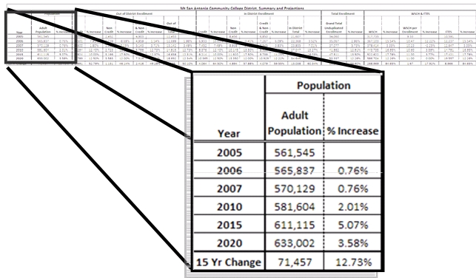

CHAPTER 2 - THE DISTRICT AND THE COLLEGE

Although proximity is a theme that runs through age and ethnicity, MSACCD has an extraordinary inflow of over
15,000 students and wide sphere of influence over neighboring districts. The fact remains that more than 11,000
students attend neighboring colleges. Although proximity is again a factor, an examination of the programs
which have attracted these students away from the District could represent significant growth opportunities.
Unemployment rates in Baldwin Park/Irwindale, La Puente/Valinda and Pomona range from 6.4 percent to 7.2
percent compared with the California rate of 6.1 percent, the Los Angeles County rate of 5.7 percent and a District weighted average unemployment rate of 4.9 percent. The unemployed population in these areas should
contribute to short term growth for the District due to the aforementioned counter-cyclical effect unemployment has on college attendance.
Mt. San Antonio Community College District has strong, well-developed programs. The District has continually
shown its ability to adapt to opportunities such as those mentioned above. Many of these opportunities will have a greater effect on non-credit programs. Because of these opportunities, the changing economy and the current levels of unemployment, the growth projections in Table 2-9 are greater than the 1.0 percent yearly population growth projected for the District. The District can remain confident that it will meet these projected increases by continuing to leverage opportunities for enrollment growth as it has in the past.
Table 2-9 presents a snapshot view of the changes in the District in Adult Population, the number of students
entering the District from outside of the District, the number of students resident in the District who are enrolled in
the College, the total head count, the number of credit students and non-credit students, the Weekly Student
Contact Hours (WSCH), and the full-time equivalent students (FTES) for each of the years included on the chart.
Table 2-10 (which is part of Table 2-9) shows the increase and the percentage increase in Adult Population from
the years 2005 to 2020. During that period the Adult Population of the District will increase by a little more than
71,000 persons representing a percentage change of less than 1 percent per year. It is projected that after the year

Table 2-10: Adult Population

MT. SAN ANTONIO COMMUNITY COLLEGE DISTRICT EDUCATIONAL MASTER PLAN - Page 42
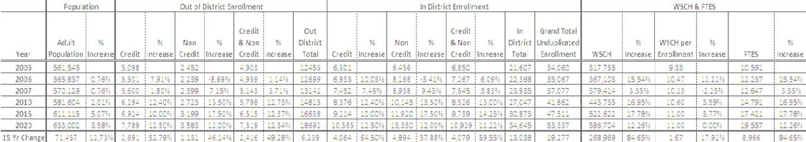

CHAPTER 2 - THE DISTRICT AND THE COLLEGE

2020, that percentage increase will continue to decline. It is obvious that there will be little increase in total College enrollment due to growth and population during the period under study. However, during the period, there will be significant changes in the ethnicity of the adult population and the age groups, and those changes, in turn, will have a significant effect upon the manner in which the District continues to meet the needs of the community.
Table 2-11 (which is part of Table 2-9) shows the changes by credit type in the number of students entering the District from other surrounding districts (Out-of-District Enrollment). Between 2005 and 2020, the number of
students entering the District from outside will increase by only 4,800 students. In the year 2007, 5,600 credit
students and 5,100 combined credit and non-credit students enrolled in the College from outside the District. These numbers compare with only 2,400 students entering and enrolling in non-credit courses only. That proportional relationship has been maintained in projections through the year 2020.
It seems likely that many of the students entering the District from other districts enrolled in credit courses, but also
enrolled in either basic skills or ESL courses. The downturn in the economy and the price of transportation could
very well have a significant effect on all of these numbers, and that effect would be a lowering of the number of out-
of-district students coming into the District. However, the same factors could have an effect on the students who are
resident in the District who leave the District to attend other colleges. The number of students remaining in the
District would probably increase and the overall effect might be a change in the total enrollment in the College.

Table 2-11: Out-of-District Enrollment

Table 2-12 (which is part of Table 2-9) shows the resident students in the District who enroll in the College (in-
district enrollment) by credit type. During the period of the study, the number of in-District students enrolling in the college is projected to increase by approximately 10,377 students. This represents an increase of about 48 percent. By the year 2020, almost 32,000 District resident students will be enrolled in the college.

MT. SAN ANTONIO COMMUNITY COLLEGE DISTRICT EDUCATIONAL MASTER PLAN - Page 43
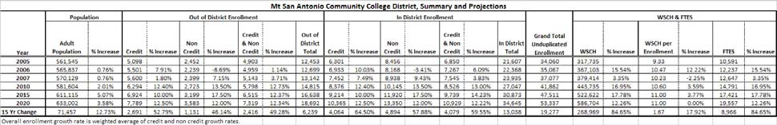
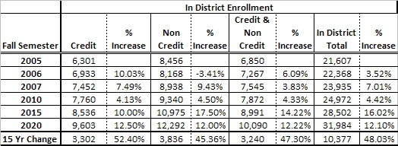

CHAPTER 2 - THE DISTRICT AND THE COLLEGE

Table 2-12: In-District Enrollment

It is interesting to note that the number of students enrolling in non-credit courses is larger than either the number of students enrolling in credit only or in the combined credit/non-credit section. As in the case of the out-of-district students, that proportional relationship will remain constant through the year 2020.
The indication is that the non-credit program is very strong and will remain an important section of the educational
program in the future, assuming that the District maintains its current policy of support for the noncredit program.
Table 2-13 (which is part of Table 2-9) shows the unduplicated head count from the year 2005 to 2020.The figures for 2005, 2006, and 2007 were submitted by the District. The figures from 2010 to 2020 are projections based on the projections made in the in-district student and out-of-district student sections of this chapter.
The head count between the years 2005 and 2020 will increase by more than 15,000 students, which represents an increase of approximately 45 percent or an annualized rate of approximately 2.8 percent per year.
The table shows that by the year 2020, more than 49,000 students will be enrolled in the college. This figure is somewhat higher than the estimate of the Chancellor’s office in the latest annual forecast of enrollment. If the projections of the Chancellor’s are extended to 2020, forecasted enrollment would be almost 46,000. The Chancellor’s office forecast of enrollment is usually considered to be quite conservative.

MT. SAN ANTONIO COMMUNITY COLLEGE DISTRICT EDUCATIONAL MASTER PLAN - Page 44
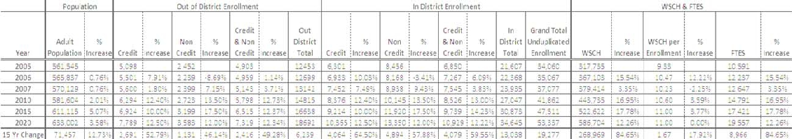

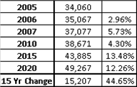

CHAPTER 2 - THE DISTRICT AND THE COLLEGE

Table 2-13: Unduplicated Enrollment

Table 2-14 (which is part of Table 2-9) shows the increase in WSCH.
The numbers for the years 2010, 2015, and 2020 are projections largely based on the history of Weekly Student
Contact Hour (WSCH) growth over the years. The projections increase slightly in the years 2015 and 2020. The
WSCH projections were calculated by multiplying the WSCH per enrolled student by the unduplicated enrollment. This is the methodology employed in the Chancellor’s office forecast of enrollment, which is produced annually, and is also employed by the District.
For purposes of planning, WSCH reported as Credit Weekly Contact Hours should be divided by the number of
credit students. At Mt. SAC, that number is difficult to calculate because of the large number of students taking both
credit and non-credit courses. A method for determining which of the combined group should be considered credit
students and which should be considered non-credit students was devised; however, when the number of credit
students only is used as a divisor, the WSCH per enrolled student turns out to be somewhere in the neighborhood
of 19 to 20 WSCH per enrolled student. Such numbers are a practical impossibility, so that investigation was not
pursued.
Table 2-14 shows that WSCH were increased by 64 percent. WSCH increased at a faster rate than the
unduplicated enrollment, which increased by about 45 percent. Those differences can be accounted for by the
slightly increased WSCH per enrolled student in 2015 and 2020. The projected FTES were calculated by multiplying the projected WSCH in those years by 17½ and dividing that product by 525.

MT. SAN ANTONIO COMMUNITY COLLEGE DISTRICT EDUCATIONAL MASTER PLAN - Page 45
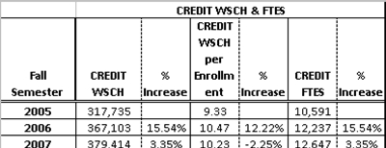
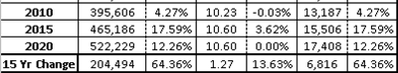

CHAPTER 2 - THE DISTRICT AND THE COLLEGE

Table 2-14: Credit WSCH & FTES

In conclusion, Figure 2-9 (the entire table showing MSACCD Summary and Projections) paints a picture of a megacampus in a District with a practically stable population. Because of its reputation, appearance, and comprehensive educational program, the District attracts a large number of students from other community college districts. It also experiences an almost as large outflow of students to other colleges nearby, possibly because of some program differences, but more likely because of ease of access to other nearby colleges.
A previous section of the study has shown that the Participation Rate within the District itself is relatively low and leaves much room for improvement by attracting some of the students who are currently leaving the District by more targeted recruitment and perhaps by changes in the educational program to better meet the needs of the residents of the District.

MT. SAN ANTONIO COMMUNITY COLLEGE DISTRICT EDUCATIONAL MASTER PLAN - Page 46

CHAPTER 2 - THE DISTRICT AND THE COLLEGE

REFERENCES
California Community Colleges Chancellor’s Office, https://misweb.cccco.edu/mis/onlinestat/ftes.cfm, July 2008.
California Department of Finance, Projection of Population by Age and Ethnicity to 2050 (2006 baseline estimate), www.dof.ca.gov, July
2008.
Employment Development Department, www.edd.ca.gov, April 2008.
Google Earth, Figure 1-27 photo used by express permission of Google.com and Google Earth and limited to 5000 copies.
Los Angeles County Economic Development Corporation, “Economic Overview and Forecast November 2005,” Prepared for the San
Gabriel Valley Economic Partnership by the Los Angeles County Economic Development Corporation, 2006.
Los Angeles County Educational and Demographic Profile 2004, http://eric.ed.gov/ERICWebPortal/custom/portlets/recordDetails/detail
mini.jsp?_nfpb=true&_&ERICExtSearch_SearchValue_0=ED485448&ERICExtSearch_SearchType_0=no&accnol=ED485448,
June 2008.
Stallard, C., “Community College Offerings to Seniors: A GIS Examination of the Extent a Community College Offers Classes to Its Senior
Community,” Claremont Graduate University, Spring 2008.

MT. SAN ANTONIO COMMUNITY COLLEGE DISTRICT EDUCATIONAL MASTER PLAN - Page 47

CHAPTER 3 - PROGRAMS AND SERVICES

MT. SAN ANTONIO COMMUNITY COLLEGE DISTRICT EDUCATIONAL MASTER PLAN - Page 48

CHAPTER 3 - PROGRAMS AND SERVICES

