CHAPTER 3 - PROGRAMS AND SERVICES

CHAPTER 3
PROGRAMS AND SERVICES
INSTRUCTION
Business and
Economic Development
Division

MT. SAN ANTONIO COMMUNITY COLLEGE DISTRICT EDUCATIONAL MASTER PLAN - Page 139

CHAPTER 3 - PROGRAMS AND SERVICES

BUSINESS AND ECONOMIC DEVELOPMENT DIVISION
John Heneise, Dean
Rich Patterson, Associate Dean

CURRENT PROGRAM
The Business and Economic Development Division office provides administrative oversight for Business and Economic Development departments, Grants (including EWD, CCC and NSF) and the Child Development Center.

FACILITIES
Division office facilities include space that is poorly configured and isolated from Division programs and faculty. Office computer technology needs to be updated now, and again in five-year increments to keep pace with the industry.

PERSONNEL
The Division employs 2 managers, 6 supervisors, 3 full-time and 4 part-time classified staff and 19 student workers. The Child Development Center needs a manager at this time.

FUTURE PLANS
Larger College enrollments will mean a proportionate increase in the Division’s workload. The Division anticipates the increased use of
custom databases to help manage data and processes and to communicate directly with students, as well as implementation of BANNER
systems as they become available. Division/Departmental website activation and maintenance will also affect future programs and
services.
FACILITIES
A Business Division Building (including offices, labs, classrooms, a conference room, and break rooms) is planned by 2012 but is
dependent on bond funding. The Child Development Center 67/68 needs space by 2010. Computer technology in labs and classrooms needs to be updated in 2010 and again in five-year increments to keep pace with demand. Keys and the Help Desk are currently offcampus and should be returned to on-campus locations.
PERSONNEL
By 2010 an additional supervisor, a full-time and a part-time classified staff and 2 student workers need to be hired. By 2020, an additional supervisor, two classified staff (one full-time and one part-time) and 2 student workers need to be hired.

BUSINESS DIVISION
PERSONNEL
Managers
Supervisors
Classified Staff (full-time) Classified Staff (part-time) Student Workers

CURRENT Additional Additional Additional Additional TOTAL
2007-08 NOW by 2010 by 2015 by 2020 as of 2020
2.00 1.00 3.00
6.00 1.00 1.00 8.00
3.00 1.00 1.00 5.00
4.00 1.00 1.00 6.00
19.00 2.00 2.00 23.00

Total 34.00 1.00 5.00 0.00 5.00 45.00

MT. SAN ANTONIO COMMUNITY COLLEGE DISTRICT EDUCATIONAL MASTER PLAN - Page 140

CHAPTER 3 - PROGRAMS AND SERVICES

ACCOUNTING
Ralph Jagodka, Co-Chair
Dan McGeough, Co-Chair

CURRENT PROGRAM
Accounting serves transfer, occupational and general interest needs of students.
ENROLLMENT
Accounting class sizes range from 28 to 36 students. Average class size in this discipline is 36. Currently, there are waiting lists of 10 students per class for Financial Accounting and Management Accounting, plus waiting lists ranging from 5 to 10 students for both Payroll Tax and Federal Income Tax.
FACILITIES
Accounting currently has two classrooms and one computer lab in Building 18, Accounting has lost two classrooms due to construction.
Two classrooms with computer, projector, and screen in the Business Division area is needed now. All classrooms need Internet
connections with current technology and work tables large enough to allow students to spread out ledgers and work materials.
TEACHING METHODOLOGIES
Teaching methodologies for Accounting currently include lecture (80%) and online classes (20%).
PERSONNEL
The Accounting program currently has 3 FTEF full-time and 5.73 FTEF part-time faculty. No additional personnel are needed this time.

FUTURE PLANS
Plans to start an IRS-accepted Enrolled Agent Tax Preparation program are underway.

ENROLLMENT
Accounting enrollment is expected to grow faster than the overall District enrollment each year through 2020 as the employment
opportunity forecast is strong. California EDD projects a 42% increase in accounting jobs (23% new and 19% replacement) through 2014.
FACILITIES
Accounting will need one additional classroom in the Business Division area by 2010; another by 2015; and one more by 2020. Consistent technology change updates will also be an on-going need.

TEACHING METHODOLOGIES
Accounting anticipates online classes will increase in popularity and the number of online classes offered will increase. Lecture methodology will reduce to 70% and online methodology will increase to 30%.

PERSONNEL
By 2010, Accounting will need an additional part-time faculty member. By 2015, 1 additional full-time and 1 part-time faculty will be needed. By 2020, an additional full-time and a part-time faculty will need to be added.

MT. SAN ANTONIO COMMUNITY COLLEGE DISTRICT EDUCATIONAL MASTER PLAN - Page 141
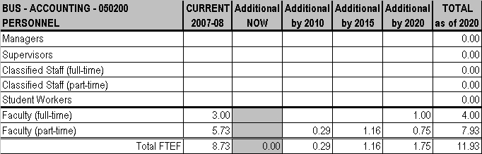
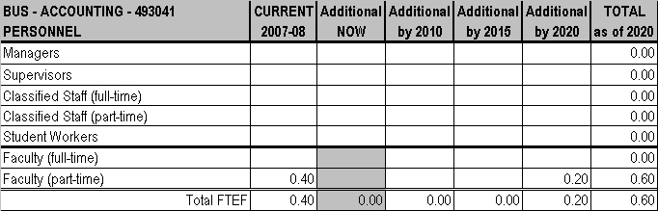
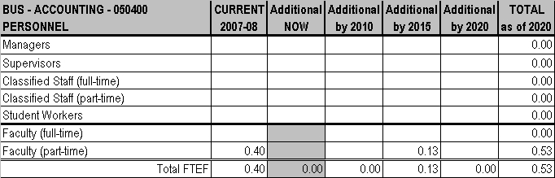

CHAPTER 3 - PROGRAMS AND SERVICES

MT. SAN ANTONIO COMMUNITY COLLEGE DISTRICT EDUCATIONAL MASTER PLAN - Page 142
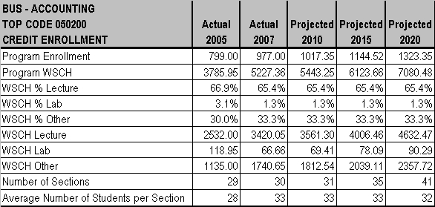
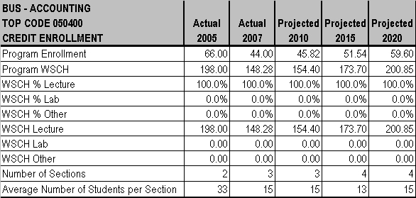
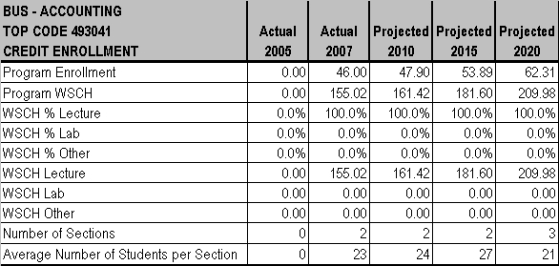

CHAPTER 3 - PROGRAMS AND SERVICES

MT. SAN ANTONIO COMMUNITY COLLEGE DISTRICT EDUCATIONAL MASTER PLAN - Page 143

CHAPTER 3 - PROGRAMS AND SERVICES

BUSINESS LAW
Amrik Dua, Chair

CURRENT PROGRAM
Business Law, which serves the transfer needs of students, is very stable.

ENROLLMENT
Business Law class sizes range from 18 to 40 students. The average class size is 29.8 for lecture classes. There is currently a waiting list of 5 students for the online section of BUSL 18.

FACILITIES
Business Law uses 4 classrooms to teach 29 sections including Paralegal courses. There is currently limited space for the larger classes; sound from adjacent class rooms can be disruptive; and temperature control could improve.

TEACHING METHODOLOGIES
Business Law uses lecture (80%) and online instruction (20%).
PERSONNEL
Business Law has 1.8 FTEF full-time and 1.4 FTEF part-time faculty. No additional personnel are needed at this time.

FUTURE PLANS
No new programs are being planned or discussed at this time.
ENROLLMENT
Enrollments in Business Law are expected to grow at the same rate as overall District enrollment between now and 2020. University enrollments may affect the ability of Business majors to transfer.
FACILITIES
By 2010, a new Business building with offices and classrooms for Business Law is anticipated, but is dependent on the passage of a bond measure. If the bond does not pass, new facilities will still be needed.

TEACHING METHODOLOGIES
Business Law anticipates no changes in teaching methodology.
PERSONNEL
By 2015, Business Law will need .2 FTEF additional part-time faculty.

MT. SAN ANTONIO COMMUNITY COLLEGE DISTRICT EDUCATIONAL MASTER PLAN - Page 144
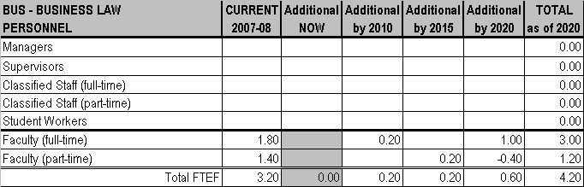
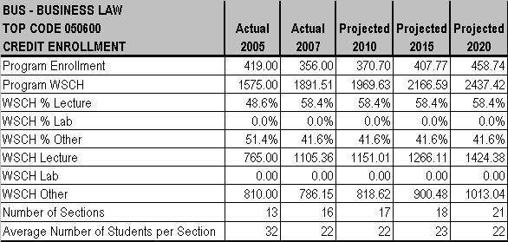

CHAPTER 3 - PROGRAMS AND SERVICES

MT. SAN ANTONIO COMMUNITY COLLEGE DISTRICT EDUCATIONAL MASTER PLAN - Page 145

CHAPTER 3 - PROGRAMS AND SERVICES

BUSINESS MANAGEMENT
Ralph Jagodka, Co-Chair
Dan McGeough, Co-Chair

CURRENT PROGRAM
Business Management serves transfer, occupational and general interest needs of students.
ENROLLMENT
Business Management class sizes range from 20 to 36 students and the average class size is 30 students for lecture classes. Currently, there is a waiting list of 8 to 10 students each for BUSM 20 online, BUSM 61 online, BUSM 51 online, and BUSM 66 online.
FACILITIES
Business Management currently has three classrooms in Building 4. There are nine computers in each room. Classrooms with sufficient space for this quantity of equipment are currently needed.
TEACHING METHODOLOGIES
Teaching methodologies for Business Management currently include lecture (80%) and online classes (20%).

PERSONNEL
Business Management currently has 1.8 FTEF full-time and 2.2 FTEF part-time faculty. Business Management Marketing has .20 FTEF full-time and .40 FTEF part-time faculty. No additional personnel are needed at this time.

FUTURE PLANS
Economic downturns tend to increase Business Management enrollment, as do CSU and UC fee hikes, so it is likely that the Department will continue to steadily increase enrollment.

ENROLLMENT
Growth for Business Management is expected to grow at the same rate as the overall District enrollment each year through 2020.

FACILITIES
Business Management will need one classroom and one office (located together), Internet access in all classrooms, ceiling projectors, and nine computers by 2015.
TEACHING METHODOLOGIES
Business Management anticipates online classes will increase in popularity and the number of online classes offered will increase. So lecture will reduce to 70% and online will increase to 30%.
PERSONNEL
Business Management will need one full-time and a .4 FTEF part-time faculty by 2015. Business Management Marketing will need .2 FTEF part-time faculty by 2010, again by 2015 and again by 2020 for a total of 1.0 FTEF part-time faculty.

MT. SAN ANTONIO COMMUNITY COLLEGE DISTRICT EDUCATIONAL MASTER PLAN - Page 146
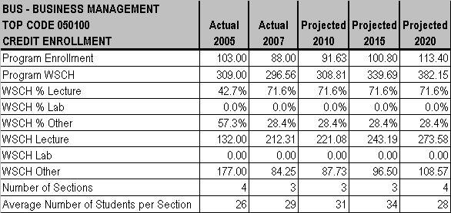
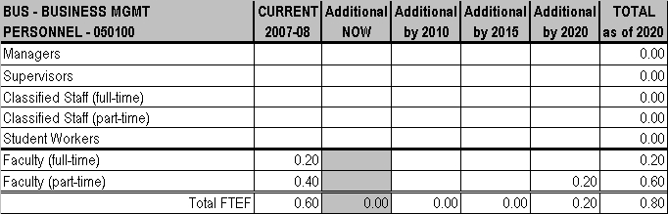

CHAPTER 3 - PROGRAMS AND SERVICES

MT. SAN ANTONIO COMMUNITY COLLEGE DISTRICT EDUCATIONAL MASTER PLAN - Page 147
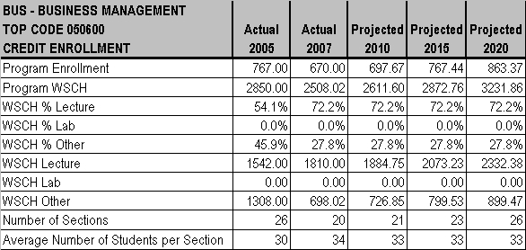
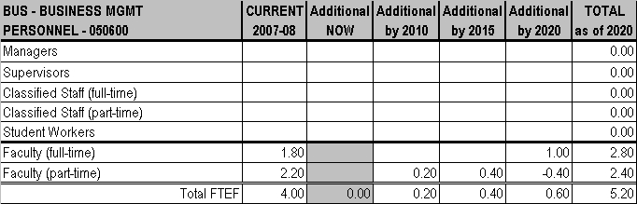

CHAPTER 3 - PROGRAMS AND SERVICES

MT. SAN ANTONIO COMMUNITY COLLEGE DISTRICT EDUCATIONAL MASTER PLAN - Page 148

CHAPTER 3 - PROGRAMS AND SERVICES

CHILD DEVELOPMENT
Melanie Diederichs, Chair

CURRENT PROGRAM
Child Development serves transfer, occupational and general interest needs of students.

ENROLLMENT
Class sizes range from 3 to 35 students. Average class sizes are 35 in lecture and 7 in lab. There is currently a waiting list of 45 students for CHLD 10 Child Growth & Development.

FACILITIES
The Department now has two classrooms and one lab in Building 9E. Two additional (20 row) classrooms, two (20 row) curriculum workrooms, and storage are needed in this building.

TEACHING METHODOLOGIES
Teaching methodologies include lecture (85%) and lab (15%). Two classes are offered online.
PERSONNEL
The Department currently has 6.91 FTEF full-time and 4.46 FTEF part-time faculty. Additional personnel needed now are 1 full-time faculty, 1.6 FTEF part-time faculty, 1 full-time and 1 half-time classified staff, and 8 student workers.

FUTURE PLANS
New course development necessary to meet the new Pre-Kindergarten credential is anticipated. New coursework and a new certificate also are being developed in response to requirements in the Child Development School Age Permit Matrix, which is issued by the
California Department of Teacher Credentialing. To expand a program transfer plan like one currently in place with Cal Poly Pomona, the Department is currently discussing transfer plan opportunities with other universities.
ENROLLMENT
Enrollment is expected to grow faster than overall District enrollment between now and 2020. Recent studies show that Early Care and
Education Teachers rank among the largest growth occupations in California. The interest and demand for Child Development course work has been heightened by increased federal educational requirements for Preschool Teachers, the State’s new education focus on the years preceding school entry, and employment opportunities to replace CD teachers who leave the field each year.
FACILITIES
The Department needs additional classroom laptops with cart and observation technology (closed circuit TV system) by 2010. If the bond issue is successful, Child Development: Education and Children’s Program will consolidate in a new building it is hoped by 2015.

TEACHING METHODOLOGIES
No changes in teaching methodologies are anticipated, but the expansion of online class offerings is planned.
PERSONNEL
By 2010, the Department will need 2 full-time faculty; .4 FTEF part-time faculty, and 2 student workers. By 2015, again, 2 full-time and a .4 FTEF part-time faculty are needed, plus 1 full-time and 1 half-time classified staff, and 2 student workers. By 2020, an additional 2 full-time and a .4 FTEF part-time faculty, 1 full-time and 1 half-time classified employees, and 2 student workers are needed.

MT. SAN ANTONIO COMMUNITY COLLEGE DISTRICT EDUCATIONAL MASTER PLAN - Page 149
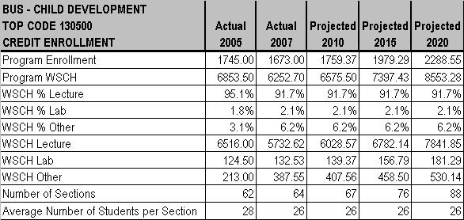
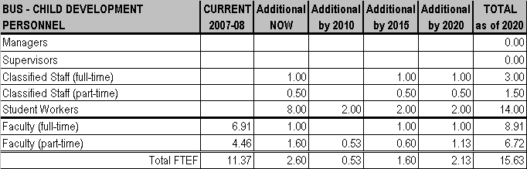

CHAPTER 3 - PROGRAMS AND SERVICES

MT. SAN ANTONIO COMMUNITY COLLEGE DISTRICT EDUCATIONAL MASTER PLAN - Page 150

CHAPTER 3 - PROGRAMS AND SERVICES

COMPUTER INFORMATION SYSTEMS (CIS)
Barry Andrews, Co-Chair
Vic Zamora, Co-Chair

CURRENT PROGRAM
Computer Information Systems serves the transfer, occupational, and general interest needs of students. Transfer classes are generally taught in the day; general interest and industry-specific classes are taught in the evening.

ENROLLMENT
Class size ranges from 24 to 36 students. The average class size is 30 for lecture classes. There are currently no waiting lists.
FACILITIES
The Department currently has 7 classrooms and 1 lab. A student project room (“Computer Play Room”) is needed now; preferably in
Room 18C. There also is a lack of rooms available for night class demand. Updating computers, network servers and switches to keep up with technology is also needed. Security equipment, especially for degree programs, and Voice Over Internet Program (VOIP) equipment is also requested now. Adding virtualization equipment -- a server “farm” which houses all applications and connects to “thin clients” (i.e. keyboard, monitor, and mouse) - could be a consideration to solve the continuous upgrade needs.

TEACHING METHODOLOGIES
Teaching methodologies currently include lecture (60%), lab (20%), and online and hybrid classes (20%).

PERSONNEL
Full-time faculty currently numbers 7.45 FTEF and there are 5.37 FTEF part-time faculty. No additional personnel are needed at this time.

FUTURE PLANS
Based on Industry Advisory Committee suggestions and Department research, two A.S. Degrees, Telecommunications and C++, are being eliminated, a programming degree Visual Basic is being restructured to have multiple options for different programming languages, the Database degree is being revised, and introduction of a new A.S. degree (E-Business) with transfer possibilities to Cal Poly Pomona is underway. All changes are targeted for implementation by Fall 2009.

ENROLLMENT
Enrollment is expected to grow at the same rate as overall District enrollment between now and 2020. The development of new computer technologies is the primary factor that will influence growth in this department. Other factors include outsourcing, online degrees offered by other educational institutions, employment opportunities to fill positions as Baby Boomers retire, and the current recession.
FACILITIES
Updating technology equipment is needed continuously through 2020 and the Department will need another classroom and/or lab by 2015, preferably in 18C - Room 2.
TEACHING METHODOLOGIES
CIS plans to offer more online and hybrid courses, so it is anticipated that lecture methodology will decrease to 50%, lab will remain at 20%, and online/hybrid will increase to 30%.
PERSONNEL
By 2010, one additional part-time faculty member is needed. By 2015, the addition of one full-time and one part-time FTEF will be needed. By 2020, one additional part-time faculty member is needed.

MT. SAN ANTONIO COMMUNITY COLLEGE DISTRICT EDUCATIONAL MASTER PLAN - Page 151
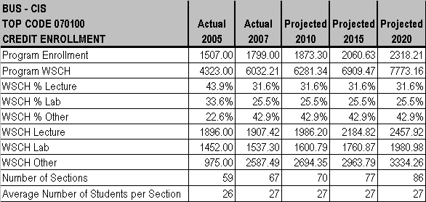
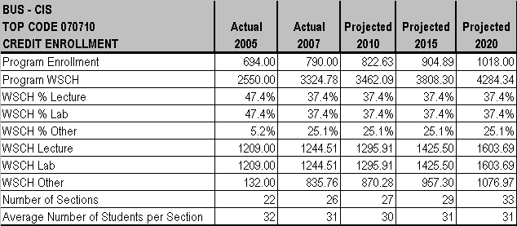

CHAPTER 3 - PROGRAMS AND SERVICES

MT. SAN ANTONIO COMMUNITY COLLEGE DISTRICT EDUCATIONAL MASTER PLAN - Page 152
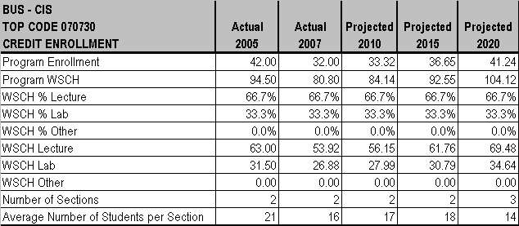
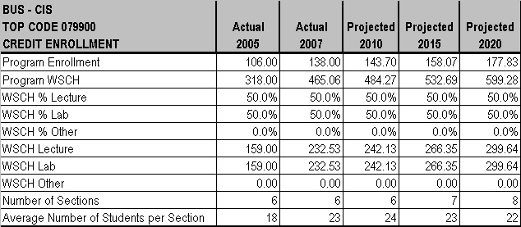
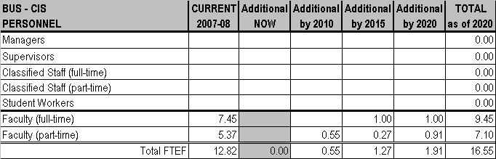

CHAPTER 3 - PROGRAMS AND SERVICES

MT. SAN ANTONIO COMMUNITY COLLEGE DISTRICT EDUCATIONAL MASTER PLAN - Page 153

CHAPTER 3 - PROGRAMS AND SERVICES

CONSUMER SERVICES / LIFE MANAGEMENT
Terri Faraone, Chair

CURRENT PROGRAM
Consumer Services/Life Management serves the transfer needs of students. Updating the program and certificate is in process now to better match student and community needs.
ENROLLMENT
Consumer Services/Life Management offers only lecture classes and the class sizes range from 24 to 36 students, with an average of 30 students per lecture class.
FACILITIES
Consumer Services currently uses one classroom in the Business division. No additional space is currently needed, but receiving a consistent room assignment with an adjustable lighting source is desired.
TEACHING METHODOLOGIES
Consumer Services/Life Management uses lecture methodology exclusively (100%).

PERSONNEL
Consumer Services/Life Management currently has 1 full-time FTEF, 1.19 FTEF part-time faculty and 1 student worker. One additional student worker is needed at this time.

FUTURE PLANS
Growth in this area is hampered because the field is not clearly defined by industry and there is an inadequate pool of newly graduated instructors interested in filling positions vacated as current faculty retires. It is anticipated that the Minimum Qualification/Equivalency requirements for adjunct faculty will need to be revised to attract new hires.
ENROLLMENT
Consumer Services/Life Management anticipates the discipline will grow at the same rate as District enrollment through 2020.
FACILITIES
If current requests are filled before 2010, Consumer Services/Life Management anticipates no additional needs.

TEACHING METHODOLOGIES
Consumer Services/Life Management expects no changes in teaching methodologies through 2020.
PERSONNEL
Consumer Services/Life Management does not project a need for additional full-time FTEF through 2020, however, two additional part-time faculty members are needed by 2010. The inadequate pool of newly graduated instructors may require hiring requirements for adjunct
faculty to be revised.

MT. SAN ANTONIO COMMUNITY COLLEGE DISTRICT EDUCATIONAL MASTER PLAN - Page 154
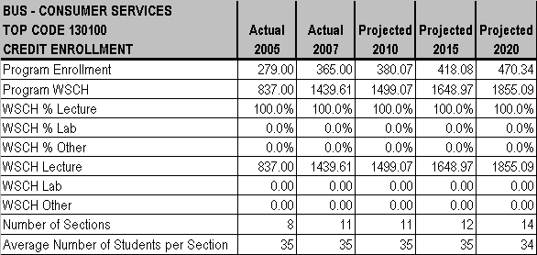
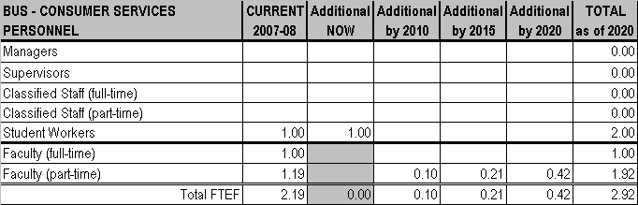

CHAPTER 3 - PROGRAMS AND SERVICES

MT. SAN ANTONIO COMMUNITY COLLEGE DISTRICT EDUCATIONAL MASTER PLAN - Page 155

CHAPTER 3 - PROGRAMS AND SERVICES

ECONOMICS
Amrik Dua, Chair

CURRENT PROGRAM
Economics serves the transfer needs of students.

ENROLLMENT
Class sizes for Economics range from 18 to 40 students with the class size average being 32.6 for lecture classes. There is a waiting list of 10 students for the online sections of BUSC 1A and 1B.

FACILITIES
Economics currently uses 7 classrooms to teach 24 sections. There is currently limited space for the larger classes; sound from adjacent class rooms can be disruptive; and temperature control could improve.

TEACHING METHODOLOGIES
Economics uses lecture (80%) and online instruction (20%).
PERSONNEL
Economics currently has 3 full-time and 1.8 FTEF part-time faculty. The program needs a half-time classified staff member at this time.

FUTURE PLANS
No new programs are being planned or discussed at this time.

ENROLLMENT
Enrollments for Economics are expected to grow at the same rate as overall District enrollment between now and 2020. University enrollments may affect the ability of Business majors to transfer.
FACILITIES
By 2010, a new Business building with offices and classrooms for Economics is anticipated, but is bond dependant. If the bond does not pass, new facilities will still be needed.
TEACHING METHODOLOGIES
Economics anticipates no changes in teaching methodology

PERSONNEL
By 2015, Economics will need .2 FTEF additional part-time faculty.

MT. SAN ANTONIO COMMUNITY COLLEGE DISTRICT EDUCATIONAL MASTER PLAN - Page 156
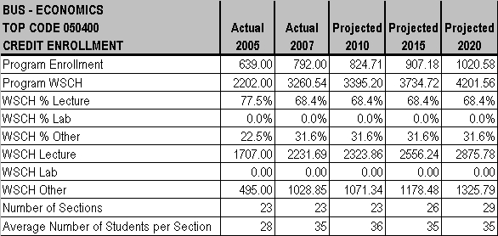
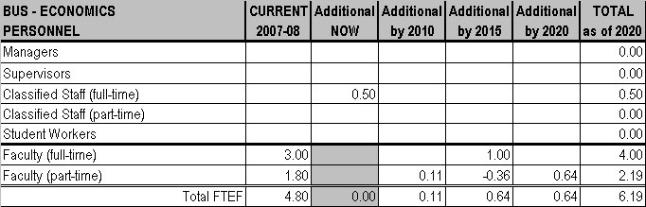

CHAPTER 3 - PROGRAMS AND SERVICES

MT. SAN ANTONIO COMMUNITY COLLEGE DISTRICT EDUCATIONAL MASTER PLAN - Page 157

CHAPTER 3 - PROGRAMS AND SERVICES

FASHION MERCHANDISING AND DESIGN TECHNOLOGY
Terri Faraone, Chair

CURRENT PROGRAM
Fashion Merchandising and Design Technology serves the transfer and occupational needs of students. This program has experienced over 70% growth in the past 5 years.
ENROLLMENT
Fashion Merchandising and Design Technology has a waiting list of 8 to 10 students for FASH 10 Clothing Construction, and FASH
63/BUSS 33 Advertising & Promotion has a waiting list of 10 to 12 students. Classes for this program range in size from 24 to 32 students. Lecture class size averages 32; lab class size averages 24 students.

FACILITIES
The program currently has one small classroom and one Home Economics lab (18-1, 19B1). Current needs are storage, desktop
computers with large screens for design (rather than current laptops), “smart” classrooms, a CAD facility (to be shared with Interior
Design), and industry equipment. Ninety-two percent of current equipment is not up to industry standards (i.e. home sewing machines rather than commercial) so students lack a tools-of-the-trade experience. Planning space for a future move to the new Business building also needs to begin.

TEACHING METHODOLOGIES
Teaching methodologies are split between lecture (60%) and lab (40%).
PERSONNEL
Fashion Merchandising and Design Technology currently has 1.6 FTEF full-time and 2.85 FTEF part-time faculty and 2 student workers. One additional full-time faculty is needed at this time.

FUTURE PLANS
Future directions include additional course offerings (in CAD design, technical/specification design, and in diverse topics ranging from
surf/extreme sports to theatrical design), a patternmaking only certificate, industry outreach programs, and developing distance learning
classes.
ENROLLMENT
Enrollments are expected to grow faster than overall District enrollment between now and 2020. The California industry is challenged to profitably compete with China, but there remains an increased need for employees with CAD skills (patternmaking, technical design, costing, etc.) to communicate business information with China-based production facilities. California maintains leadership status and the Labor Market expects growth during the period 2004 through 2014 in three areas: design (11% to 39% growth),
merchandising/management (13% to 25% growth), and marketing/sales/product development (13% to 35% growth).
FACILITIES
Space in the new Design Technology Center had been allocated to Fashion Merchandising and Design Technology, but was relinquished because Fashion is experiencing the largest growth of any program in the division and the planned space will be too small. By 2010, when Interior Design vacates its current location, Fashion will be given the 20-9 lab space until a new Business building is constructed.
Temporary storage will also be needed. By 2015, the program will need the following facilities in the new building: 3 lab classrooms,
general storage, a student display/critique space, designated storage for vintage costume collection, 1 lecture classroom with storage and window display space, and a tech lab.
TEACHING METHODOLOGIES
Fashion Merchandising and Design Technology plans to offer more lab classes, so methodology is anticipated to change to lecture (40%) and lab (60%).

PERSONNEL
Fashion Merchandising and Design Technology will need one additional full-time and a .15 FTEF part-time faculty plus an additional student worker by 2010. An additional full-time faculty member is needed by 2015 and again by 2020.

MT. SAN ANTONIO COMMUNITY COLLEGE DISTRICT EDUCATIONAL MASTER PLAN - Page 158
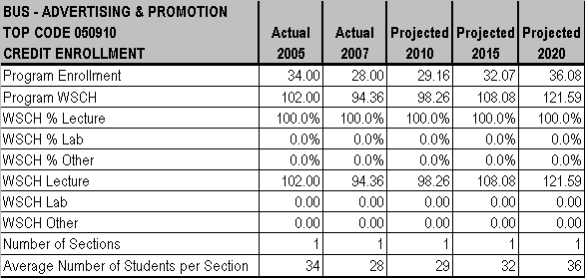
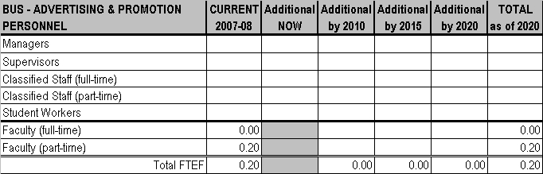

CHAPTER 3 - PROGRAMS AND SERVICES

MT. SAN ANTONIO COMMUNITY COLLEGE DISTRICT EDUCATIONAL MASTER PLAN - Page 159
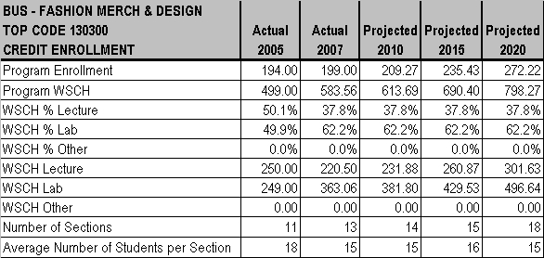
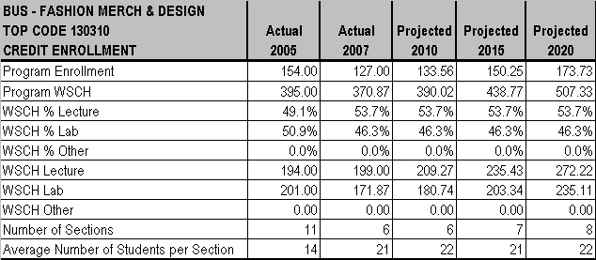

CHAPTER 3 - PROGRAMS AND SERVICES

MT. SAN ANTONIO COMMUNITY COLLEGE DISTRICT EDUCATIONAL MASTER PLAN - Page 160
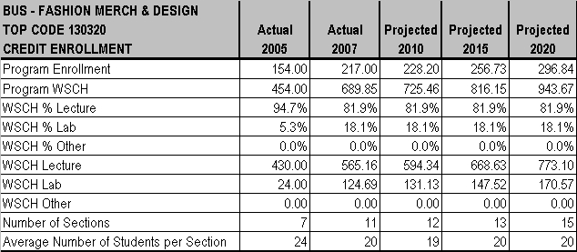
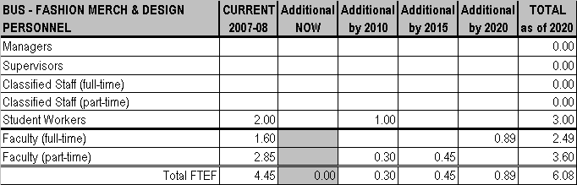

CHAPTER 3 - PROGRAMS AND SERVICES

MT. SAN ANTONIO COMMUNITY COLLEGE DISTRICT EDUCATIONAL MASTER PLAN - Page 161

CHAPTER 3 - PROGRAMS AND SERVICES

HOSPITALITY AND RESTAURANT MANAGEMENT
Terri Faraone, Chair
Fawaz Al-Malood, Instructor

CURRENT PROGRAM
Hospitality and Restaurant Management (HRM) serves the transfer, occupational and general interest needs of students and provides the education necessary for many entry-level, supervisory, and management positions. The public, inspired by cooking shows on TV, has created a demand to develop a full Culinary Arts program. In response, development of a Culinary Arts degree program and related certificate programs (i.e., Baking & Pastry, Garde Manger, and Quantity Production) are in process. A goal to offer certificate programs that can be completed 100% online is nearly complete and discussions are underway with Cal Poly and Collins Schools of Hospitality Management to jointly develop a 2+2+2 program in conjunction with high schools and ROP programs.

ENROLLMENT
Class size ranges from 5 (for Work Experience) to 36. The average class size is 23 students for lecture and 24 students for lab. There currently are no waiting lists.

FACILITIES
HRM currently has two classrooms and one lab split between Buildings 21 and 19, but has no designated space and lacks teaching space needed to meet its full potential and enrollment demands. A Computer Applications/Demo Room and supportive technology is needed now. Passage of the bond measure is crucial to proceeding on additional needs: a Food Service Lab (in 19B-3), Training Kitchen (in a location to be determined), the retrofit of the Commercial Kitchen (in 19B-5), and equipment.
TEACHING METHODOLOGIES
HRM uses lecture methodology (93%) which includes hybrid/online classes, lab methodology (3.5%), and work experience (3.5%) which is a required component for students enrolled in a certificate program or planning to transfer to a four-year university.
PERSONNEL
HRM currently has .60 FTEF full-time faculty, .21 FTEF part-time faculty, and 2 student workers. Additional staff currently needed are 1 full-time and 1 half-time classified staff, and 1 student worker.

FUTURE PLANS
HRM plans to expand the online certificate offering to include degree programs.

ENROLLMENT
HRM has grown 13% annually since 2003 and anticipates growing faster than the District enrollment growth each year through 2020. The anticipated continued growth reflects industry growth (107% between 1997 and 2007), job market growth (225,200 new jobs nationally is forecast between 2007 and 2017), and the media’s popularization of Culinary Arts (i.e. the “Food Network”).
FACILITIES
HRM will need technology upgrades by 2010. By 2015, HRM will need a Training Kitchen, a Commercial Kitchen, a Computer Applications/Demo Room, and associated equipment and technology.
TEACHING METHODOLOGIES
As HRM plans to add more lab classes and offer a Culinary Program which will increase required units and work experience hours,
changes in methodology to 60% lecture (including hybrid/online), 30% lab, and 10% other (i.e. work experience) are anticipated.
PERSONNEL
HRM will need one additional half-time faculty member by 2010. By 2015, an additional full-time faculty member and 1 full-time and 1 halftime classified staff will be needed. By 2020, an additional half-time faculty member is needed.

MT. SAN ANTONIO COMMUNITY COLLEGE DISTRICT EDUCATIONAL MASTER PLAN - Page 162
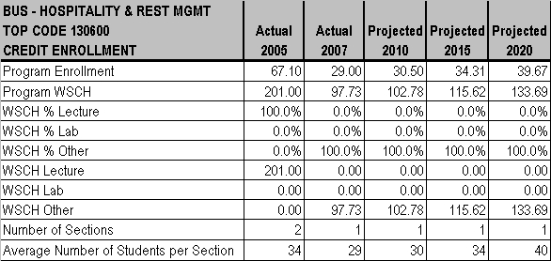
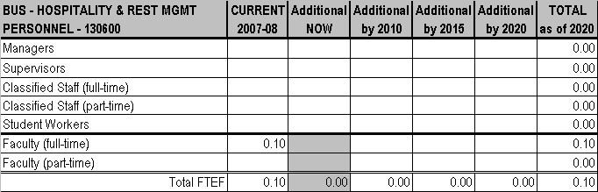

CHAPTER 3 - PROGRAMS AND SERVICES

MT. SAN ANTONIO COMMUNITY COLLEGE DISTRICT EDUCATIONAL MASTER PLAN - Page 163
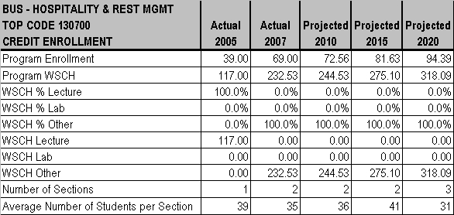
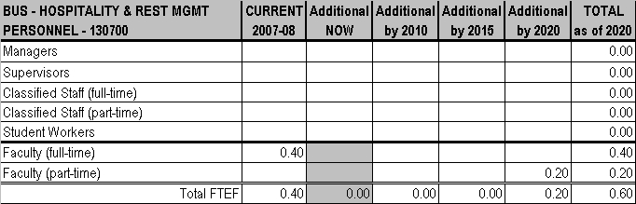

CHAPTER 3 - PROGRAMS AND SERVICES

MT. SAN ANTONIO COMMUNITY COLLEGE DISTRICT EDUCATIONAL MASTER PLAN - Page 164
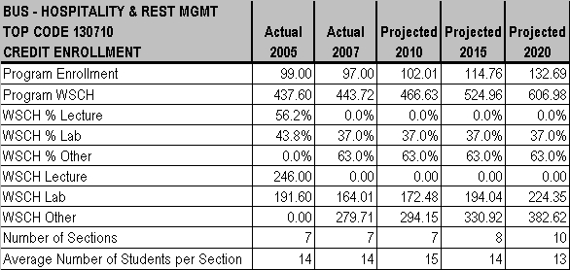
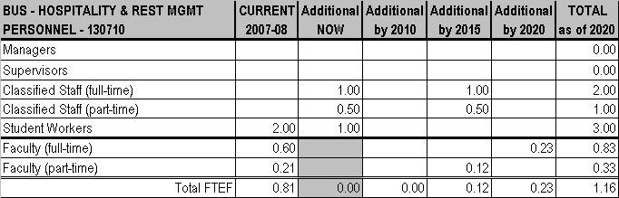

CHAPTER 3 - PROGRAMS AND SERVICES

MT. SAN ANTONIO COMMUNITY COLLEGE DISTRICT EDUCATIONAL MASTER PLAN - Page 165

CHAPTER 3 - PROGRAMS AND SERVICES

INTERIOR DESIGN
Terri Faraone, Chair

CURRENT PROGRAM
Interior Design serves the transfer and occupational needs of students. Curriculum revision is in process to include commercial interior design and product design.
ENROLLMENT
For Interior Design, average class sizes range from 18 to 30 students; lecture class sizes average 30 students; lab classes average 18
students.
FACILITIES
Interior Design has one combination lecture/lab classroom (Room 20-9) which has no room for growth or technology. A station lab for 8-
10 persons with CAD programs with a scanner and a large bed color printer are needed now to meet new technology requirements.
TEACHING METHODOLOGIES
Teaching methodologies for Interior Design classes include lecture (25%) and lab (75%).

PERSONNEL
Interior Design currently has 1.02 FTEF full-time and 1.28 FTEF part-time faculty and 1 student worker. No additional personnel are needed at this time.

FUTURE PLANS
There is an increasing need for interior designers to serve the needs of a retiring population. In addition, public interest in eco products and energy efficient environments is driving the need for employees in the industry. The addition of commercial design will prepare students to meet industry demand for personnel qualified in the areas of new construction and building retrofits.
ENROLLMENT
Interior Design anticipates growth will continue at the same rate as the District enrollment in 2010 and then grow faster than the District through 2020.

FACILITIES
Interior Design will need an interior specific 24-station desktop lab with CAD programs, scanners, and plotters in 2010. Technology updates to meet industry standards will be needed in 2015 and 2020.

TEACHING METHODOLOGIES
Interior Design anticipates no changes in teaching methodologies through 2020.
PERSONNEL
By 2010 Interior Design will need one additional full-time and one additional part-time faculty. One additional student worker will be needed by 2015.

MT. SAN ANTONIO COMMUNITY COLLEGE DISTRICT EDUCATIONAL MASTER PLAN - Page 166
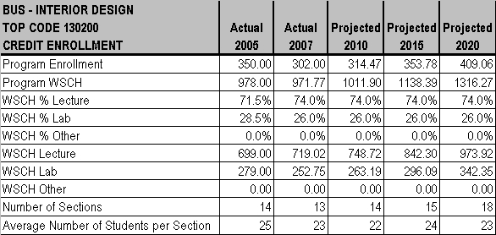
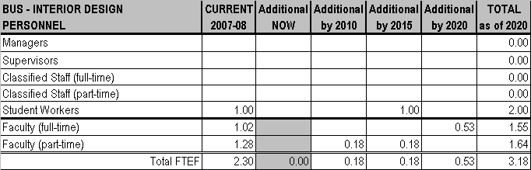

CHAPTER 3 - PROGRAMS AND SERVICES

MT. SAN ANTONIO COMMUNITY COLLEGE DISTRICT EDUCATIONAL MASTER PLAN - Page 167

CHAPTER 3 - PROGRAMS AND SERVICES

MARKETING
Amrik Dua, Chair

CURRENT PROGRAM
Marketing serves the transfer needs of students.

ENROLLMENT
Marketing class sizes range from 18 to 36 with the average size of the lecture classes being 22.3. There are currently no waiting lists.
FACILITIES
Marketing currently uses 3 classrooms. There is currently limited space for the larger classes; sound from adjacent class rooms can be disruptive; and temperature control could improve.
TEACHING METHODOLOGIES
Marketing uses lecture (85%) and online instruction (15%).

PERSONNEL
Marketing currently has 2.2 FTEF part-time faculty. No additional personnel are needed at this time.

FUTURE PLANS
Marketing is very stable and no new programs are being planned or discussed at this time.

ENROLLMENT
Enrollments for Marketing are expected to grow at the same rate as overall District enrollment between now and 2020. University enrollments may affect the ability of Business majors to transfer.

FACILITIES
By 2010, a new Business building with offices and classrooms is anticipated; if the bond does not pass, new facilities will still be needed..

TEACHING METHODOLOGIES
Marketing anticipates no changes in teaching methodology.
PERSONNEL
Marketing will need additional .2 FTEF part-time faculty by 2020.

MT. SAN ANTONIO COMMUNITY COLLEGE DISTRICT EDUCATIONAL MASTER PLAN - Page 168
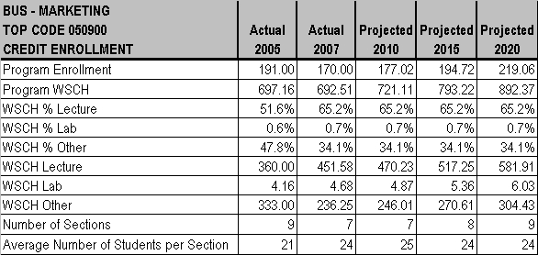
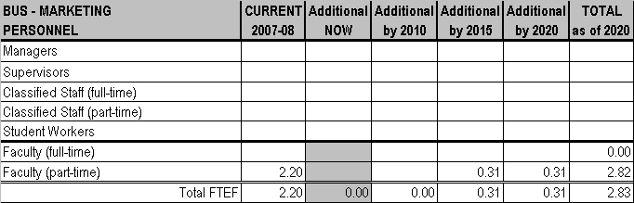

CHAPTER 3 - PROGRAMS AND SERVICES

MT. SAN ANTONIO COMMUNITY COLLEGE DISTRICT EDUCATIONAL MASTER PLAN - Page 169

CHAPTER 3 - PROGRAMS AND SERVICES

NUTRITION AND FOODS
Terri Faraone, Chair

CURRENT PROGRAM
Nutrition and Foods serves the transfer, occupational and general interest needs of students.

ENROLLMENT
Class size for Nutrition and Foods classes ranges from 24 to 36 students; averaging 36 students for lecture classes and 24 students for lab
classes.

FACILITIES
Nutrition and Foods currently has two classrooms in Building 19B, the vintage Home Economics facility. The foods lab space
inappropriately doubles for lecture classes and there is insufficient lab and storage space. New ranges were purchased, but they are
residential rather than commercial quality which does not support food sciences or a culinary program. However, no new space is
requested at this time, but space design input is being made for the construction of the new Business building to be completed by 2015.
TEACHING METHODOLOGIES
Teaching methodology for Nutrition and Foods classes include lecture (85%) and lab (15%).

PERSONNEL
Nutrition and Foods currently has 2.49 FTEF full-time and 3.48 FTEF part-time faculty, and 2 student workers. One additional full-time faculty is needed at this time.

FUTURE PLANS
Nutrition and Foods will move toward establishing a transfer program for Nutrition majors and a relationship with Exercise Science and the Wellness Center to promote healthy and active lifestyles for the campus community.
ENROLLMENT
Nutrition and Foods anticipates growth will be faster than District enrollment each year through 2020 due to the dramatic increase in obesity in the U.S. and the greater need for qualified personnel to educate the population.

FACILITIES
Nutrition and Foods will move to the new Business building when it is completed in 2015. The building will need appropriate space and equipment to support a lab test kitchen, classroom, Hospitality and Restaurant Management professional kitchen and lab space for culinary program, a student operated restaurant, an office for lab tech, and storage.
TEACHING METHODOLOGIES
Nutrition and Foods expects no changes in teaching methodologies through 2020.

PERSONNEL
Nutrition and Foods will need one additional full-time FTEF, one half-time FTEF, and two additional student workers by 2010. By 2015, the program will need one full-time and one part-time faculty additions, one half-time classified staff person, and one additional student worker. By 2020, an additional half-time classified staff person and one student worker will be needed. Hospitality and Restaurant Management will share classified staff with Nutrition and Foods.

MT. SAN ANTONIO COMMUNITY COLLEGE DISTRICT EDUCATIONAL MASTER PLAN - Page 170
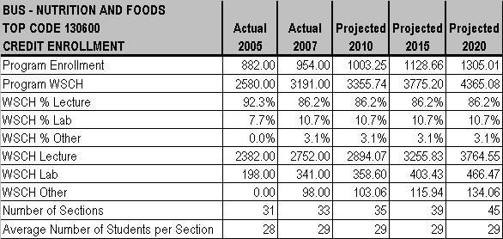
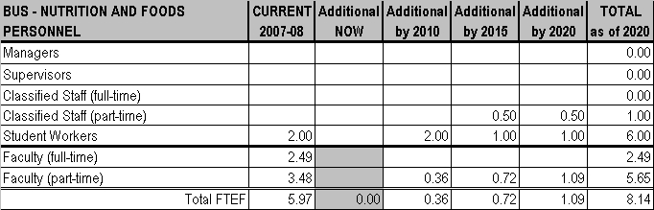

CHAPTER 3 - PROGRAMS AND SERVICES

MT. SAN ANTONIO COMMUNITY COLLEGE DISTRICT EDUCATIONAL MASTER PLAN - Page 171

CHAPTER 3 - PROGRAMS AND SERVICES

OFFICE TECHNOLOGY
Bev Crespo, Chair

CURRENT PROGRAM
Office Technology serves occupational and general interest needs of students.

ENROLLMENT
Class sizes range from 28 to 36 students. Average lecture class size is 30. There are currently waiting lists averaging 5 students per section except for COMP 1 which has 10 students waiting.

FACILITIES
The Department now has a computer lab in Room 17-5. It is too small, has no room for growth, is not ADA accessible, is ergonomically deficient, and has dangerous paths to the exits. The Department proposes adding on to current space by removing a wall and expanding into Room 17-3 (currently used by IT). Updating software and hardware on usual replacement schedules is also needed now.
TEACHING METHODOLOGIES
Teaching methodologies include lecture (75%) and lab (25%). Students go to the Business Division computer lab.

PERSONNEL
The Department currently has 3 full-time and 4.10 FTEF part-time faculty members. One additional full-time faculty member is needed at
this time.

FUTURE PLANS
The Department was considering starting Customer Service as a new program, but it is likely this department will be absorbed by the
Computer Information Systems Department in the near future and Customer Service does not fit into that Department’s curriculum.

ENROLLMENT
Employment opportunities impact student enrollment. When employment is low, Department enrollment increases. Enrollment is expected to grow at the same rate as the District between now and 2010.
FACILITIES
There is the need for usual, continuous updating of software and hardware through 2020.
TEACHING METHODOLOGIES
No change in teaching methodology is anticipated.

PERSONNEL
By 2010, the Department anticipates eliminating one part-time faculty member and adding two full-time faculty. Personnel needs by 2015 and beyond are uncertain due to the likely absorption of this Department by another.

MT. SAN ANTONIO COMMUNITY COLLEGE DISTRICT EDUCATIONAL MASTER PLAN - Page 172
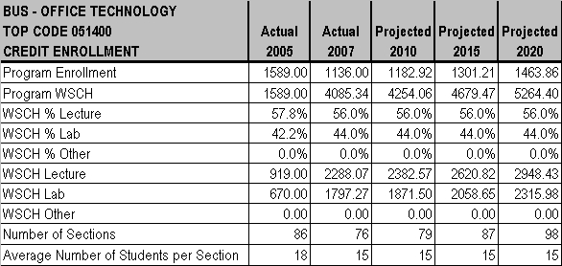
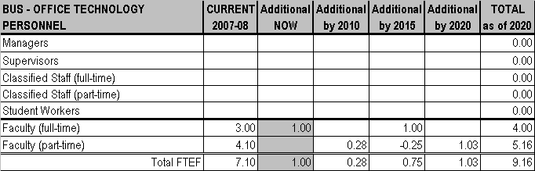

CHAPTER 3 - PROGRAMS AND SERVICES

MT. SAN ANTONIO COMMUNITY COLLEGE DISTRICT EDUCATIONAL MASTER PLAN - Page 173

CHAPTER 3 - PROGRAMS AND SERVICES

PARALEGAL
Amrik Dua, Chair

CURRENT PROGRAM
Paralegal serves the transfer and occupational needs of students.

ENROLLMENT
Paralegal class sizes range from 18 to 40 students. Average class size is 29.9 for lecture classes. There are currently no students on waiting lists.

FACILITIES
Paralegal currently uses classrooms 18, 20, 21A, and 21B; there is currently limited space for the larger classes; sound from adjacent class rooms can be disruptive; and temperature control could improve.

TEACHING METHODOLOGIES
Paralegal uses lecture for all classes with the exception of a one credit unit internship class.
PERSONNEL
Paralegal currently has .4 FTEF full-time and 2.2 FTEF part-time faculty. No additional personnel are needed at this time.

FUTURE PLANS
No major changes for the Paralegal program are planned; however, more courses will be offered online.
ENROLLMENT
Fluctuations in the legal industry can affect enrollment in the Paralegal program, but at this time the program is expected to grow at the same rate as the District every year through 2020.
FACILITIES
By 2010, a new Business building with offices and classrooms for Paralegal is anticipated, but if the bond does not pass, new facilities will still be needed. The Paralegal program will also need a law library and storage space by 2015.

TEACHING METHODOLOGIES
The Paralegal program anticipates teaching methodology will change to lecture (80%) and online instruction (20%).
PERSONNEL
By 2015, the Paralegal program will need .2 FTEF additional part-time faculty.

MT. SAN ANTONIO COMMUNITY COLLEGE DISTRICT EDUCATIONAL MASTER PLAN - Page 174
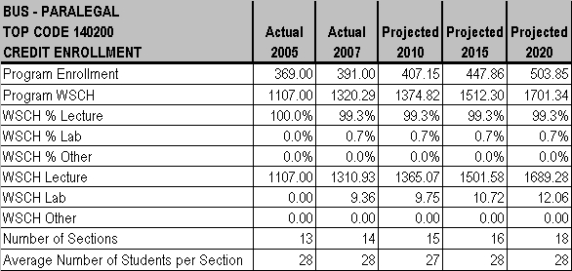
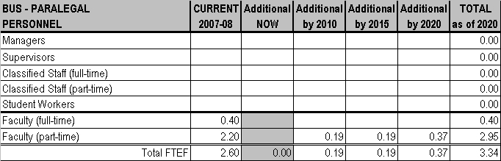

CHAPTER 3 - PROGRAMS AND SERVICES

MT. SAN ANTONIO COMMUNITY COLLEGE DISTRICT EDUCATIONAL MASTER PLAN - Page 175

CHAPTER 3 - PROGRAMS AND SERVICES

REAL ESTATE
Amrik Dua, Chair

CURRENT PROGRAM
Real Estate serves the occupational needs of students.

ENROLLMENT
Class sizes for Real Estate range from 18 to 45 students. The average class size for lecture classes is 31.1 students. The waiting list for the Real Estate Principles class is estimated at 15 students.

FACILITIES
Real Estate currently uses 6 classrooms. There is currently limited space for the larger classes; sound from adjacent class rooms can be disruptive; and temperature control could improve.

TEACHING METHODOLOGIES
The Real Estate program currently uses lecture (90%) and online instruction (10%).
PERSONNEL
Currently, the Real Estate program has 1 full-time and 2.4 FTEF part-time faculty. No additional personnel are needed at this time.

FUTURE PLANS
The Real Estate program will possibly expand the existing Appraisal program. As the average age of licensed appraisers in California is
over 60, program changes may be forthcoming to address increased job opportunities during the next five years to replace retirees.

ENROLLMENT
At this time, the Real Estate program expects to grow at the same rate as overall District enrollment each year through 2020, but real estate cycles and changes in real estate appraisal licensing requirements could affect future enrollment.

FACILITIES
By 2010, a new Business building is anticipated with space for Real Estate classes.

TEACHING METHODOLOGIES
With online instruction increasing in popularity, Real Estate anticipates that teaching methodologies will shift to lecture (75%) and online instruction (25%).

PERSONNEL
By 2015, the Real Estate program will need .2 FTEF part-time faculty.

MT. SAN ANTONIO COMMUNITY COLLEGE DISTRICT EDUCATIONAL MASTER PLAN - Page 176
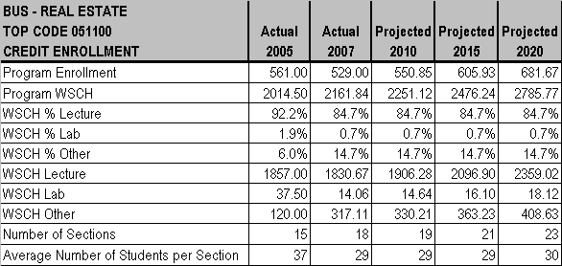
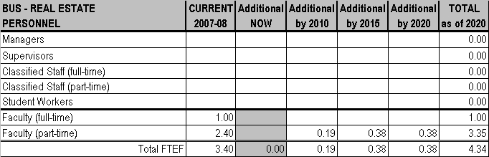

CHAPTER 3 - PROGRAMS AND SERVICES

MT. SAN ANTONIO COMMUNITY COLLEGE DISTRICT EDUCATIONAL MASTER PLAN - Page 177

CHAPTER 3 - PROGRAMS AND SERVICES

MT. SAN ANTONIO COMMUNITY COLLEGE DISTRICT EDUCATIONAL MASTER PLAN - Page 178

CHAPTER 3 - PROGRAMS AND SERVICES

