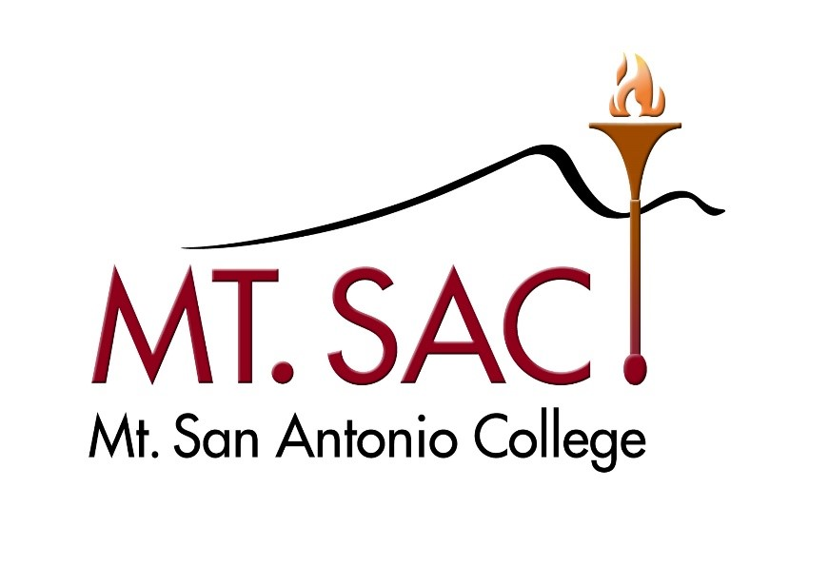

Follow-Up Report

Submitted by  
Mt. San Antonio College  
1100 N. Grand Avenue  
Walnut, CA 91789

to

Accrediting Commission for Community and Junior Colleges

September 2025

Certification

To: Accrediting Commission for Community and Junior Colleges

From: Martha O. Garcia, Ed. D., President & Chief Executive Officer   
Mt. San Antonio College,

1100 N. Grand Avenue, Walnut, CA 91789

This Follow-Up Report is submitted to ACCJC to demonstrate resolution of deficiencies cited by the Commission in the action letter dated June 12, 2024. The Follow-Up Report reflects the nature and substance of this institution, as well as its best efforts to align with ACCJC Standards and policies and was developed with appropriate participation and review by the campus community.

Signatures:

|  |  |  |
| --- | --- | --- |
| Dr. Martha O. Garcia Date President and Chief Executive Officer |  | Peter Hidalgo Date President, Board of Trustees |
| Dr. Kelly Fowler Date Vice President of Instruction and Accreditation Liaison Officer |  | Dani K. Silva Date President, Associated Students |
| Dr. Tania Anders Date President, Academic Senate |  | Yvette Garcia Date President, Classified Senate |
| Lianne Greenlee Date Assistant Dean, Accreditation and Planning |  | Emily Woolery Date President, Faculty Association |
| Brandon Gillett Date President, California School Employees Association, Chapter 262 |  | George Gutierrez Date President, California School Employees Association, Chapter 651 |
| Allie Frickert Date Faculty Accreditation Coordinator |  | Hong Guo Date Faculty Accreditation Assistant Coordinator |

Contents

1. Background 1

2. Advancements in Distance Education in 2023 2

3. Advancements in Distance Education in 2024 3

4. Advancements in Distance Education in 2025 and Summary of Long-term RSI Sustainability Plans 9

5. Follow-Up Report Preparation 14

# Response to Identified Compliance Requirements

|  |
| --- |
| **College Compliance Requirement: Standard II.A.7 and Commission Policy on Distance Education and Correspondence Education**  In order to meet the Standard(s), the Commission requires that the college ensure that regular and substantive interaction takes place in distance education courses. |

## Background

The faculty and other employees of Mt. San Antonio College (Mt. SAC) have engaged in the implementation of Regular and Substantive Interaction (RSI), formerly called Regular and Effective Contact (REC), since 2018. An Academic Senate-appointed workgroup moved forward a set of recommendations including a REC rubric in November of 2019 (1_01_2019 Faculty Workgroup Rubric and Recommendations). The COVID-19 pandemic interrupted the rubric adoption process. As Mt. SAC emerged from the pandemic, new federal and state regulations shifted from REC to RSI. The Distance Learning Committee (DLC) took up the challenge of revising their REC rubric to reflect the new RSI regulations, and the RSI rubric was approved by the Academic Senate in September of 2022 (1_02_RSI Rubric Final Senate Approval 9-1-22). The College also endeavored to raise faculty awareness of the new RSI requirements using an accreditation lens. A spring 2022 survey from the Faculty Center for Learning Technology (FCLT) assessed training needs for RSI and was leveraged for fall 2022, which included a Faculty FLEX Day breakout training as well as a series of collaborative forums to raise awareness of RSI (1_03_FCLT DL Needs Assessment Survey; 1_04_RSI Fall FLEX Day 2022; 1_05_Accreditation RSI Forum October 2022). A more extensive history of RSI development at Mt. SAC is detailed on the Mt. SAC Distance Learning RSI website (1_06_Distance Learning Website - RSI History at Mt. SAC).

Figure 1. Overview of Mt. SAC RSI History

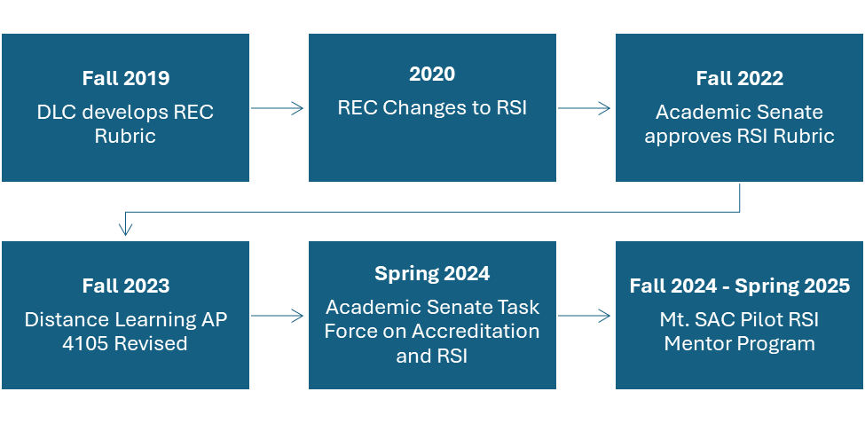

Evidence

* 1_01_2019 Faculty Workgroup Rubric and Recommendations
* 1_02_RSI Rubric Final Senate Approval 9-1-22
* 1_03_FCLT DL Needs Assessment Survey
* 1_04_RSI Fall FLEX Day 2022
* 1_05_Accreditation RSI Forum October 2022
* 1_06_Distance Learning Website - RSI History at Mt. SAC

## Advancements in Distance Education in 2023

To ensure continuous improvement, the Distance Learning Committee (DLC), Academic Senate, and Faculty Association (FA) collaborated throughout 2023 and 2025 to evaluate faculty engagement with Regular and Substantive Interaction (RSI), analyze Canvas Impact Course Report data, incorporate feedback from the RSI Pilot Peer Mentor Program, and refine training modules and contractual language to align with evolving accreditation expectations.

In Fall 2023, the ACCJC Peer Review Team identified Distance Education (DE) as a Core Inquiry. Simultaneously, Mt. San Antonio College (Mt. SAC) faculty were working on improvements to policies and relevant training for RSI. The DLC and Academic Senate revised AP 4105 Distance Learning to incorporate robust RSI requirements to ensure implementation in distance education classes (2_01_AP 4105 Approved 10-23-23). A new Distance Learning (DL) course approval form was adopted and immediately implemented, requiring documented plans for RSI in each course (2_02_DL Course Amendment Form; 2_03_DLC Website – DL Amendment Form).

The FA and the District ratified the Collective Bargaining Agreement with the new language requiring all DE faculty to undergo training in RSI (2_04_Contract RSI Defined). The DLC and the Faculty Center for Learning Technology (FCLT) updated mandatory training for all Mt. SAC faculty who teach online, the Skills and Pedagogy for Online Teaching (SPOT) Certification, to include an in-depth module that that demonstrates to faculty how to effectively apply RSI in their Canvas courses (2_05_SPOT Module RSI). To earn the SPOT certification, a faculty member’s course shell must be reviewed by a SPOT-certified Faculty Reviewer using the SPOT rubric in a one-on-one intensive process. When necessary, adjustments are required to bring the course into compliance with the rubric before certification is earned (2_06_SPOT Certification Webpage). The DLC and FCLT collaborated to add a comprehensive RSI training module into the mandatory four-year cycle for SPOT Recertification (2_07_SPOT Recertification). Lastly, the DL classroom evaluation form, H.4.c Classroom Visitation Evaluation of Distance Learning Faculty, is used alongside the DL amendment form, which specifies required methods of RSI and state regulations for student to student content, to ensure regular evaluation of both full time and part time faculty (2_02_DL Course Amendment Form; 2_08_Sample H.4.c Evaluation).

The College provides continuous opportunities for RSI training, implementation, and improvement. FCLT provided an active RSI campaign in Canvas offering one-on-one support with the instructional design team of classified professional course designers and reminders about the RSI federal requirement (2_09_FCLT F23 Campaign). FCLT also provided support for newly developed distance learning courses and began implementing Canvas Impact Course Report as a new mechanism for assessing RSI data through big picture data points that provide weekly metrics of various forms of RSI pedagogy (2_10_RSI Consultations 22-23; 2_11_FCLT Impact Course Report Campaign 2023). Midway through the 2023-2024 academic year, members of the DLC provided Spring FLEX Day training on using the self-review rubric to improve RSI practices and planned for training workshops on RSI for Spring 2024 (2_12_Spring FLEX DLC Workshop Using Self-Review RSI Rubric; 2_13_Spring 2024 Find out Fridays RSI).

Evidence

* 2_01_AP 4105 Approved 10-23-23
* 2_02_DL Course Amendment Form
* 2_03_DLC Website – DL Amendment Form
* 2_04_Contract RSI Defined
* 2_05_SPOT Module RSI
* 2_06_SPOT Certification Webpage
* 2_07_SPOT Recertification
* 2_08_Sample H.4.c Evaluation
* 2_09_FCLT F23 Campaign
* 2_10_RSI Consultations 22-23
* 2_11_FCLT Impact Course Report Campaign 2023
* 2_12_Spring FLEX DLC Workshop Using Self-Review RSI Rubric
* 2_13_Spring 2024 Find out Fridays RSI

## Advancements in Distance Education in 2024

In February 2024, the ACCJC Peer Review Team identified deficiencies in Mt. San Antonio College’s (Mt. SAC’s) demonstration of Regular and Substantive Interaction (RSI) during their review of asynchronous online courses. In anticipation of a recommendation on RSI from ACCJC, the Academic Senate convened a Task Force on Accreditation and RSI immediately following the Peer Review Team’s visit in February 2024. President Garcia collaborated with the Academic Senate leaders to charge the task force with compiling faculty recommendations on RSI training, addressing immediate and long-term faculty support needs to ensure alignment with Accreditation Standards and Policies. This RSI work reflected the shared commitment of the College to sustain RSI best practices beyond accreditation, with the goal of providing an engaging and equitable educational experience for all students.

During the spring 2024 semester, this Academic Senate Task Force reviewed the RSI work of other colleges, such as Kapi’olani College’s “RSI coaching program” and recommended a two-phase strategy for implementation. The initial phase focused on short-term RSI goals and training in the summer and fall of 2024 to prepare faculty for full RSI implementation in the spring 2025 semester. The first phase emphasized faculty peer mentorship and online course review using the locally approved Mt. SAC RSI rubric, developed based on federal and state RSI standards. This first phase involved strategic one-on-one training for faculty, compensation for faculty participating in the peer mentoring RSI program, RSI peer mentors, and coordinators, and collaboration with academic administrators to ensure the sustainable integration of RSI criteria into Mt. SAC’s distance learning framework. The subsequent phase centered on sustainably institutionalize RSI practices in online courses to meet the College’s mission of “providing an engaging and supportive teaching and learning environment for students of diverse origins, experiences, needs, abilities,” while also meeting federal and state standards for RSI (3_01_Academic Senate Task Force on Accreditation and RSI Report 1-10-24).

Following these task force recommendations from the Academic Senate, the Faculty Association (FA) and the District negotiated a side letter and a Memorandum of Understanding (MOU) regarding Article 13 Distance Learning that established contractual expectations for distance education and introduced a compensated voluntary RSI review process using a one-on-one faculty RSI peer mentorship approach (3_02_May Side Letter; 3_03_Article 13 MOU 5-25-24). The Academic Senate took immediate action to appoint two RSI coordinators and to recruit 10 RSI mentors for the planned fall 2024 and winter 2025 RSI Pilot Peer Mentor Program (3_04_Senate Appointments).

In addition to providing faculty support through peer mentorship, the new contract language for Article 13 Distance Learning uses a three-pronged approach to ensure that RSI will be met by faculty in future DE courses: 1) Initial Skills and Pedagogy for Online Teaching (SPOT) Certification, which includes rigorous training on RSI as well as a process for an initial RSI review; 2) All faculty teaching online must be evaluated as part of the regular classroom evaluation process using the H.4.c form by a SPOT certified faculty member; and 3) The four-year SPOT Recertification process will include the RSI self-evaluation and peer review as a mandatory process: “Once a professor successfully demonstrates RSI during their first review, they will subsequently participate in RSI review during their SPOT recertification cycle” (3_05_FA Contract Class Evals; 3_03_Article 13 MOU 5-25-24).

At the state level, the Academic Senate for California Community Colleges (ASCCC) adopted the resolution titled *Supporting Regular and Substantive Interaction as an Academic and Professional Matter to Enhance Student Success and Meet Standards*. This resolution, initiated by the Mt. SAC local Senate Executive Board, served as a response to the Accrediting Commission for Community and Junior Colleges (ACCJC) and launched statewide efforts to address consistent RSI review and assessment in distance education courses (3_06_ASCCC Resolution on RSI).

In June 2024, as the College began to implement the RSI Pilot Peer Mentor Program, Mt. SAC received confirmation from the ACCJC of Reaffirmation of Accreditation for 18 Months, with a Follow-up Report and Visit. During Summer 2024, Mt. SAC’s RSI faculty coordinators and accreditation faculty coordinators participated in the ACCJC RSI Rubric Development Pilot, contributing feedback to the Commission (3_07_Report Out to ASC September 2024). At that time, the five Mt. SAC faculty and one classified professional in collaboration with ACCJC pilot program members, interpreted the category of Direct Instruction for Substantive Interaction to include faculty to student instruction during scheduled office hours—provided those hours had a designated day, time, and location, rather than open-ended “by appointment” availability. This interpretation was incorporated into RSI training and mentorship practices at Mt. SAC (3_08_Mt. SAC Rubric Aligned Practice) (See Figure 2). The interpretation was influenced by the ongoing absence of clear, published regulatory definitions or prescriptive policies at the federal or state level, regarding what constitutes Direct Instruction or synchronous office hours as Regular and Substantive Interaction.

In this context, Mt. SAC faculty relied on professional judgment and pilot participation guidance to inform their understanding of these activities as both regular and substantive instructional opportunities. However, in November 2024, the ACCJC issued an updated version of the rubric clarifying that Direct Instruction (for Substantive Interaction) applies exclusively to synchronous and hybrid courses and does not include office hours, (though notably the “[Addendum to Protocols for Distance Education](https://accjc.org/wp-content/uploads/DE-Assessment-Tool-for-Peer-Reviewers-Auto-Calculate-November-2024.xlsx)” has different language and does not refer to a course modality specifically). As a result of the updated ACCJC guidance, Mt. SAC’s current rubric, shaped during the pilot phase, along with our local Administrative Procedure (AP) 4105 and Distance Learning Handbook, will require revision to align with the Commission’s updated standards for RSI. College faculty plan to revise our local guidance materials during the 2025-2026 academic year for future re-training of faculty as over 500 faculty were trained under the prior ACCJC pilot rubric guidance (see end of section 4 for future plans).

Figure 2. Mt. SAC Summer Pilot Direct Instruction Interpretation

Of Substantive Interaction

|  |  |  |  |  |
| --- | --- | --- | --- | --- |
| Initial | Emerging | Developed | Highly Developed | Mt. SAC Aligned Practices (based on Summer Pilot) |
| Synchronous engagement providing lectures or presentations that cover course content. | Synchronous engagement providing lectures or presentations to cover course content.  Synchronous facilitation of class discussions, encouraging student participation. | Synchronously incorporates multiple teaching methodologies to facilitate effective direct instruction, such as flipped classrooms, critical thinking, and dialogue on learning outcomes and competencies. | Synchronously utilizes various media and technologies to facilitate learning and competencies, effective teaching methodologies, and incorporates culturally competent strategies that yield equitable student outcomes. | Zoom study sessions  Weekly Student Hours must be scheduled and have an available location such as a direct Zoom link or office location. They cannot be done by appointment only. These office hours are scheduled to provide substantive opportunities where faculty and students engage in academic dialogue and instruction as aligned with the academic expectations outlined in the course outline of record. |

In fall 2024, RSI coordinators and the Accreditation Core Team introduced the RSI Pilot Peer Mentor Program the week prior to the fall semester start with department chair training and a session during the Fall Faculty FLEX Day, announcing the RSI Pilot Peer Mentoring Program and encouraging faculty participation in the RSI review process (3_09_Department Chairs Training 8-23-24; 3_10_Fall FLEX Day Training). The RSI Pilot Peer Mentor Program included the training and norming for faculty RSI peer mentors who were tasked with reviewing course shells and providing feedback to enhance online teaching practices (3_11_Screenshot of Mentor Resources in RSI Hub; 3_12_Fall Training Norming Mentors). The RSI coordinators collaborated with the Faculty Center for Learning Technology (FCLT) and the Distance Learning Committee (DLC) to establish a regular communication process for all distance education faculty, including a weekly bulletin, organized training sessions, and an open RSI forum in providing RSI support to faculty for the fall 2024 semester (3_13_RSI Bulletin #2; 3_14_DLC Agenda and Minutes September 2024). The RSI coordinators also worked collaboratively with the FCLT to launch a comprehensive “RSI Hub” where faculty began to sign up for the RSI Review in October 2024. The launch coincided with the announcement of a comprehensive training forum on RSI to be held in October as well as the availability of drop-in individual appointments (3_15_RSI Bulletin #3 Fall Week 6).

As mentioned above, the RSI Pilot Peer Mentor Program review process began with faculty signing up through the RSI Hub, completing a pre-review survey to assess needs, and reviewing training resource modules covering each component of RSI (3_16_RSI Pre-Review Survey; 3_17_Hub Modules on the Four Types of RSI and Monitoring). Faculty then engaged in a self-reelection exercise using the RSI rubric, which provided faculty an opportunity to review and assess their own pedagogical practices and identify how RSI was implemented in their courses. At this stage, the RSI coordinator assigned each faculty member going through the RSI review process to an RSI peer mentor and access to the online course for review (3_18_Sample Faculty Self-Reflection Rubric).

The RSI peer mentors conducted individualized reviews of each course to determine whether faculty demonstrated alignment with the Mt. SAC RSI Rubric and criteria. RSI peer mentors provided constructive feedback in writing and through one-on-one meetings to support faculty in enhancing their RSI pedagogical practices. (3_19_Mentor Created Feedback Templates and Tips). When necessary, faculty revised their Canvas course design, instructional strategies, or both to meet RSI requirements and expectations. Upon confirming that the course met the required RSI standards, RSI Peer Mentors completed the RSI rubric and submitted the appropriate documentation through a Smartsheet form to track completion and initiate the RSI stipend for faculty who participated in the RSI Peer Review process. (See Figure 3).

Figure 3. Mt. SAC RSI Peer Mentor Program Flowchart

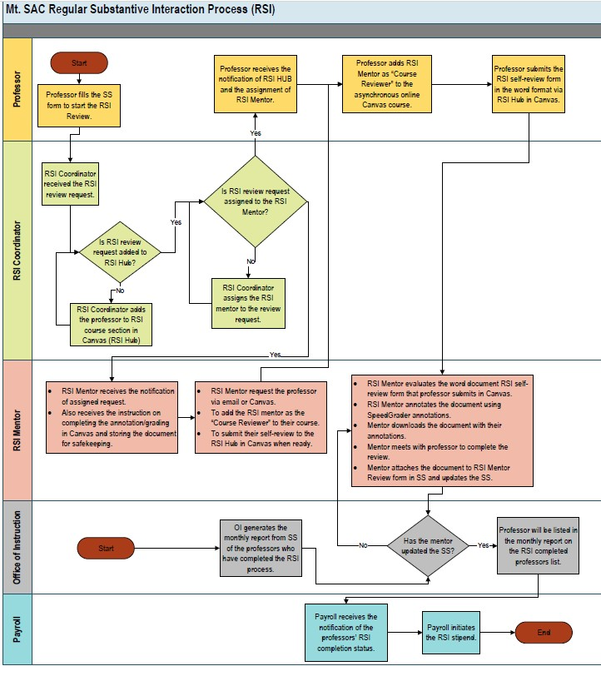

As part of the RSI review process, RSI peer mentors evaluated each course against specific standards aligned with the Mt. SAC RSI Rubric, providing targeted guidance to help faculty understand and apply each category of RSI. The RSI standards reviewed included direct student engagement, with a focus on clarifying the nature of providing live instruction through synchronous sessions based on the team’s interpretation of the ACCJC Summer Pilot Rubric. RSI peer mentors trained faculty to document evidence of such sessions in the course syllabus and home page (3_20_Mentor Feedback Example Category S1). RSI peer mentors also reinforced the importance of providing grading feedback that is both meaningful, substantive, and tailored to individual student performance (3_21_Mentor Feedback Example Category S2). The RSI peer mentors also emphasized that expectations for communication with students should be clearly defined in the syllabus and consistently maintained through weekly announcements, structured content modules, clearly stated learning objectives, and accessible channels for student inquiries (3_22_Mentor Feedback Example Category S3).

The RSI peer mentors also guided faculty in strengthening other key areas of interaction, including discussion facilitation, student-to-student engagement, and ongoing monitoring of student progress. Based on the results of the RSI review process, the facilitation of discussions was found by the RSI peer mentors to be the most misunderstood section. RSI peer mentors explained that faculty may choose to meet the S4 category of the RSI requirement on the Mt. SAC RSI rubric by actively facilitating discussions by intentionally guiding student dialogue, posting clarifying questions, and providing meaningful instructional input through the discussion exchange (3_23_Mentor Feedback Example Category S4). Regular student-to-student interaction, although not a federal requirement, was part of the RSI review check and included activities such as discussion boards, peer reviews, or other forms of student-to-student interaction. Finally, RSI peer mentors emphasized that faculty must monitor student success through regular outreach, such as using Gradebook outreach features, sending Canvas inbox messages to students falling behind, using the assignment comments to monitor engagement, or soliciting feedback via surveys, with evidence of these interactions documented to ensure ongoing engagement and support throughout the term (3_24_Resource to Mentees on Feedback and Monitoring).

Building on course-level efforts, the DLC advanced broader institutional strategies to embed RSI into campus-wide practices and policies. In fall 2024, the DLC strengthened the faculty’s institutional commitment to mentor review by recommending to the Academic Senate that RSI review become a part of the four-year SPOT Recertification process (3_25_DLC Recommendations to Academic Senate). The DLC also finalized the Distance Learning Handbook to provide guidance on and support for all aspects of distance education pedagogy, including RSI (3_26_DL Handbook Finalized).

Building on these campus-wide efforts, FCLT mobilized to support faculty RSI training and improvement in fall 2024 and winter 2025. Faculty continued to schedule consultations with FCLT instructional designers to receive personalized guidance on integrating RSI-compliant strategies into their course designs. Additionally, FCLT provided a variety of workshops focusing on RSI best practices, which, while optional, contributed to professional development and supporting mandatory SPOT Recertification hours (3_27_FCLT RSI Support News Bytes November 2024). In November 2024, FCLT partnered with the RSI faculty coordinators and RSI peer mentors to hold an RSI Summit that highlighted faculty work on RSI, with faculty submitting “best practice” examples to the Canvas RSI Hub (3_28_RSI Summit Flyer). These examples were made available for peer review and emulation, fostering a culture of continuous improvement (3_29_RSI Summit Showcase Home Page).

In fall 2024, the College prioritized comprehensive faculty outreach to promote participation in the RSI Pilot Peer Mentor Review program and ensure broad campus-wide engagement. Campus-wide communication included updates to key groups such as the Accreditation Steering Committee (ASC), the President’s Advisory Committee (PAC), Academic Senate, Faculty Association (FA), and Instructional Leadership Team (ILT), ensuring all stakeholders were informed, engaged, and in alignment with institutional goals (3_07_Report Out to ASC September 2024; 3_30_Sample RSI PAC Report; 3_31_Sample Senate Presentation; 3_32_Sample FA Presentation). Faculty accreditation coordinators also visited division meetings to connect with department chairs, providing direct support and fostering collaboration (3_33_Division Meeting Outreach Presentation). In addition to the weekly bulletins from the RSI coordinators, the DL coordinators sent out regular updates and reminders (3_34_Sample Email from DL Coordinator Fall 24). Moreover, the Accreditation Core Team created a newly enhanced webpage, providing transparent access to resources, evidence, and best practices for RSI which served as resources for the College campus (3_35_Mt. SAC Accreditation Webpage).

Participation in the RSI Pilot Peer Mentor Review program during fall 2024 provided valuable insight into faculty engagement with RSI practices and highlighted areas for continued improvement. By the end of the fall semester, 345 out of 450 DL faculty signed up for an RSI review, with about half completing it, either initially, or after revising course shells and/or adjusting their pedagogies. RSI peer mentors found the self-reflection model valuable for helping faculty assess their own RSI practices in asynchronous courses. While nearly all faculty believed they were meeting RSI in their self-assessments, only about half were initially affirmed by their RSI peer mentor without needing revisions to either teaching practices or visibility of these practices to reviewers (3_36_BOT December Report RSI Dashboard Data). Although the mentoring program clarified definitions, application to categories, and online teaching best practices, RSI peer mentors’ recommendations often focused on making existing RSI practices more apparent to both students and reviewers. For example, RSI peer mentors emphasized the importance of including clear RSI-related policies in the syllabus, using Canvas-native tools that leave RSI evidence within the course shell, and optionally, implementing a Canvas “Module Zero” to collect and describe evidence for RSI practices that occur outside of Canvas (3_37_Mentor Feedback Template Example; 3_38_Example Mentee Email Affirming Edits). In certain cases, faculty required additional support and training to align their course design and instructional practices with College expectations and ACCJC standards for RSI (3_39_Sample Review Needing Significant Edits to Pass).

To build on the momentum of the RSI Pilot Peer Mentor program and strengthen institutional implementation, the College took steps to expand and formalize the initiative. Based on the success of the voluntary RSI Pilot Peer Mentor Program and the goal of expanding participation to all faculty teaching asynchronous online courses, the FA and the District signed an updated side letter in December 2024. This agreement extended the RSI Pilot Peer Mentor Program through spring 2025 and made participation mandatory for faculty teaching asynchronous online courses in winter or spring 2025. Plans for spring 2025 also included the anonymous review of 100 courses through the internal RSI program to assess the success of the RSI review process and identify areas for further growth (3_40_December 2024 RSI Side Letter).

Evidence

* 3_01_Academic Senate Task Force on Accreditation and RSI Report 1-10-24
* 3_02_May Side Letter
* 3_03_Article 13 MOU 5-25-24
* 3_04_Senate Appointments
* 3_05_FA Contract Class Evals
* 3_06_ASCCC Resolution on RSI
* 3_07_Report Out to ASC September 2024
* 3_08_Mt. SAC Rubric Aligned Practice
* 3_09_Department Chairs Training 8-23-24
* 3_10_Fall FLEX Day Training
* 3_11_Screenshot of Mentor Resources in RSI Hub
* 3_12_Fall Training Norming Mentors
* 3_13_RSI Bulletin #2
* 3_14_DLC Agenda and Minutes September 2024
* 3_15_RSI Bulletin #3 Fall Week 6
* 3_16_RSI Pre-Review Survey
* 3_17_Hub Modules on the Four Types of RSI and Monitoring
* 3_18_Sample Faculty Self-Reflection Rubric
* 3_19_Mentor Created Feedback Templates and Tips
* 3_20_Mentor Feedback Example Category S1
* 3_21_Mentor Feedback Example Category S2
* 3_22_Mentor Feedback Example Category S3
* 3_23_Mentor Feedback Example Category S4
* 3_24_Resource to Mentees on Feedback and Monitoring
* 3_25_DLC Recommendations to Academic Senate
* 3_26_DL Handbook Finalized
* 3_27_FCLT RSI Support News Bytes November 2024
* 3_28_RSI Summit Flyer
* 3_29_RSI Summit Showcase Home Page
* 3_30_Sample RSI PAC Report
* 3_31_Sample Senate Presentation
* 3_32_Sample FA Presentation
* 3_33_Division Meeting Outreach Presentation
* 3_34_Sample Email from DL Coordinator Fall 24
* 3_35_Mt. SAC Accreditation Webpage
* 3_36_BOT December Report RSI Dashboard Data
* 3_37_Mentor Feedback Template Example
* 3_38_Example Mentee Email Affirming Edits
* 3_39_Sample Review Needing Significant Edits to Pass
* 3_40_December 2024 RSI Side Letter

## Advancements in Distance Education in 2025 and Summary of Long-term RSI Sustainability Plans

As the Regular and Substantive Interaction (RSI) Pilot Peer Mentor Program entered its final phase in early 2025, the College continued to provide structured support to faculty and monitor progress to ensure sustained alignment with RSI requirements and standards. From January through February 2025, the RSI Pilot Peer Mentor Program continued to provide ongoing support to faculty, helping them maintain high standards of interaction in their courses. By the new deadline of January 31, 2025, established in the December 2024 Side Letter, 534 faculty signed up for RSI review, with 450 faculty completing the RSI review process by the end of the winter term in February 2025. The RSI coordinators and Faculty Center for Learning Technology (FCLT) maintained an ongoing RSI Dashboard to monitor mentee progress across all College divisions teaching asynchronous online credit courses (4_01_RSI Dashboard End of Winter Term Data). To further support faculty and sustain ongoing progress, FCLT offered both open appointments for RSI and targeted training opportunities. These consistent efforts were designed to equip faculty with the tools and knowledge needed to effectively implement RSI best practices and ensure that their courses meet the necessary standards for student engagement and accreditation compliance (4_02_FLCT Spring Training). FCLT also played a key role in configuring and implementing the RSI-filtered Canvas Impact Course Report, thereby enhancing both mentors’ and faculty’ ability to track and analyze RSI in their online courses (4_03_RSI Impact Course Report Screenshot).

Mt. San Antonio College (Mt. SAC) launched a comprehensive set of activities and communications to support the RSI throughout the spring 2025 semester to sustain momentum and ensure continued compliance with the accreditation standards. The spring 2025 semester kickstarted with the Spring 2025 FLEX Day updating faculty on RSI and a specialized “bootcamp” for faculty still working to complete their RSI review process (4_04_Spring 2025 FLEX Presentation; 4_05_Spring 2025 FLEX Breakout Session RSI). Throughout the early spring 2025 semester, RSI peer mentors continued to wrap up reviews not completed during the winter 2025 intersession to ensure that every faculty actively teaching completed a supportive RSI training process (4_06_RSI Data Dashboard Mid-Spring Semester) (See Figure 3). Campus-wide communication kept faculty informed through regular updates from RSI coordinators, the Accreditation Core Team, DL coordinators, the Academic Senate, the Faculty Association, and the Office of Instruction (4_07_Instruction Sample Monday Minutes; 4_08_DL Coordinator Sample Email). College-wide communication was maintained through regular updates to the Board of Trustees, Accreditation Steering Committee, the President’s Advisory Council, Academic Senate, Faculty Association, and Instructional Leadership Team (4_09_Sample Spring Update to Constituent Groups). Periodically, collaborative faculty and administrator team meetings helped to coordinate efforts and communication among stakeholders.

Figure 3. Mt. SAC RSI Mentoring Results

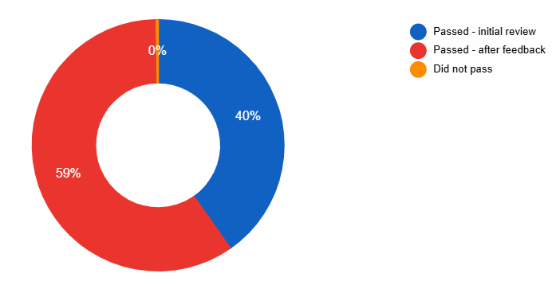

As part of the College’s ongoing commitment to high-quality online instruction, Mt. SAC has taken deliberate steps to enhance and institutionalize faculty preparation for RSI in distance learning courses. Central to this effort is the enhancement of the Skills and Pedagogy for Online Teaching (SPOT) training program to ensure it aligns with the most current standards for online instruction. A key addition to the SPOT program is the inclusion of a full module on RSI, and the examination of a shell by SPOT certifiers, which is now a mandatory component of the training (2_05_SPOT Module RSI). To standardize quality and improve training effectiveness, Mt. SAC’s Distance Learning Committee (DLC) recommended that the College no longer accept all alternative state-provided online training courses, such as @ONE’s Introduction to Asynchronous Online Teaching and Learning (IAOTL), to fully satisfy the local SPOT training requirements. This decision was driven by the recognition that while IAOTL has been updated to incorporate RSI, it does not have a deep dive into the pedagogical implementation of RSI strategies that is now a standard of Mt. SAC training for faculty teaching online. This comprehensive approach ensures that faculty are consistently trained to meet the evolving needs of distance education while supporting student success (4_10_DLC Recommendation for Oversight on External DE Certifications; 4_11_AS Approval of DLC Recommendation on External DE Certifications).

Building on the demonstrated success of the RSI Pilot Peer Mentor Program, Mt. SAC took steps to formalize and expand its support structure for faculty engaged in distance education. The RSI Pilot Peer Mentor Program was highly successful based on the data that 55% of the 506 completers making improvements to their course shell or pedagogy to pass the review (4_06_RSI Data Dashboard Mid-Spring Semester). Therefore, the Academic Senate proposed a permanent RSI coordinator to assist with faculty recertification of their SPOT training (every four years) as well as providing consistent mentoring and support to both new and existing SPOT-certified faculty (4_12_2025 Appendix E RSI Coordinator Proposal). In addition, Senate proposed an ongoing pool of trained faculty RSI peer mentors to support the work of the RSI coordinator, particularly in years where there is a large cohort of faculty completing their SPOT Recertification (4_13_2025 Appendix E RSI Mentors Proposal). If these proposals are agreed upon by the FA and the District, they will support a sustainable RSI mentor program that will become normalized into the ongoing training of distance learning faculty (See Figure 4).

Figure 4. Mt. SAC Mentor Program Mentee Reflections

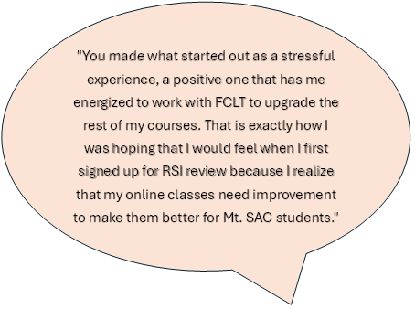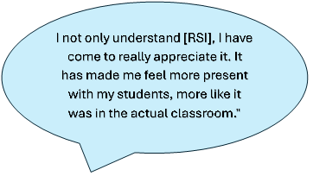

To further embed RSI into the College’s long-term instructional infrastructure, Mt. SAC is advancing a range of strategic initiatives led by the FCLT, DL coordinators, and the DLC. To support the institutionalization of RSI, the FCLT, DL coordinators, and the DLC are implementing several key future initiatives. The DLC integrated RSI reviews as a required component of SPOT recertification starting in Fall 2024 and is continuing to refine the recertification process to address gaps identified through formal RSI reviews. The FCLT is developing two self-paced RSI workshops: a 1-hour version to support immediate SPOT recertification needs, targeted for release by May 2025, and a 2-hour version to serve as an ongoing recertification option alongside an RSI review, targeted for release by the end of 2025 (4_14_DLC 2025 Proposed Workshops for SPOT Recert). Additionally, FCLT and DL coordinators are enhancing the RSI component of SPOT certification by adding an RSI Plan assignment and offering ongoing RSI-focused office appointments (4_15_RSI Webpage FCLT Appointments). To further support faculty, FCLT has developed a series of live RSI workshops, including four RSI Labs (one for each RSI criterion) and three themed sessions: RSI for Equity and Inclusion, Cidi Labs for RSI, and Level Up Your RSI: Game-Changing Tools for Efficiency (4_16_DLC Minutes 3-25-25).

Finally, FCLT is piloting the ReadyGO platform to streamline and institutionalize review processes. ReadyGO integrates the review cycle directly into courses with customized checklists, providing program coordinators with dashboards to track and manage progress. It also supports expanded reviews for accessibility compliance and can be adapted for SPOT certification and first-time DL instructor checklists. This tool is expected to enhance the efficiency, consistency, and transparency of RSI and accessibility reviews across the institution (4_17_ReadyGO Planning Email February 2025). College faculty and staff have also been invited to present Mt. SAC’s RSI Pilot Peer Mentor Program as part of the 2025 Online Teaching Conference Pre-Conference Workshops, hosted by the California Virtual Campus (CVC). This invitation, extended to members of the FCLT by CVC’s Director of Professional Development, highlights Mt. SAC’s statewide leadership in faculty-driven models for RSI implementation and distance education quality assurance (4_18_Online Teaching Conference Mt. SAC Led Workshop).

In the 2024 Side Letters, the College outlined a stipulation for the conclusion of the 2024-25 RSI Pilot Peer Mentor Program, including a provision for the RSI Faculty Coordinators to audit 100 randomly selected asynchronous online courses during the latter half of the Spring 2025 semester (3_40_December 2024 RSI Side Letter). This audit will serve as a key measure to assess the effectiveness and impact of the RSI Pilot Peer Mentor Program initiative and the local Mt. SAC Pilot RSI Rubric to guide future improvements and support ongoing faculty development as the long-term RSI peer review program will be refined and reassessed in 2025-2026 (4_19_DLC Minutes Audit Update April 2025). Additionally, data on faculty perceptions of the program were gathered through an optional exit survey conducted at the conclusion of the RSI review process (4_20_RSI Faculty Pre vs Post Survey Comparison). Lastly, data will be collected and analyzed to compare student retention and success rates for asynchronous online courses from spring 2024 to spring 2025.

Figure 5. Faculty Surveys Before and After Mentoring

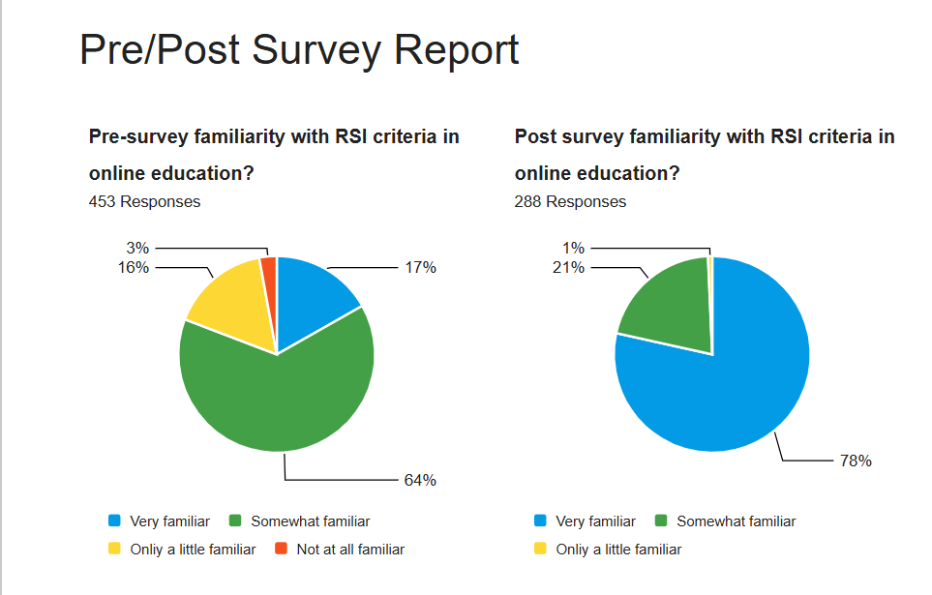

### Looking Ahead: The Future of Distance Education at Mt. San Antonio College

As Mt. SAC transitions from the initial 2024-2025 RSI Pilot Peer Mentor Program to a fully institutionalized model of online instructional quality assurance, the College remains committed to aligning with evolving accreditation standards while supporting faculty development and student success. Recognizing the lack of prescriptive federal and state definitions for Direct Instruction and synchronous office hours under RSI regulations, Mt. SAC is proactively building local expertise and scalable mentorship infrastructure to bridge this gap. Future priorities include revising AP 4105 and the Distance Learning Handbook to reflect the November 2024 ACCJC rubric update, integrating potential tools such as ReadyGO, and enhancing SPOT certification and recertification processes with robust RSI components.

The College will also analyze data from the Spring 2025 audit of asynchronous courses, faculty surveys of the RSI pilot mentor program, success and retention comparisons, and a comprehensive research study on student’s experiences in distance education, to inform long-term strategies. Of note, the survey indicated that students value office hours and suggested that additional office hours would be beneficial (4_21_Distance Education Research Student Experiences Draft). To ensure sustainability and faculty leadership in this evolving landscape, the Academic Senate has proposed the creation of permanent contractual positions for RSI faculty coordinators and RSI peer mentors (4_12_2025 Appendix E RSI Coordinator Proposal; 4_13_2025 Appendix E RSI Mentors Proposal). The Academic Senate is considering a resolution to propose additional staffing support for FCLT that would directly support faculty needs (4_22_Senate Draft Resolution for Increased Instructional Designers for FCLT). These roles would provide ongoing support, training, and quality review to uphold a faculty-driven peer review model that embeds RSI standards into the culture of distance education at Mt. SAC—promoting both regulatory compliance and pedagogical excellence.

Evidence

* 4_01_RSI Dashboard End of Winter Term Data
* 4_02_FLCT Spring Training
* 4_03_RSI Impact Course Report Screenshot
* 4_04_Spring 2025 FLEX Presentation
* 4_05_Spring 2025 FLEX Breakout Session RSI
* 4_06_RSI Data Dashboard Mid-Spring Semester
* 4_07_Instruction Sample Monday Minutes
* 4_08_DL Coordinator Sample Email
* 4_09_Sample Spring Update to Constituent Groups
* 2_05_SPOT Module RSI
* 4_10_DLC Recommendation for Oversight on External DE Certifications
* 4_11_AS Approval of DLC Recommendation on External DE Certifications
* 4_12_2025 Appendix E RSI Coordinator Proposal
* 4_13_2025 Appendix E RSI Mentors Proposal
* 4_14_DLC 2025 Proposed Workshops for SPOT Recert
* 4_15_RSI Webpage FCLT Appointments
* 4_16_DLC Minutes 3-25-25
* 4_17_ReadyGO Planning Email February 2025
* 4_18_Online Teaching Conference Mt. SAC Led Workshop
* 3_40_December 2024 RSI Side Letter
* 4_19_DLC Minutes Audit Update April 2025
* 4_20_RSI Faculty Pre vs Post Survey Comparison
* 4_21_Distance Education Research Student Experiences Draft
* 4_22_Senate Draft Resolution for Increased Instructional Designers for FCLT

## Follow-Up Report Preparation

Beginning in Fall 2024, Mt. San Antonio College (Mt. SAC) initiated resolution responses to the identified compliance requirements and began sharing these plans with the College community, providing ongoing updates throughout the 2024-25 academic year. In early spring 2025, the Accreditation Core Team drafted the Follow-Up Report. To ensure comprehensive input, feedback was solicited from governance groups, including the Accreditation Steering Committee, Academic Senate Executive Board, Distance Learning Committee, Faculty Association Executive Board, President’s Advisory Council, department chairs, and Instructional Leadership Team through a series of “roadshow” presentations. Additionally, the College engaged the broader campus community by posting a public draft of the Follow-Up Report on the Mt. SAC website and inviting feedback through an online form and a feedback forum (3_35_Mt. SAC Accreditation Webpage). This approach ensured the accuracy of the Follow-Up Report and inclusion of a wide range of perspectives (5_01_Follow Up Report Announcement Flyer).

Evidence

* 3_35_Mt. SAC Accreditation Webpage
* 5_01_Follow Up Report Announcement Flyer

Table 1. Mt. SAC RSI Timeline

|  |  |
| --- | --- |
| Date | Activity |
| Spring 2019 | Faculty work group creates rubric on Regular and Effective Contact |
| October 2019 | Distance Learning Committee approves REC rubric |
| November 2019 | Academic Senate approves REC rubric |
| September 2020 | Federal Requirement Change to RSI [34 CFR § 600.2 i](https://www.ecfr.gov/current/title-34/subtitle-B/chapter-VI/part-600/subpart-A#600.2) |
| August 2022 | RSI Fall FLEX Day Presentation |
| August 2022 | Faculty Center for Learning Technology Needs Assessment Survey |
| September 2022 | Academic Senate approves DLC recommendations & finalized RSI rubric |
| October 2022 | Distance Learning and RSI Accreditation Forum |
| January 2023 | Academic Senate approves Canvas Merging Shells and Related Matters Workgroup RSI recommendations |
| October 2023 | AP 4105 Distance Learning revisions approved |
| Summer & Fall 2023 | FCLT RSI Support: Workshops, 1-1 Consultations |
| November 2023 | DL Course Approval Form approved |
| May 2024 | Collective Bargaining Agreement with RSI ratified |
| February 2024 | Academic Senate convenes Task Force on Accreditation and RSI |
| April 2024 | Academic Senate approves Task Force report and recommendations |
| April 2024 | ASCCC approval of Resolution Number 107.01: Supporting RSI |
| April 2024 | Mt. SAC Academic Senate RSI Resolution in solidarity with ASCCC 107.01 |
| May 2024 | Side Letter and MOU to implement the Taskforce recommendations |
| May 2024 | Distance Learning Handbook V finalized |
| June 2024 | RSI Coordinators Appointed by Academic Senate |
| July 2024 | Mt. SAC faculty participate in ACCJC Pilot Rubric development |
| July – August 2024 | Development of RSI Pilot Peer Mentoring Program & RSI Hub |
| Summer & Fall 2024 | FCLT RSI Campaign: Find Out Fridays, 1-1 Consultations, Impact Reports |
| August 2024 | Updated accreditation & RSI websites launched |
| August 2024 | Department Chair Training on RSI |
| September 2024 | Faculty RSI Peer Mentors Trained |
| September 2024 | Outreach through Division Meetings begins |
| October 2024 | RSI requirement added to SPOT Recertification |
| October 2024 | RSI Pilot Peer Mentoring Program Launched & RSI Weekly Bulletins begin |
| November 2024 | RSI Reaching the Summit Showcase |
| December 2024 | Article 13 RSI Side Letter and MOU updated |
| January 2025 | RSI Dashboard data sent weekly to FA, AS, & instructional Deans |
| February 2025 | RSI Bootcamp |
| February 2025 | Campus-wide communication through the Monday Minutes begins |
| February 2025 | Article 13 RSI Side Letter and MOU updated |
| March 2025 | RSI update to the Board of Trustees |
| April-June 2025 | Assessment of RSI Pilot Peer Mentoring Program |

Table 2. Mt. SAC Acronyms Used in Follow-Up Report

|  |  |
| --- | --- |
| Acronym | Full Name or Description |
| ACCJC | [Accrediting Commission for Community and Junior Colleges](https://accjc.org/) |
| AP | [Administrative Procedure](https://www.mtsac.edu/governance/trustees/apbp/) |
| AS | [Academic Senate](https://www.mtsac.edu/governance/academicsenate/) |
| ASC | [Accreditation Steering Committee](https://www.mtsac.edu/governance/committees/accreditation/purpose-and-function.html) |
| BOT | [Board of Trustees](https://www.mtsac.edu/governance/trustees/) |
| COVID-19 | [Coronavirus Disease 2019](https://www.cdc.gov/coronavirus/2019-ncov/index.html) |
| DE | Distance Education |
| DL | [Distance Learning](https://www.mtsac.edu/distancelearning/) |
| DLC | [Distance Learning Committee](https://www.mtsac.edu/dlc/) |
| FA | [Faculty Association](https://msac-fa.org/index.htm) |
| FCLT | [Faculty Center for Learning Technology](https://www.mtsac.edu/fclt/index-2023.html) |
| IAOTL | [@One’s Introduction to Asynchronous Online Teaching and Learning](https://onlinenetworkofeducators.org/) |
| ILT | [Instructional Leadership Team](https://www.mtsac.edu/instruction/team.html) |
| MOU | [Memorandum of Understanding](https://www.investopedia.com/terms/m/mou.asp) |
| Mt. SAC | [Mt. San Antonio College](https://www.mtsac.edu/) |
| PAC | [President’s Advisory Council](https://www.mtsac.edu/governance/committees/pac/) |
| REC | Regular and Effective Contact |
| RSI | [Regular and Substantive Interaction](https://www.mtsac.edu/distancelearning/rsi.html) |
| SPOT | [Skills and Pedagogy for Online Teaching](https://www.mtsac.edu/distancelearning/spot.html) |
| Title 5 | [California Code of Regulations, Title 5. Education](https://www.cde.ca.gov/ls/fa/sf/title5regs.asp) |