TRACDAT

Manual for Documenting
The Planning for Institutional Effectiveness (PIE) Process
at Mt. San Antonio College
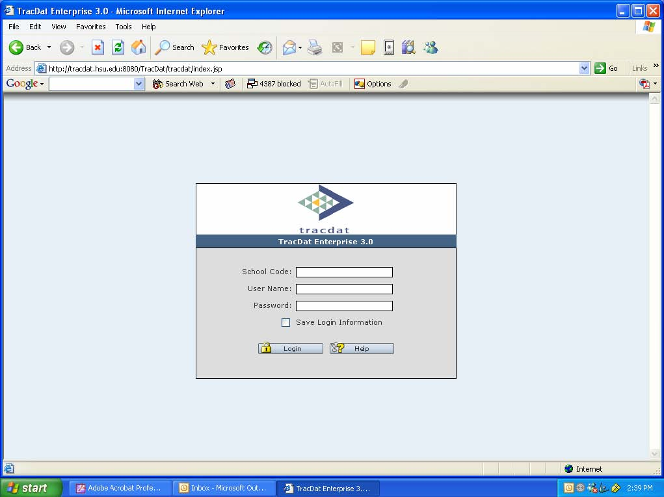

Spring 2007

INTRODUCTION | 3
USES OF TRACDAT | 3
TRACDAT LOGIN | 4
TRACDAT LOGOUT | 6
TRACDAT PERMISSIONS | 6
TRACDAT NAVIGATION | 7
Moving Between Fields
TRACDAT STANDARD BUTTONS | 8
GETTING STARTED: ENTERING INFORMATION ON COLLEGE/UNIT | 9
Information Tab | 11
Custom Fields Tab | 13
Goals Tab | 15
Related Goals Tab | 16
PLAN & DOCUMENT | 17
Objectives Tab | 20
Related Goals Tab | 24
Assessment Method Tab | 27
ASSESSMENT RESULTS | 28
Summary of Data Tab | 31
Use of Results Tab | 34
Related Data Tab | 35
MAINTAINING A HISTORICAL RECORD | 36
TRACDAT REPORTS | 37
APPENDIX A: Rubric for SLO/AUO | 39

INTRODUCTION
This manual is a step-by-step guide to assist TracDat users at Mt. SAC on the different functions of TracDat. TracDat is an assessment management tool designed to meet the assessment and planning needs of each department. TracDat allows for department/division and institution-wide viewing of assessment plans and uniform reporting across departments. Each Unit is responsible for entering/maintaining their PIE plans and assessment results in TracDat.

Please contact the Information Technology Help Desk at ext. 4357 if you have questions about this manual or if you need TracDat assistance.

Please contact ___________ if you have questions about how to develop Student Learning Outcomes (SLO) or Administrative Unit Objectives (AUO.)

Please contact _________ if you have questions about the Planning for Institutional Effectiveness (PIE) process.

USES OF TRACDAT

TracDat can be used to manage and document the following institutional effectiveness activities at Mt. SAC:

- Document student learning outcomes and results
- Document administrative unit objectives and results
- Manage AUOs/SLOs/Strategic Actions
- Complete the PIE process electronically
- Show strengths and weaknesses
- Link department goals and SLO/AUO activities to the College goals
- Access to PIE-related reports

TRACDAT LOGIN
Logging in to TracDat:
- 1. Go to the Institutional Effectiveness Committee webpage by typing http://inside.mtsac.edu/organization/committees/iec/
- 2. Click on the TracDat link
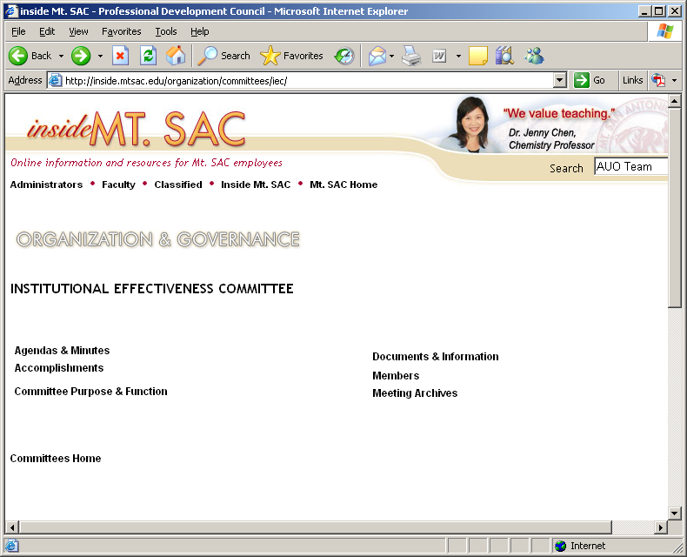

3. Enter School Code: Mt. SAC
4. Enter your User Name
5. Enter your Password
6. Click Login
Contact the IT Help Desk at ext. 4357 if you need a User Name or Password.

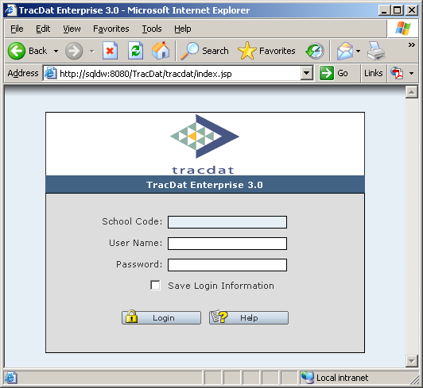 

TRACDAT LOGOUT
Logging out of TracDat:
1. Click on the logout link
in the upper right hand corner of the toolbar.
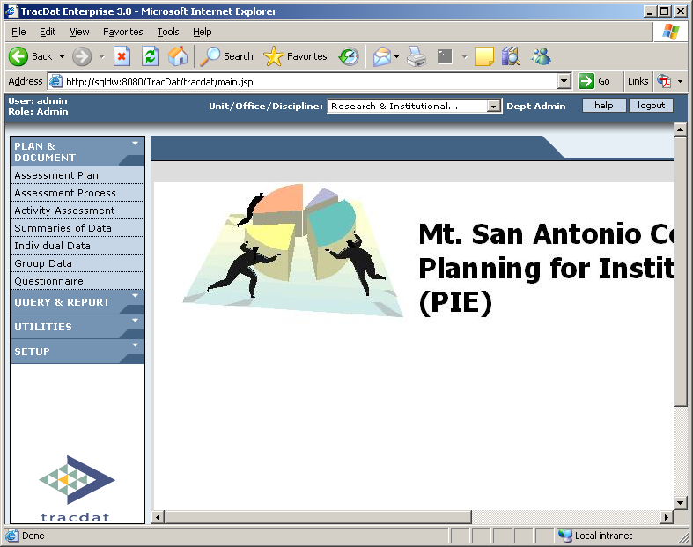

TRACDAT PERMISSIONS
TracDat provides different levels of users, each with varying access to information. Users will only have access to data from the department(s) they are affiliated with. For example, Deans could access all of the departments in their division but department chairs would have access to their department only. The following user roles are identified by TracDat:
- Read Only: Ability to view any data for the departments they have clearance for. Does not have permission to enter data, edit or delete data.
- Data Entry: Ability to add new data, edit and delete previous data for the departments they have clearance for.
- Dept User: Ability to add, delete, modify, print, query, and export any of the data for the departments they have clearance for.
TRACDAT NAVIGATION
The Navigation Bar is located on the far left hand side of the TracDat Screen. TracDat is broken into four main areas:
- Plan & Document
- Query & Report
- Utilities
- Setup

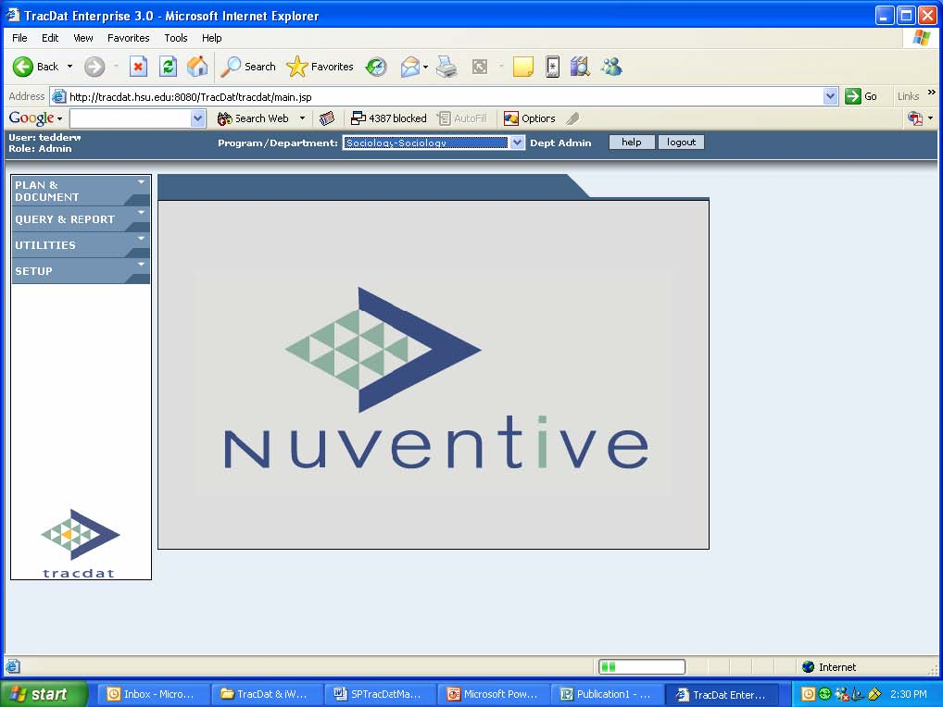

TRACDAT STANDARD BUTTONS

The following are standard TracDat buttons found on most screens and their function:

Screen Buttons
- To save information click the Save Button at the bottom of each screen. Make sure that you save every time you enter something onto the TracDat screens. If you add new information to TracDat and then switch screens without saving, you will lose the newly typed information.

- To delete information entered into TracDat, the user must click the Delete button at the bottom of each screen (where present).

- To clear text that has not been saved in a field click Cancel.

- Date Picker - allows the user to view the calendar in order to select a date.

To check the spelling of words in the content of the active field

 ,Apply Filter and Remove Filter  Produces a dialogue box, which allows the selection of a sub-set of records for viewing based on specific criteria (Apply Filter). If a filter is currently active, clicking the filter button removes the filter.

The Print Preview button is used to generate reports and screen content across multiple tables. All reports open in a web browser window. To print, choose print on the browser menu.

- Opens the TracDat help file.

GETTING STARTED: Initial Setup

Departments are responsible for developing their PIE plans and inputting them in TracDat. The terminology, format, and setup used in the PIE process is not always consistent with TracDat setup so the table below was developed to show where each component of the PIE plan fits in TracDat.

PIE Component | TracDat Location
Department Contact Information | Unit/Office Discipline Setup; Custom Fields Tab
3. Internal/External Conditions | Unit/Office Discipline Setup; Custom Fields Tab
4. Department/Unit Goals | Unit/Office Discipline Setup; Goals Tab
5. SLO/AUOs & Simple Goal Plan | Assessment Plan; Objectives Tab
6. Resources | Assessment Plan; Objectives Tab

1. Select the Unit/Office/Discipline for the PIE that you are working on from the drop down menu.

2. Select Unit/Office/Discipline Setup

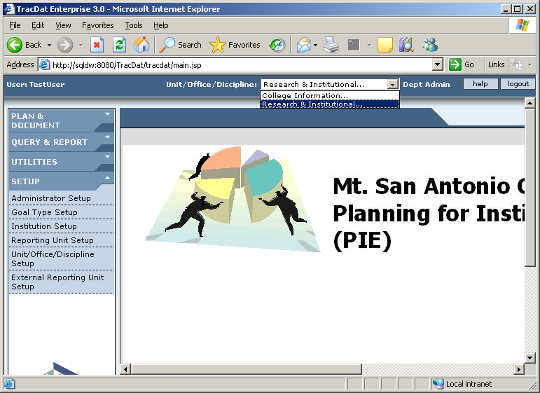

Information Tab

- 1. Unit/Office/Discipline Name: Click the drop-down box and select the appropriate unit
- 2. Mission Statement: Insert or type mission of the unit into the mission statement box (only include if already developed.)
- 3. Vision Statement: Insert or Type vision of the unit into the vision statement box (only include if already developed.)
- 4. Scroll to the bottom of page and click SAVE

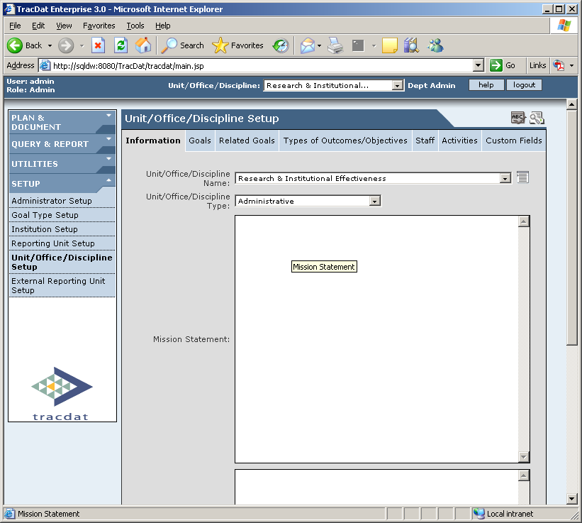

WORK SHEET TO ASSIST WITH PLANNING EFFORTS

NOTE: This is a work sheet page, and it is optional. You can make notes here to assist in completing your PIE in TracDat.

- Internal/External Conditions
Consideration of internal and external conditions is the basis of department/unit planning and assessment processes.

3a. Identify those external conditions that have influenced the department/unit goal-setting process:
Note: External conditions include disciplinary or regulatory changes, changes in technology or legislative changes, accreditation recommendations, enrollment issues, advisory committee input, etc.

3b. Identify those internal conditions that have influenced the department/unit goal-setting process. Please include a periodic review of attached data [provided for academic departments only].
Note: Internal conditions include results of previous SLOs/AUOs assessment, IT data, changes in technology, changes in budget, staffing, resources, enrollment issues, facilities issues, etc.

Information on this work sheet page is entered in the Custom Fields Tab in TracDat – See page 13 for directions.

Custom Fields Tab – Section 3A and 3B of PIE

- 1. Contact: Enter the contact name from the PIE form
- 2. External Conditions: Enter the external conditions from section 3A of the PIE form
- 3. Internal Conditions: Enter the internal conditions from section 3B of the PIE form

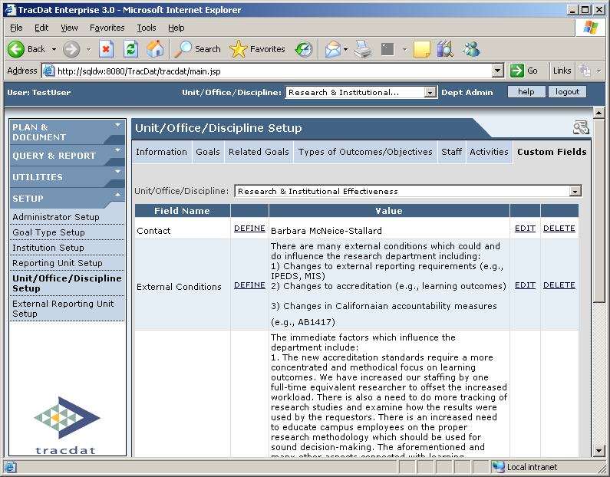

WORK SHEET TO ASSIST WITH PLANNING EFFORTS

NOTE: This is a work sheet page and it is optional. You can make notes here to assist in completing your PIE in TracDat.

4. Department/Unit Goals Department/Unit goals allow the area to focus its priorities. Prompted in part by College goals and generated by faculty/staff, they guide area planning and assessment.
Goals:
4a. List a MINIMUM OF TWO GOALS to be addressed through the SLOs/AUOs process. Please do not list outcomes statements here. When appropriate, identify the connection of your goals to the College goals.
1.

2.

3.
4b. List a MAXIMUM OF THREE goals that will not be assessed through the SLOs/AUOs process. When appropriate, identify the connection of your goals to the College goals.
1.
2.
3.

Information on this work sheet page is entered in the Goals Tab and the Related Goals Tab in TracDat – See page 15 & 16 for directions.

Goals Tab – Section 4A and 4B of PIE

- 1. Goal Type: Leave this blank
- 2. Unit/Office/Discipline Goal: Type each goal in the box. Section 4a or 4b from PIE.
NOTE: Previous years goals may have already been entered for you. If you need to add goals, do so now.
- 3. Order: Order the goals in numerical order (if you do not enter a number the system will place the goals in the order you entered them into the system)
- 4. SAVE after typing each goal and a new box will appear.
If a goal is no longer valid – do not delete it. To show it is inactive - no longer link objectives to inactive goals.

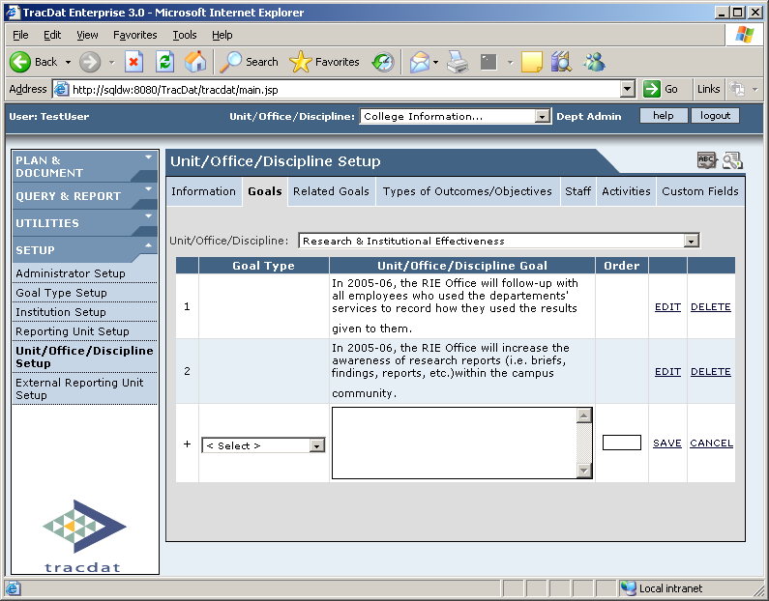

Related Goals Tab

- 1. Unit/Office/Discipline: Choose the first Unit/Office/Discipline goal.
- 2. Related To: Select Mt. San Antonio College from the drop down menu
- 3. Check all of the Institution goals that relate to your unit goal 1. If your goal does not relate to any Institution goal, select the last option, ZZ.
- 4. Scroll to the bottom and click SAVE after relating each goal.
- 5. Continue linking with all other Unit/Office/Discipline goals

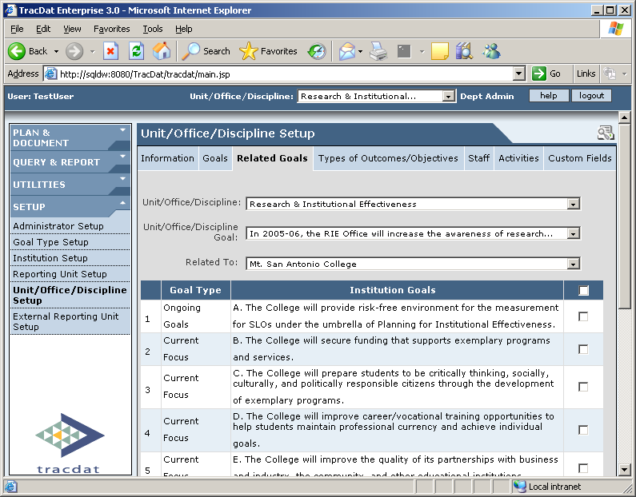

PLAN AND DOCUMENT

1. Select the Unit/Office/Discipline for the PIE that you are working on from the drop down menu.

2. Select Assessment Plan from the Navigation Bar.

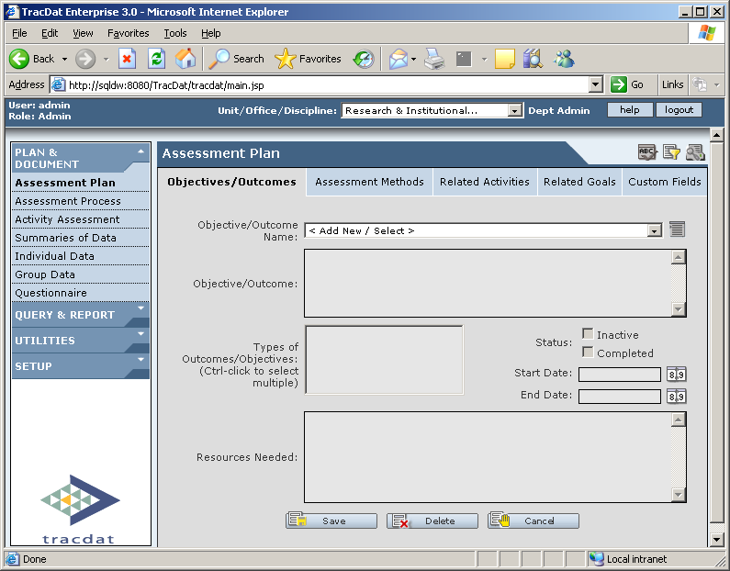

WORK SHEET TO ASSIST WITH WRITING an SLO / AUO / STRATEGIC ACTION

NOTE: Completing this Work Sheet is optional. See Rubric in Appendix A for evaluation of an SLO/AUO.
5. SLOs/AUOs SLOs/AUOs are a means of evaluating and validating area/program effectiveness. Created and assessed by department /unit faculty/staff, they can inform planning.
Note: Student Learning Outcomes (SLOs) are expressed in statements of what students will be able to think, know, do, or feel because of a given educational experience. The purpose of this assessment process is to improve student learning.
5A.
Intended Outcomes (SLOs) | Means of Assessment  and Criteria for Success | Summary of Data  Collected | Use of Results
 | See Assessment Methods Tab (Page 26 of TracDat Guide) | See Summary of Data Tab (Page 31 of TracDat Guide) | See Use of Results and Follow-Up Tab (Page 34 of TracDat Guide)

Most areas will complete either 5a or 5b, but you may complete both if they apply.

Note: Administrative Unit Objectives (AUOs) are expressed as statements of what clients experience, receive, or understand as a result of a given service. The purpose of this assessment process is to improve the unit’s service.
5B.
Intended Objectives (AUO’s) | Means of Assessment  and Criteria for Success | Summary of Data  Collected | Use of Results
 | See Assessment Methods Tab (Page 26 of TracDat Guide) | See Summary of Data Tab (Page 31 of TracDat Guide) | See Use of Results and Follow-Up Tab (Page 34 of TracDat Guide)

WORK SHEET (CONTINUED)

Everyone please complete 5c

5C. Goal Implementation
Goal implementation is a non-evaluative process necessary to achieve the area goals. Determined by faculty/staff, goal implementation facilitates planning.
 | Department/Unit Goal (Strategic Action) | Responsible Parties | Implementation Timeline | Status of Implementation
 |  |  |  | Planning | Implementing | Completed
 |  | See Assessment Methods Tab (Page 26 of TracDat Guide) | See Assessment Methods Tab (Page 26 of TracDat Guide) | See Summary of Data Tab (Page 31 of TracDat Guide) | See Summary of Data Tab (Page 31 of TracDat Guide) | See Use of Results and Follow-Up Tab (Page 34 of TracDat Guide)

Information on these work sheet pages is entered in the Objectives Tab in TracDat – See page 20 for directions.

Objectives Tab

- 1. Objective / Outcome / Strategic Action Name: Click “Add New” from the dropdown box. Type in an abbreviated name (keep length to area of box). Note: To edit the abbreviated name, click on this icon to modify the text.
- 2. Objective / Outcome / Strategic Action: Type in the full objective/outcome or department goal – section 5A, 5B or 5C from the PIE form.
- 3. Types: Select AUO, SLO or Strategic Action.
- 4. Status: A) If objective is active – do not mark anything;
    - B) If objective is no longer being addressed is your plan – mark inactive and enter an end date.
    - C) If objective is complete – mark complete and enter an end date.
5. Start Date: Type date objective becomes active.
6. End Date: Type date objective has been completed or becomes inactive.

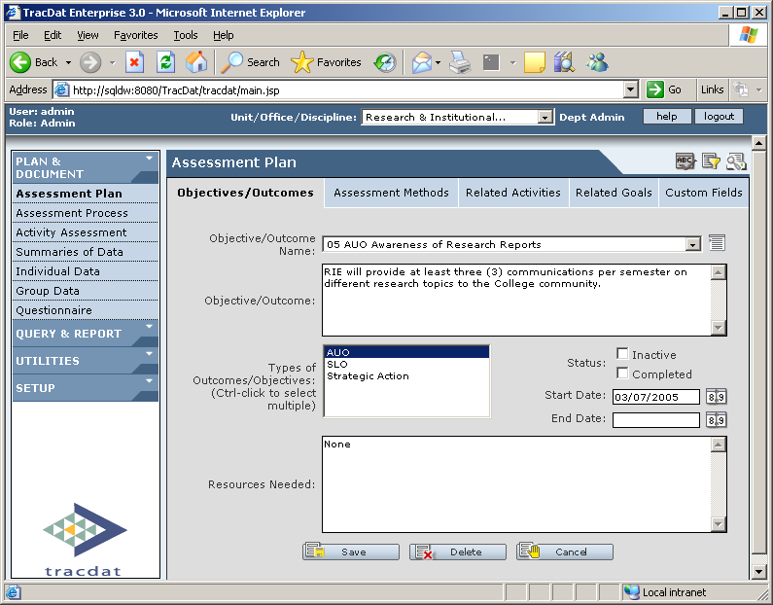

This page is intentionally left blank.

WORK SHEET TO ASSIST WITH RESOURCES REQUEST

  - Resources
Resources support achievement of goals. Requested by department/unit faculty/staff, they directly support plan implementation.

Note: Resources include: research support, budget allocation, training, instructional equipment, marketing, staffing (classified, faculty, and/or
management positions), facilities, etc.

Department/Unit Goal | Resources Needed? Yes No |  | If yes, please list resources needed

Information on this work sheet page is entered in the Objectives Tab in TracDat – See page 23 for directions.

Objectives Tab - Continued

7. Resources Needed (Section 6 of PIE): Type any resources needed including funds, space, and additional staff. Type “none” as needed.
8. Click SAVE
9. Repeat until all are entered

Related Goals Tab
- 1. Objective / Outcome / Strategic Action Name: Choose from drop-down box
- 2. Related to: Select the unit first and check all that apply (Note: This is exactly the same linkage as you did under Unit Setup, Related Goals Tab.) Then select Mt. San Antonio College and check all that apply.
- 3. Click SAVE.
- 4. Repeat the process for each objective / outcome / strategic action.

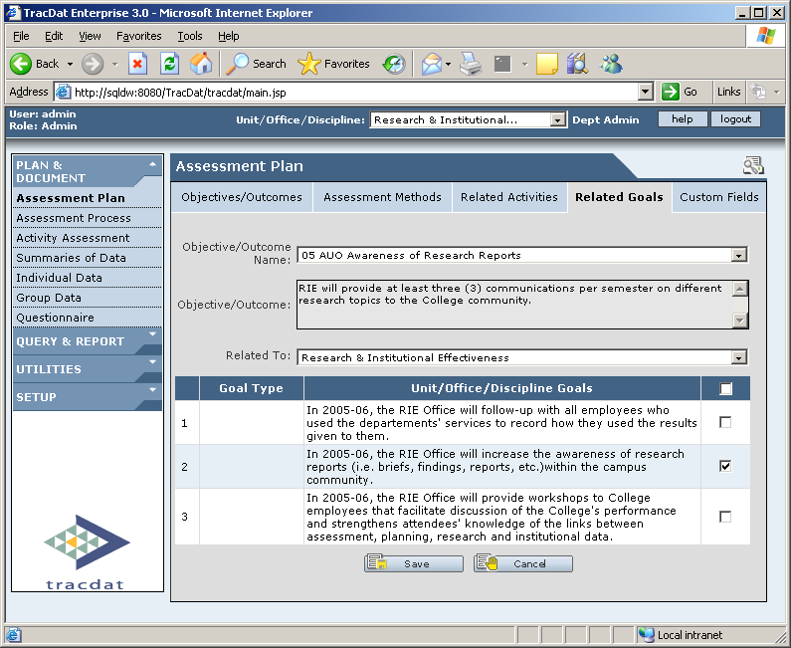

WORK SHEET TO ASSIST WITH WRITING MEANS OF ASSMENT

NOTE: Completing this Work Sheet is optional. See Rubric in Appendix A for evaluation of an SLO/AUO.
5. SLOs/AUOs SLOs/AUOs are a means of evaluating and validating area/program effectiveness. Created and assessed by department /unit faculty/staff, they can inform planning.
Note: Student Learning Outcomes (SLOs) are expressed in statements of what students will be able to think, know, do, or feel because of a given educational experience. The purpose of this assessment process is to improve student learning.
5A.
Intended Outcomes (SLOs) | Means of Assessment  and Criteria for Success | Summary of Data  Collected | Use of Results
 |  | See Summary of Data Tab (Page 31 of TracDat Guide) | See Use of Results and Follow-Up Tab (Page 34 of TracDat Guide)

Most areas will complete either 5a or 5b, but you may complete both if they apply.

Note: Administrative Unit Objectives (AUOs) are expressed as statements of what clients experience, receive, or understand as a result of a given service. The purpose of this assessment process is to improve the unit’s service.
5B.
Intended  Objectives (AUO’s) | Means of Assessment  and Criteria for Success | Summary of Data  Collected | Use of Results
 |  | See Summary of Data Tab (Page 31 of TracDat Guide) | See Use of Results and Follow-Up Tab (Page 34 of TracDat Guide))

WORK SHEET (CONTINUED)

Everyone please complete 5c

5C. Goal Implementation
Goal implementation is a non-evaluative process necessary to achieve the area goals. Determined by faculty/staff, goal implementation facilitates planning.
 | Department/Unit Goal (Strategic Action) | Responsible Parties | Implementation Timeline | Status of Implementation
 |  |  |  | Planning | Implementing | Completed
 |  |  |  | See Summary of Data Tab (Page 31 of TracDat Guide) | See Summary of Data Tab (Page 31 of TracDat Guide) | See Use of Results and Follow-Up Tab (Page 34 of TracDat Guide)

Information on this work sheet page is entered in the Assessment Methods Tab in TracDat – See page 27 for directions.

Assessment Method Tab

- 1. Objective / Outcome / Strategic Action Name: Choose your first objective / outcome / strategic action from the drop-down box.
- Note: If complete - Strategic Action Plans MUST be detailed on the Summary of Data screen (Page XX)
- 2. Assessment Method: Enter the Means of Assessment i.e. survey, focus group, test etc. – section 5A or 5B or 5C on the PIE form.
- 3. Order: Order the measures in numerical order (if you do not enter a number the system will place the measures in the order you entered them into the system)
- 4. Criterion: Enter the Criteria for Success – section 5A or 5B on the PIE form.
- 5. Timeframe: Enter the assessment schedule (frequency of assessment, when) – was part of the Means of Assessment / Criteria for Success section 5A or 5B on the PIE form and Timeline from section 5C of the PIE form.
6. Responsible Person – Type in the name of the person responsible for this item.
- 7. Assessment Tool: Click on the “Add Document Link” and attach measurement file or webpage (example: rubrics, survey, etc.)
- 8. Click SAVE.
- 9. Repeat the process for each objective / outcome / strategic action.

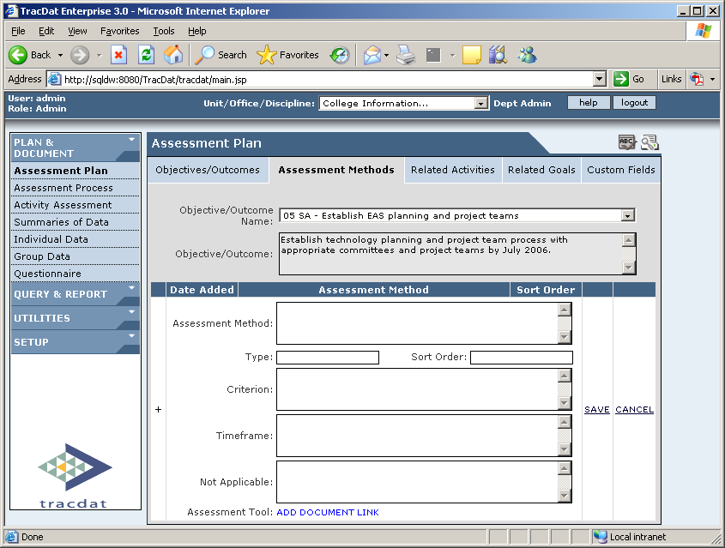
STORE ASSESSMENT DOCUMENTS HERE.

ASSESSMENT RESULTS IN TRACDAT

This section provides step-by-step instructions for recording results of assessment into TracDat.

Steps To Summary of Data
- 1. Plan and Document Tab: Select “Summaries of Data”
- 2. Select Summary of Data Tab
3. Select “Add New” from the
drop down menu
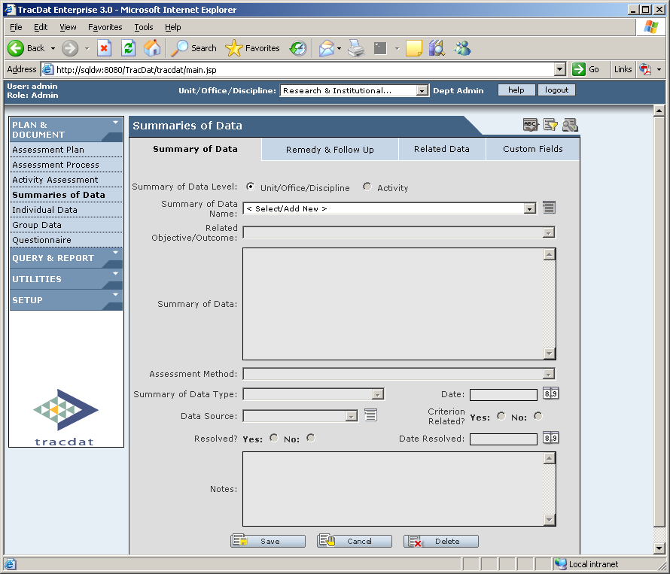

WORK SHEET TO ASSIST WITH WRITING SUMMARY OF DATA COLLECTED

NOTE: Completing this Work Sheet is optional. See Rubric in Appendix A for evaluation of an SLO/AUO.
5. SLOs/AUOs SLOs/AUOs are a means of evaluating and validating area/program effectiveness. Created and assessed by department /unit faculty/staff, they can inform planning.
Note: Student Learning Outcomes (SLOs) are expressed in statements of what students will be able to think, know, do, or feel because of a given educational experience. The purpose of this assessment process is to improve student learning.
5A.
Intended Outcomes (SLOs) | Means of Assessment  and Criteria for Success | Summary of Data  Collected | Use of Results
 |  |  | See Use of Results and Follow-Up Tab (Page 34 of TracDat Guide)

Most areas will complete either 5a or 5b, but you may complete both if they apply.
Note: Administrative Unit Objectives (AUOs) are expressed as statements of what clients experience, receive, or understand as a result of a given service. The purpose of this assessment process is to improve the unit’s service.
5B.
Intended  Objectives (AUO’s) | Means of Assessment  and Criteria for Success | Summary of Data  Collected | Use of Results
 |  |  | See Use of Results and Follow-Up Tab (Page 34 of TracDat Guide)

WORK SHEET (CONTINUED)

Everyone please complete 5c

5C. Goal Implementation
Goal implementation is a non-evaluative process necessary to achieve the area goals. Determined by faculty/staff, goal implementation facilitates planning.
 | Department/Unit Goal (Strategic Action) | Responsible Parties | Implementation Timeline | Status of Implementation
 |  |  |  | Planning | Implementing | Completed
 |  |  |  |  |  | See Use of Results and Follow - Up Tab (Page 34 of TracDat Guide)

Information on this work sheet page is entered in the Summary of Data Tab in TracDat – See page 31 for directions.

Summary of Data Tab
- 1. Summary of Data Name: Name the result (The name should be something that will trigger what it represents and should be short—TracDat will automatically insert into the result name the objective / outcome / strategic action it corresponds to and the date the result was entered once the result is saved.)
- 2. Related Objective/Outcome: Choose from drop-down box the objective/outcome/strategic action which corresponds to the result.
- 3. Summary of Data: Type a brief summary – column 4 from the Nichol’s five column model section 5A or 5B or status of implementation section 5C from the PIE form. (You may attach documents to the Related Data Tab containing the data) You must still have a summary even if you have attached the data.
- 4. Summary of Data Type:
  - a. If you meet your criterion or if the result was positive select “Distinction/Strength.”
  - b. If you did not meet your criterion or if the result was negative select “Problem/Limitation.”
5. Resolved:
- a. If a result was been labeled as a “Problem/Limitation,” but now has been corrected or if a result has met your criterion—RESOLVED
  - i. Enter date resolved
- b. If the objective has not been resolved or if you did not meet your criterion then it is NOT RESOLVED.
6. Date: Enter date result was obtained.
7. Notes: Additional notes can be entered into this box.
8. Click SAVE.
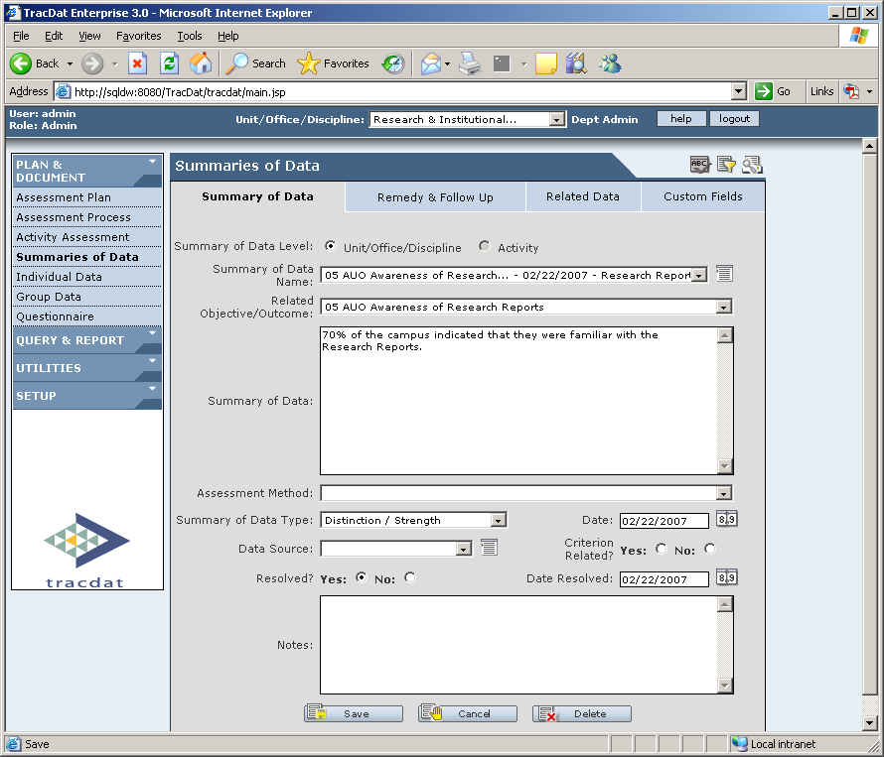

WORK SHEET TO ASSIST WITH WRITING USE OF RESULTS

NOTE: Completing this Work Sheet is optional. See Rubric in Appendix A for evaluation of an SLO/AUO.

5. SLOs/AUOs SLOs/AUOs are a means of evaluating and validating area/program effectiveness. Created and assessed by department /unit faculty/staff, they can inform planning.
Note: Student Learning Outcomes (SLOs) are expressed in statements of what students will be able to think, know, do, or feel because of a given educational experience. The purpose of this assessment process is to improve student learning.
5A.
Intended Outcomes (SLOs) | Means of Assessment  and Criteria for Success | Summary of Data  Collected | Use of Results

Most areas will complete either 5a or 5b, but you may complete both if they apply.

Note: Administrative Unit Objectives (AUOs) are expressed as statements of what clients experience, receive, or understand as a result of a given service. The purpose of this assessment process is to improve the unit’s service.
5B.
Intended  Objectives (AUO’s) | Means of Assessment  and Criteria for Success | Summary of Data  Collected | Use of Results

WORK SHEET (CONTINUED)

Everyone please complete 5c

5C. Goal Implementation
Goal implementation is a non-evaluative process necessary to achieve the area goals. Determined by faculty/staff, goal implementation facilitates planning.
 | Department/Unit Goal (Strategic Action) | Responsible Parties | Implementation Timeline | Status of Implementation
 |  |  |  | Planning | Implementing | Completed

Information on this work sheet page is entered in the Use of Results and Follow-Up Tab in TracDat – See page 34 for directions.

Use of Results and Follow-Up Tab

- 1. Summary of Data Name: Select from the drop-down list the result you want to add follow-up information.
- 2. Date: TracDat automatically inserts the current date.
- 3. Use of Results: Type the changes that will occur due to the observation.
4. Follow Up: Click “Follow Up” if you are adding information about a previously entered Remedy.
- 4. Click Save.
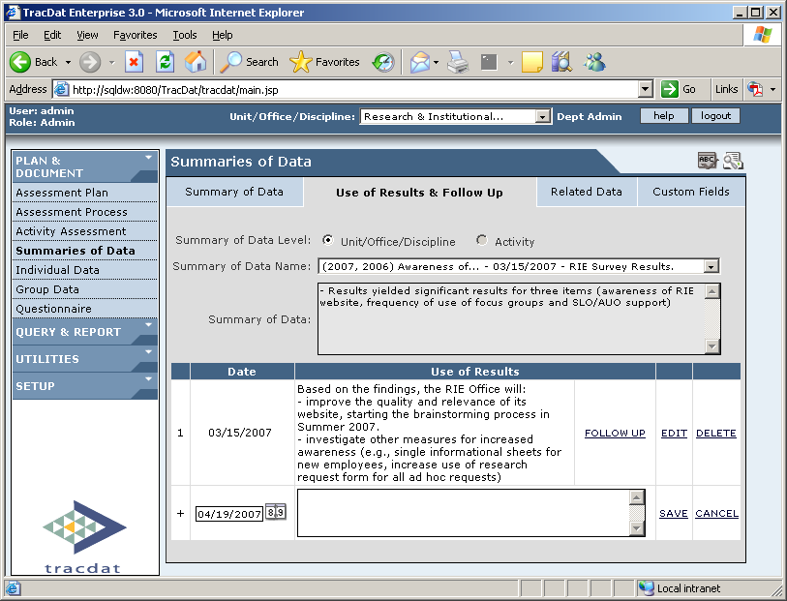

Related Data Tab

- 1. Summary of Data Name: Select from drop-down list this data name which you would like to attach data.
- 2. Type: URL, File, Group Date
  - a. URL- click the button to the left of URL and type the link in the box beside web link. Links should begin with http:
  - b. File- click the button to the left of FILE and click browse to upload file from your computer.
  - c. Group Data- This option will not be used.
- 3. Click SAVE.

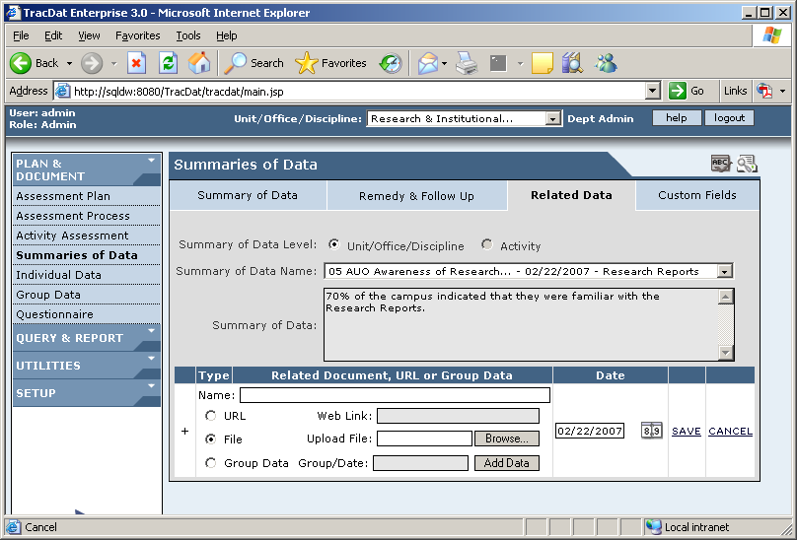

Store Research Results, Tabulations of survey data, and other documents here.

MAINTAINING A HISTORICAL RECORD IN TRACDAT

It is very important to maintain a historical record in TracDat. Departments changing their PIE plans will indicate obsolete objectives / outcomes / strategic actions are “Inactive,” DO NOT DELETE – mark them as “Inactive!”

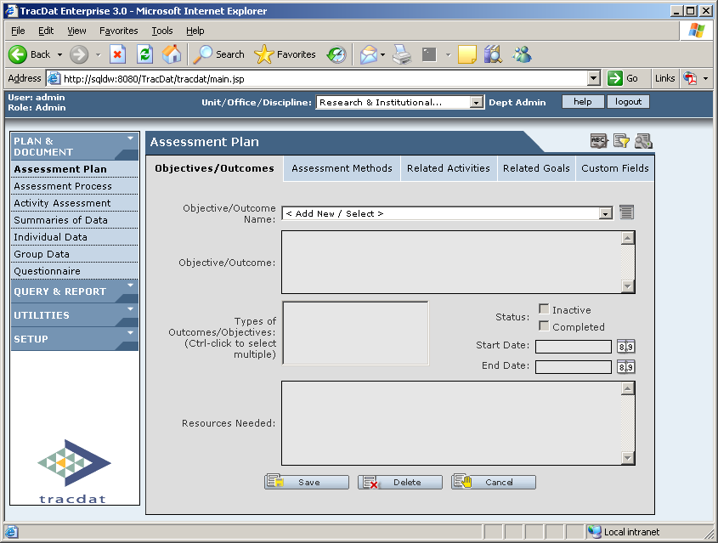

DO NOT DELETE ANY DATA

REPORTS

- From the Navigation Bar click on Query and Report
- Click on Standard Reports

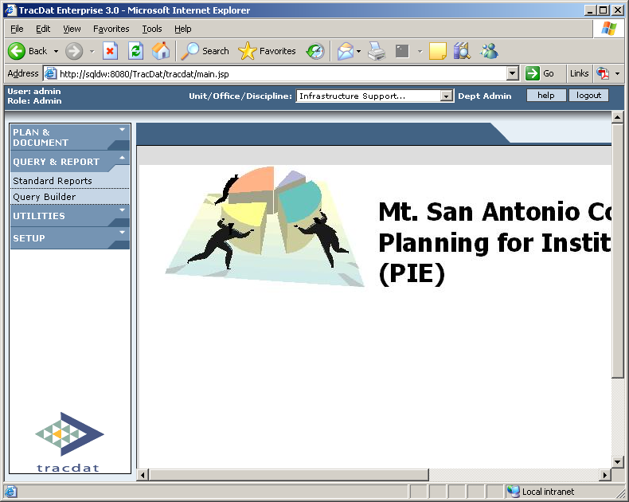

Standard Five Column Report

- Report Name: Select Institution Assessment
- Unit/Offices/Disciplines: Select the Unit/Office/Discipline name
- Goal Type: Select All
- Summary of Data Date: Leave Blank
- Click View Report

Report will open in a separate web browser.

