|  |
| --- |
| **Employee**  **Wellness Committee** |

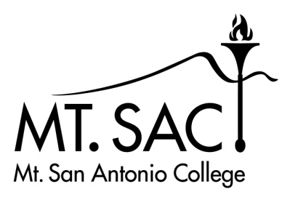

##### 

##### MEETING AGENDA

##### May 1, 2024

**Facilitator: Lorraine Jones and Lizette Henderson**

|  |
| --- |
| **Location: 720-2210G or Zoom Time: 2:00pm-3:30pm** |
| **Committee Members:**   |  |  |  |  |  |  | | --- | --- | --- | --- | --- | --- | | Lorraine Jones | Sandra Weatherilt |  | |  | | | Lizette Henderson | Chris Failla | Kevin Truong | |  | | | Marta Lopez | Norma Vizcarra | Vanessa Salazar (notes) | |  | | Stacy Lee  Lucy De Leon  Larry Silva | Joe Jennum  Art Gonzalez  Misty Kolchakian  Duetta Wasson |  |  | | |
| **AGENDA ITEMS:**  1. Welcome/Introduction  2. Review agenda  3. Review meeting notes from April 3, 2024  4. Add breathwork classes and St. Jude classes to the Wellness Center website  5. Next Wrap Up Party | May 30, 2024  6. Employee Wellness Fair | October 2024  7. Employee Counseling Center hosting- Send Silence Packing Exhibit | May 8, 2024 | 9:00am-4:00pm  8. Upcoming AED Defibrillator Training date?  9. Healthcare Preventive Incentives  10. Committee member updates |
|  |

**Employee Wellness Committee upcoming meeting:**

June 5, 2024

**Future Agenda Items:**