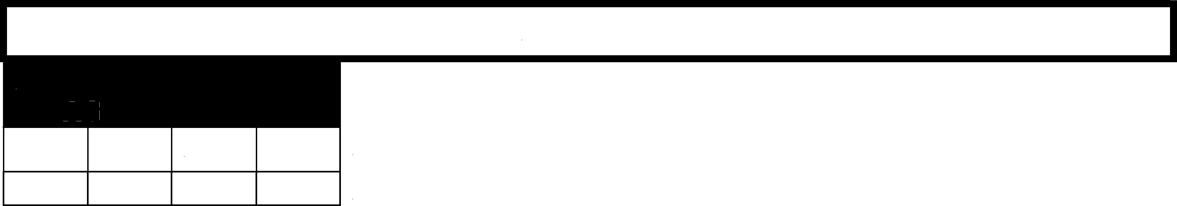

L.2: MUTUAL AGREEMENT
Adjunct Prob. Regular Dept.
Chair

X X X X

2022-2025 FACULTY CONTRACT

- Appendix L.2: Petition for Mutual Agreement■
■ Mt. San Antonio College■

Instructions: To be completed in cases where mutual agreement is required by contract and has not been reached between the professor and the division dean or designated educational administrator.
Name:Click or tap here to enter text.
Email:Click or tap here to enter text. Phone:Click or tap here to enter text.
Division:Click or tap here to enter text. Department:Click or tap here to enter text.
Contract Mutual Agreement Reference:Click or tap here to enter text.
Clearly describe the remedy you seek in resolution of this request for mutual agreement.:Click or tap here to enter text.
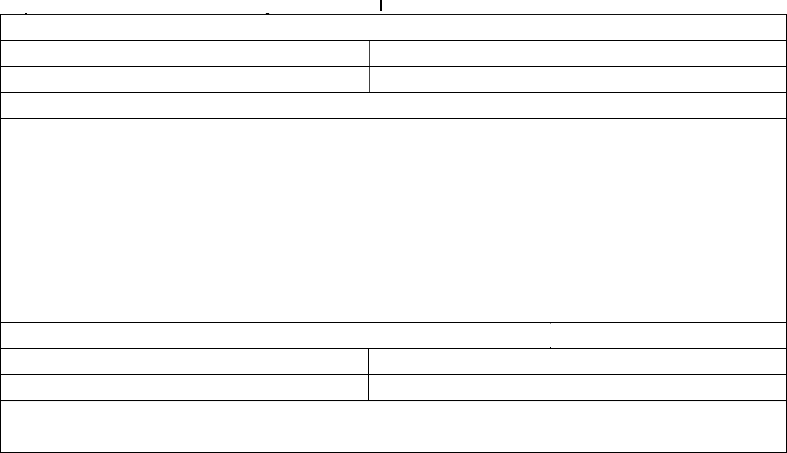

Signature: Click or tap here to enter text. Click or tap to enter a date.
Date:
Date:

Resolved:Click or tap here to enter text. Click or tap to enter a date.
Not Resolved:Click or tap here to enter text. Date:Click or tap to enter a date.
The District will provide the filing part and the Faculty Association with written documentation of the informal meeting within seven (7)

working days of the meeting.

