
We are in the final week of the semester – Week 16!

As we close out the spring semester, I want to express our sincere appreciation from the Office of Instruction and the Instructional Leadership Team for the incredible work you do to support our students, each other, and the mission of Mt. SAC. Your dedication, creativity, and support have made a meaningful difference, from the classroom to committee meetings and everything in between. We are grateful for you. With grades wrapping up and summer just around the corner, we hope you take time to step away, recharge, and enjoy a well-deserved break.
In light of this past weekend’s ICE activity, immigration raids, and the deployment of the National Guard in Los Angeles, Dr. Garcia offered words of care and clarity to our Mt. SAC community (email message below). She acknowledged the fear and pain these events have caused, particularly for undocumented students, students from mixed-status families, and others directly impacted. Dr. Garcia reaffirmed Mt. SAC’s commitment to equity, inclusion, and the legal protections outlined in Senate Bill 54 and Assembly Bill 21, including the assurance that our campus police do not and will not collaborate with ICE. Her message also highlighted the support available through the DREAM Program and campus services. Dr. Garcia’s message is a reminder to take care of ourselves and one another during this difficult time. Mt. SAC remains committed to living out our mission, vision, and core values and to being a place where every student and employee feel safe, supported, and seen.
This week’s Monday Minute Topics:
- Dr. Garcia's Message of Care
- Dream Center: Supporting Undocumented Students in Uncertain Times
- Mt. SAC 2025 Commencement Ceremony: Sign-In Update
- How Can You Help With Final Exams Week and Final Grades: Providing Flexibility This Week
- Spring 2025 Final Grades
- New Legislation Supporting LGBTQIA+ Community at Mt. SAC
- The Learfield and Ron Case Awards: Mt. SAC Athletics Program Recognition
- Temporary Walkway Closures for ADA-Compliant Walkway Construction (June 16 – August 15)
- Your Feedback Requested: The Monday Minute
- Resources and Important Dates

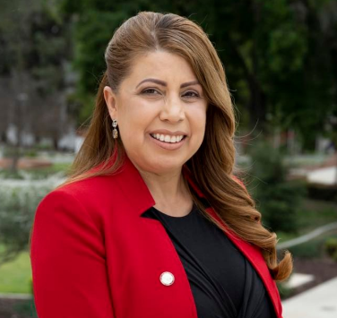 | A Message of Care: Dr. Garcia  Dr. Garcia shared this message earlier this morning:  Dear Mt. SAC Family,  I hope you are well. Thinking of you and wishing safety and wellness for you and your loved ones. In light of recent news regarding increased Immigration and Customs Enforcement (ICE) activity, immigration raids, and the federal activation of the National Guard in Los Angeles in response to protests over the weekend, I want to take a moment to speak from the heart—and to reassure our entire campus community that you belong here, and you are cared for deeply. Additionally, I am sharing Chancellor Christian’s communication below.  For many, we recognize these weekend’s activities may have caused anxiety, fear, and uncertainty—especially for our undocumented students, students from mixed-status families, and others who may already feel vulnerable. Please know you are not alone, and you are deeply cherished by this community, your extended family.  Regardless of your background, Mt. SAC’s commitment to equity and justice for all students is steadfast and shared by our Board of Trustees and campus community. We are united in our mission to create an inclusive and empowering educational environment, where every student—regardless of immigration status, race, religion, gender identity, sexual orientation, or background—feels a true sense of belonging, can thrive, and succeed.  Since its enactment, Mt. SAC will continue to honor and uphold the protections of our students provided under Senate Bill 54 (2017) and Assembly Bill 21 (2017). These important California laws prevent local law enforcement and community college police departments from using resources to investigate, detain, or report individuals to federal immigration authorities. This means that under California State law Mt. SAC Campus Police do not—and will not—collaborate with ICE in immigration enforcement. Any personally identifiable information related to immigration status is kept strictly confidential and will only be shared if legally required by a judicial order. (Resources: Legal Advisory: California and its Community Colleges Remain Sanctuary Jurisdictions and Undocumented Student Data Privacy).  We will continue to pledge full support to our undocumented students through the following actions:  - Maintaining the DREAM Program as a safe and supportive resource hub;  - Providing secure spaces for counseling, legal advice, academic support, and assistance with completing the California Dream Act;  - Upholding student privacy and protecting personal information;  - Ensuring professional development for staff to provide culturally competent support; and  - Collaborating with community partners to offer legal, medical, and mental health support.  We acknowledge the heavy emotional weight that many are carrying. Please take time to care for yourselves and lift each other during these traumatic times. We encourage all students to connect with our available Student Services, including our Behavioral Health Services and the DREAM Program, where you will find staff ready to support you with compassion and care.  Mt. SAC is more than a campus—it is a community grounded in love, equity, and hope. Let us continue to be a source of strength for one another. Thank you for your courage, your commitment to your education, and the education of all students at Mt. SAC.  With care and concern,  Dr. Martha Garcia
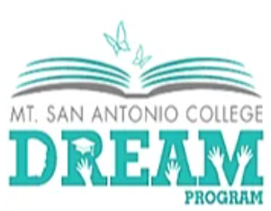 | Dream Center: Supporting Undocumented Students in Uncertain Times  In one of the episodes of the Mt. SAC Podcast this spring, Dream Center Supporting Undocumented Students in Uncertain Times #209, features Dario Fernandez, Director of the DREAM Center, discussing the challenges undocumented students and students from mixed-status families face, along with ways the campus community can support them. The DREAM Center provides critical support, including financial aid guidance, legal resources, and counseling to help students navigate these barriers.  We can help by staying informed, sharing vetted resources, and providing an inclusive campus environment. The DREAM Center’s Know Your Rights website offers valuable information, including legal resources, workshops, and preparedness plans which the campus community is welcome to share with students. Also, the Know Your Rights! Know What to Do flyer provides detailed guidance on responding to such situations.  On Tuesday, June 10, at 2 pm, will be a Carecen College Legal Services Zoom presentation. Attendance requires participants to register prior to the webinar. Additional information can be found on the Carecen Zoom Presentations for Spring 2025 website located on the DREAM Center’s Know Your Rights website.  Please contact Dario Fernandez, Director of the DREAM Center, if you have any questions.  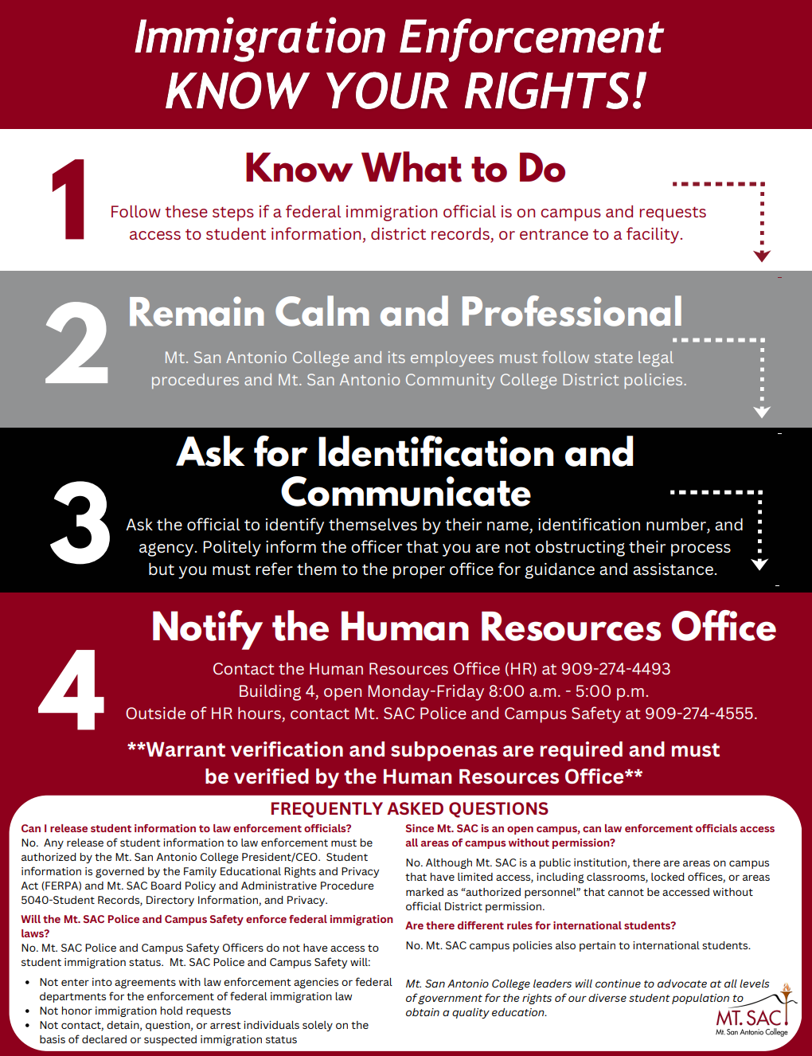
 | Mt. SAC 2025 Commencement Ceremony: Sign-In Update  Laura Martinez shared this email last week about a new option to Sign-In at Commencement:  I am excited to announce that, in partnership with Technical Services, we will utilize their electronic ticketing system to check in all full-time faculty! This means you no longer need to wait in line to sign the “official Commencement book.” Instead, full-time faculty will receive an email on Thursday, June 12, from commencement@mtsac.edu or tickets@mtsac.edu. In the email, a link will provide access to your digital ticket. Tickets can be saved to your Apple Wallet or Google Wallet. If you do not receive an email, please check your spam folder.  At Commencement, faculty will now “check in” by having their ticket scanned at any of the security screening entry points. Faculty who are unable to access their ticket will be allowed entry at the security checkpoints if they have their regalia. Any full-time faculty member who does not have their ticket or experiences any issues can stop by the faculty check-in canopy to sign in.  This new system will reduce your wait time and not take away from your focus on celebrating our students’ success!  Please email Laura Martinez (lmartinez@mtsac.edu) if you have any questions.
 | How Can You Support Your Students During Finals Week: Providing Flexibility This Week  In light of the uncertainty many students and employees are experiencing due to this weekend’s events, we encourage you to extend flexibility and support during finals week.  Options such as working individually with students on final exams, considering an Incomplete grade, or referring students to a counselor to discuss an Emergency Withdrawal (EW), if appropriate, can provide needed relief. Your care and responsiveness can make a meaningful difference during this uncertain time.  Working with Students Experiencing Extenuating Circumstances Due to the Current Events on a Case-by-Case Basis. Faculty are encouraged to work with these students on a case-by-case basis to identify appropriate options that support their ability to complete final exams. This may include offering a make-up exam or, when possible, providing the exam in an online format to accommodate individual circumstances. Thoughtful flexibility can help students navigate this challenging time while maintaining academic integrity.  Incomplete Grades. A student may request an Incomplete or the professor may initiate the petition on behalf of the student who is currently passing the class under the following circumstances: verifiable illness or emergency or verifiable work conflict. Incompletes may only be issued for requirements missed commencing the fourteenth (14) week of a regular semester class or after 85% of a short-term or summer or winter intersession class. Re-enrollment in the same course for purposes of making up the Incomplete is prohibited. The petition is subject to the approval of the professor. If granted, the student must complete all outstanding course requirements stipulated by the professor within one year, or the Incomplete will become a letter grade assigned by the professor.(2024-25 catalog addendum, p. 30. AP 4230 Grading and Academic Record Symbols):  Excused Withdrawal (EW). A professor can award an EW (Excused Withdrawal) only when a student is permitted to withdraw from a course(s) due to specific events beyond the control of the student affecting their ability to complete a course(s) and may include a job transfer outside the geographical region, an illness in the family where the student is the primary caregiver when the student is incarcerated in a California State Prison or county jail when the student is the subject of an immigration action or other extenuating circumstances such as the current events in the Los Angeles area. Upon verification of these conditions and consistent with the district’s required documentation substantiating the condition, an excused withdrawal symbol may be assigned at any time after the period established by the governing board during which no notation is made for withdrawals.  The “EW” shall not be counted in progress probation and dismissal calculations or toward the number of permitted withdrawals or counted as an enrollment attempt. A student may petition for the EW by submitting a Petition for Exceptional Action along with documentation to the Admissions and Records Office. Effective Spring 2024, students can request an EW without added documentation (i.e. rationale/justification for the request). Students have until the last day of instruction to request an EW. EWs are not available for prior terms. (2024-25 catalog addendum, p. 31. AP 4230 Grading and Academic Record Symbols).  Connect with Your Dean. In circumstances in which you would like to discuss other options regarding your final exam, please connect with your Dean or Division Office. For example, if you are considering adjustments to your final exam, such as shifting an in-person exam to an online format for the entire class, please reach out to your Dean or Division Office to discuss. These changes must be approved in advance to ensure consistency with college processes and equitable support for students. Your Dean or Division Office is also a resource if you need help navigating unique student situations or determining the most appropriate options during this time.
 | Spring 2025 Final Grades  As we continue to support students through final exams this week, please remember that final grades are still due by 8 p.m. on Tuesday, June 17. If you anticipate any delays or encounter challenges submitting grades by the deadline, please contact your Dean or Division Officee as soon as possible to discuss your situation.  The Admissions and Records Office will initiate the "grade roll" or "batch" process of all Spring grades in Banner immediately following the 8 pm deadline on Tuesday.  We thank you for submitting your grades on or before Tuesday, June 17. Here are some reasons why students need their grades posted on time:  - Students need to know if they passed a pre-requisite course so they can register for the next course in a sequence.  - Students need to complete units aligned with the federal or state financial aid they have received.  - Our Veteran students may need proof of completion to receive veterans' benefits.  - Students send their transcripts to their transfer university, confirming they are ready to transfer in the upcoming semester.  - Students' wage increases, bonuses, or promotional opportunities depend on passing employer-approved courses or programs.  - Students must show satisfactory progress on their academic and/or progress probation status.  Below are some helpful resources for navigating the Grade Submission Process. Please get in touch with your Division Office if you have any questions or concerns.  - Who Do I Contact in My Division: Instruction, School of Continuing Education, or Student Services?  - Grade Changes and Incompletes  Once again, if you anticipate that your grade submission process may be delayed (after 8 p.m. on June 17), please immediately contact your Dean or Associate Dean.
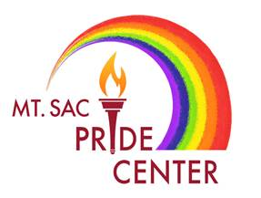 | New Legislation Supporting LGBTQIA+ Community at Mt. SAC  As part of statewide implementation of SB 1491, all California community colleges are now required to designate a campus point of contact to support the needs of LGBTQIA+ faculty, staff, and students. At Mt. SAC, the Director of the Pride Center, which is currently in recruitment, will serve as the point of contact. Over the coming months, procedures, training, and promotional strategies in compliance with the legislation will be developed and updates will be shared in the Fall Semester.  If you have any questions, please reach out to Dr. Eric Lara.
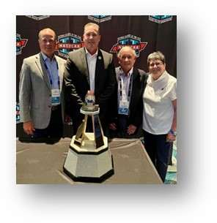 | The Learfield and Ron Case Awards: Mt. SAC Athletics Program Recognition  Over the weekend, the Mt. SAC Athletics Program was recognized with the prestigious Learfield Director’s Cup Award at the National Athletic Directors Meeting. The Learfield Director’s Cup Award is the nation’s most prestigious award in collegiate athletics and honors the top two-year college athletics program in the nation based on overall performance in national championship events. Mt. SAC last received this recognition in 2014, making this a remarkable achievement more than a decade later.  Mt. SAC Athletics also earned the Ron Case Cup Award presented by Daktronics and awarded by the National Alliance of Two-Year College Athletic Administrators (NATYCAA). This award recognizes the best two-year college athletics programs in California and Western United States. Named in honor of Ron Case, who led the award from its inception in 2004 through 2024, the award reflects sustained leadership in collegiate athletics. This is the twelfth consecutive honor and fifteenth overall for the Mt. SAC Athletics Program.  Congratulations to our student-athletes, coaches, classified professionals, and the entire athletics support team for these outstanding accomplishments!
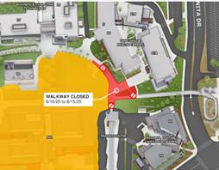 | Temporary Walkway Closures for ADA-Compliant Walkway Construction (June 16 – August 15)  On Friday, an email from Gary Gidcumb, Senior Manager of Construction Projects, announced the construction of a new ADA-compliant walkway connecting to the future Technology and Health Building. The following pathways will be temporarily closed from June 16, 2025, to August 15, 2025:  Bonita Bridge - Accessible Path Closure  The accessible path to Buildings 66, 67A, and 67B will be closed for construction. The main walkway will remain open. For accessible entry to these buildings, please contact ACCESS at (909) 274-4288 for assistance.  Temple Bridge - Pathway Closure  The pathway from the Transit Center / Gateway Parking Structure heading north into campus will be closed for construction.  We apologize for any inconvenience and appreciate your cooperation during this improvement project. Please contact Gary Gidcumb with any questions or concerns at (909) 274-5739 or ggidcumb@mtsac.edu.
 | Your Feedback Requested: The Monday Minute  As we close out the semester, we invite you to take a brief survey to help the Office of Instruction assess the Monday Minute. With just four quick questions, the survey is designed to gather your input on what is working, what could be improved, and how this communication can better support you. Your feedback will help us enhance how we share updates, highlight achievements, and keep our campus community informed.  The Monday Minute survey will remain open throughout the summer, so you can respond at your convenience. Thank you for taking a moment to share your thoughts.
 | Important Dates and Resources:  - Resource: Course Cancellation Protocol Final May 1 2025  - Summer 2025 Merging Canvas Course Shells Deadline: Monday, June 9, 2025  - Spring 2025 Finals Week: June 9 – June 15, 2025  - Mt. SAC Commencement:  - Friday, June 13, 2025  - Procession Line Up at 5:15 pm  - Ceremony Begins Promptly at 5:30 pm  - Spring 2025 Final Grades Due Date: Tuesday, June 17, 2025, at 8 pm  - Mt. SAC 2035: Review the draft and provide your feedback by Wednesday, June 11  - Summer 2025 Term Begins: June 23, 2025 (Monday)  - Fall 2025 Merging Canvas Course Shells Deadline: Monday, August 11, 2025  - Fall 2025 FLEX Day: August 22, 2025 (Friday) from 8 am – 3:30 pm  - Fall 2025 Term Begins: August 25, 2025 (Monday)  - 2025 – 2026 Academic Calendar  - Mt. SAC Calendar of Events
As you continue to support students through this challenging time, please know how much your care, flexibility, and presence matter. Your well-being is just as important as the support you give to others. Support is available through Mt. SAC’s Employee Counseling Center, Behavioral Health Services, and other campus resources.
Please continue to reach out to your Dean or Division Office to share your concerns and identify any assistance needed. We are here to support you.
Thank you,
Kelly Fowler

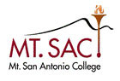 | Kelly Fowler, Ph.D.  Vice President of Instruction | Accreditation Liaison Officer  (she/her/hers)  kelly.fowler@mtsac.edu  (909) 274-5414  (909) 274-2955  Building: Building 414, Room: 2170  Mt. San Antonio College  1100 N. Grand Avenue  Walnut CA 91789  www.mtsac.edu

