JLP17 Complaining at a Restaurant (Chapter 12)
STOP: Before you begin this activity, open and follow recording instructions here.

Pair # _________

Partner A: ________________________________
Student ID: _______________________________
Instructor: ________________________________
Level: ______________ Date: ________________
Partner B: ________________________________
Student ID: _______________________________
Instructor: ________________________________
Level: ______________ Date: ________________

All links in this activity direct to the JLP Activities page on the LLC website. Find your activity number and click the drop down to find links to videos, audio, and/or websites used in this activity.

Section 1: Vocabulary Mastery
Instructions: Write the translation of the following words and phrases into Japanese. Try to use your book and your partner before using other materials or the internet. In the third column, draw a picture, write a note to yourself or put some kind of pronunciation guide for Japanese. Use the third column to help remember the word in Japanese.

Vocabulary | Translation | Notes/Pictures/Pronunciation Guide (anything to help you)
- Waiter
- Chef
- Menu
- Sweet
- Spicy
- Salty
- Sour
- Old
- Dirty
- Cold
- Hot
- noisy
- slow
- curry
- salad
- sushi
- ramen
- to make
- crowded
- to put in

Concept Check: Too Much
The helping verb ～すぎる can be used after adjectives and verbs to indicate too much of something. For instance, 食べすぎる would translate as “To eat too much.” ~すぎるcarries a negative connotation, so we can use it to complain or express our distaste of something.
- When using すぎる with -ru verbs, the final -ru is dropped and followed by すぎる.
  - Ex.食べすぎましたから、おなかがいたいです．My stomach hurts because I ate too much.
- When using -u verbs, the final u-sound changes to an i-sound and you add すぎる.
  - Ex.このウェイターは話(はな)しすぎます。This waiter talks too much.
It may also be used with i-stem and na adjectives.
- For i-stem adjectives, the -i is dropped and is followed by すぎる, such as わかすぎる (too young).
  - Ex. このスープはあつすぎます。This soup is too hot.
- For na adjectives, the adjective stays the same and is followed by すぎる, such as ふべんりすぎる (too inconvenient).
  - Ex. このレストランはしずかすぎます。This restaurant is too quiet.

Section 2: Restaurant Complaints
Instructions: Write a complaint using すぎる for each of the pictures below.

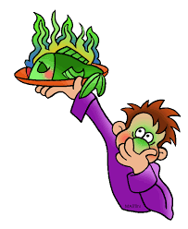
____________________________________________

____________________________________________
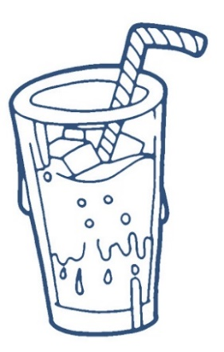
____________________________________________
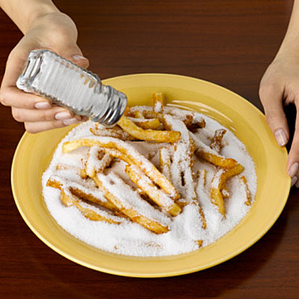
____________________________________________
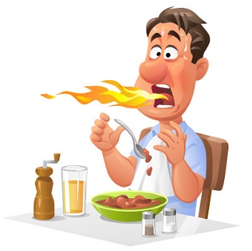
____________________________________________

____________________________________________

Section 3: Dialogue Creation
You and your friend decided to try out a new restaurant! Unfortunately, everything seems to be going wrong. Create a dialogue making complaints about the restaurant, service, food, etc.
Instructions: Use the space below to help create the conversation. The conversation should be 1.5-2.5 minutes. You will record this dialogue in the next section. Ask for help if necessary.
Speaker1:
Speaker 2:
Speaker 1:
Speaker 2:
Speaker1:
Speaker 2:
Speaker1:
Speaker 2:
Speaker 1:
Speaker 2:

Section 4: Record and Save Your Recording
Instructions: Perform the dialogue you created with your partner. Make sure you do not end your Zoom meeting until you have performed your dialogue with your partner.

