JLP19 Going to a Party (Chapter 13)
STOP: Before you begin this activity, open and follow recording instructions here
Pair # _________

Partner A: ________________________________
Student ID: _______________________________
Instructor: ________________________________
Level: ______________ Date: ________________
Partner B: ________________________________
Student ID: _______________________________
Instructor: ________________________________
Level: ______________ Date: ________________

All links in this activity direct to the JLP Activities page on the LLC website. Find your activity number and click the drop down to find links to videos, audio, and/or websites used in this activity.

Section 1: Vocabulary Mastery
Instructions: Write the translation of the following words and phrases into Japanese. Try to use your book and your partner before using other materials or the internet. In the third column, draw a picture, write a note to yourself or put some kind of pronunciation guide for Japanese. Use the third column to help remember the word in Japanese.
Vocabulary | Translation | Notes/Pictures/Pronunciation Guide (anything to help you)
- Party
- To sing
- To dance
- Karaoke
- To bring (a thing)
- To bring (a person)
- To invite
- Pizza
- Cake
- Soda
- Ice cream
- Balloons
- To talk/ to chat
- To drive
- To walk
- Game console
- Boardgame
- Videogame
- Saturday
- Weekend

Concept Check: Potential Verbs
To say that someone can do or knows how to do something in Japanese, we use potential verbs. Watch the video below to review how to conjugate verbs into potential form.
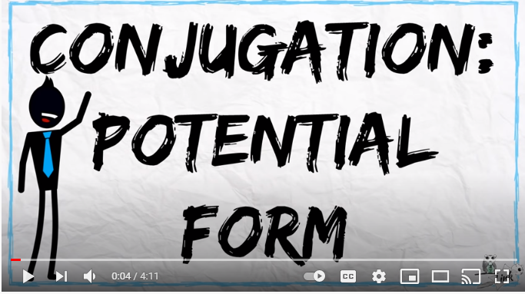

Section 2: Can You Do This?
Instructions: Respond to the following questions using potential verbs.
- 土曜日(どようび)にパーティーにいきますか。
- カラオケをうたいますか。
- おどりますか。
- パーティーにケーキをもってきますか。
- ゲーム機(き)をもってきますか。
- パーティーにうんてんしますか。
- たくさんのともだちをしょうたいしますか。
- ともだちとしゃべりますか。
- たくさんソーダをのみますか。
- ビデオケームをしますか。

Section 3: Dialogue Creation
A mutual friend invites you both to a party. Using potential form, discuss whether you can go, what you are able to bring, how you might get there, and what you might do at the party.
Instructions: Use the space below to help create the conversation. The conversation should be 1.5-2.5 minutes. You will record this dialogue in the next section. Ask for help if necessary.
Speaker1:
Speaker 2:
Speaker 1:
Speaker 2:
Speaker1:
Speaker 2:
Speaker1:
Speaker 2:
Speaker 1:
Speaker 2:

Section 4: Record and Save Your Recording
Instructions: Perform the dialogue you created with your partner. Make sure you do not end your Zoom meeting until you have performed your dialogue with your partner.

