JLP22 Christmas Time (Chapter 14)
STOP: Before you begin this activity, open and follow recording instructions here.

Pair # _________

Partner A: ________________________________
Student ID: _______________________________
Instructor: ________________________________
Level: ______________ Date: ________________
Partner B: ________________________________
Student ID: _______________________________
Instructor: ________________________________
Level: ______________ Date: ________________

All links in this activity direct to the JLP Activities page on the LLC website. Find your activity number and click the drop down to find links to videos, audio, and/or websites used in this activity.

Section 1: Vocabulary Mastery
Instructions: Write the translation of the following words and phrases into Japanese. Try to use your book and your partner before using other materials or the internet. In the third column, draw a picture, write a note to yourself or put some kind of pronunciation guide for Japanese. Use the third column to help remember the word in Japanese.
Vocabulary | Translation | Notes/Pictures/Pronunciation Guide (anything to help you)
- Christmas
- Parents
- Friends
- Older brother
- Older sister
- Younger brother
- Younger sister
- Winter scarf
- Stuffed animal
- Sweater
- Comic book
- Hat
- Necktie
- Necklace
- Socks
- Candle
- Gift card
- To receive
- To give (to others)
- To give (me)

Concept Check: あげる・くれる・もらう
In Japanese, there are two verbs that can be used to describe “to give.” These verbs are あげる and くれる.
Which one we use depends on who is the giver, who is the receiver, and what their relationship to each other is. When we want to phrase a sentence with the receiver as the subject, we need to use the verb もらう. Watch the video below to review when to use あげる, くれる, and もらう.
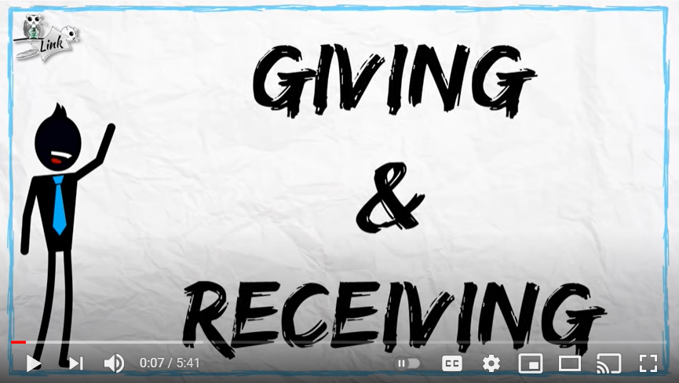

Section 2: Activity
Instructions: It’s time for your annual Christmas gift exchange! Write the names of the friends you are exchanging gifts with in the blanks below. Choose your own items and describe who gave what to whom using あげる /くれる.
- _______________ 私
- _______________ 私
- _______________ 私
- _______________ 私
- _______________ 私
- _______________ 私


- ________________________________________________________________________________________
- ________________________________________________________________________________________
- ________________________________________________________________________________________
- ________________________________________________________________________________________
- ________________________________________________________________________________________
- ________________________________________________________________________________________

Section 3: Dialogue Creation
You meet up with your friend at the mall to go Christmas shopping. Tell each other what you plan on giving to your family members (parents, siblings, grandparents, uncles/aunts).
Instructions: Use the space below to help create the conversation. The conversation should be 1.5-2.5 minutes. You will record this dialogue in the next section. Ask for help if necessary.
Speaker1:
Speaker 2:
Speaker 1:
Speaker 2:
Speaker1:
Speaker 2:
Speaker1:
Speaker 2:
Speaker 1:
Speaker 2:

Section 4: Record and Save Your Recording
Instructions: Perform the dialogue you created with your partner. Make sure you do not end your Zoom meeting until you have performed your dialogue with your partner.

