JLP29 Living with a Roommate (Chapter 21)
STOP: Before you begin this activity, open and follow recording instructions here.

Pair # _________

Partner A: ________________________________
Student ID: _______________________________
Instructor: ________________________________
Level: ______________ Date: ________________
Partner B: ________________________________
Student ID: _______________________________
Instructor: ________________________________
Level: ______________ Date: ________________

All links in this activity direct to the JLP Activities page on the LLC website. Find your activity number and click the drop down to find links to videos, audio, and/or websites used in this activity.

Section 1: Vocabulary Mastery
Instructions: Write the translation of the following words and phrases into Japanese. Try to use your book and your partner before using other materials or the internet. In the third column, draw a picture, write a note to yourself or put some kind of pronunciation guide for Japanese. Use the third column to help remember the word in Japanese.
Vocabulary | Translation | Notes/Pictures/Pronunciation Guide (anything to help you)
- Roommate
- Apartment
- Bedroom
- Livingroom
- Kitchen
- Bathroom
- Precious; Valuable
- Messy; Disorganized
- To complain
- To make dirty
- To clean
- To break
- To clean
- To do laundry
- To wash dishes
- To be noisy
- To be quiet
- To smoke
- To cook
- To steal

Concept Check: ～てほしい／～ないでほしい
To describe what you want someone to do or not to do in Japanese, you can use ～てほしいor ～ないでほしい.
When using ～てほしい, you will conjugate the verb into て-form and use the particleに to show who you want to do the action.
Ex. 私はルームメートに皿(さら)を洗(あら)ってほしいです。 I want my roommate to wash the dishes.
The format is similar when using ～ないでほしい, however you must remember to conjugate the verb into the negative form.
Ex. 私はルームメートにうるさくしないでほしいです。I do not want my roommate to be noisy.

Section 2: What Makes a Good Roommate?
Instructions: Look at the pictures below and decide if you think it is something you want a good roommate to do or not. Write your answers in the space provided using ～てほしいor ～ないでほしい.
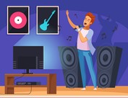
____________________________________________
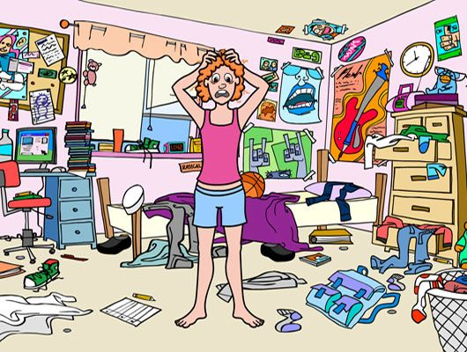
____________________________________________

____________________________________________
____________________________________________

____________________________________________

___________________________________________
Section 3: Dialogue Creation
You and your friend are putting out an ad for a new roommate. Take turns discussing what you would like an ideal roommate to do or not do.
Instructions: Use the space below to help create the conversation. The conversation should be 30 seconds to 1.5 minutes for beginning levels and longer for upper levels. You will record this dialogue in the next section. Ask for help if necessary.
Speaker1:
Speaker 2:
Speaker 1:
Speaker 2:
Speaker1:
Speaker 2:
Speaker1:
Speaker 2:
Speaker 1:
Speaker 2:

Section 4: Record and Save Your Recording
Instructions: Perform the dialogue you created with your partner. Make sure you do not end your Zoom meeting until you have performed your dialogue with your partner.

