KLP02 Korean Language Class
STOP: Before you begin this activity, open and follow recording instructions for online activities or on-campus activities.

Pair # __________

Partner A: ________________________________
Student ID: _______________________________
Instructor: ________________________________
Level: ______________ Date: _________________
Partner B: ________________________________
Student ID: _______________________________
Instructor: ________________________________
Level: ______________ Date: _________________

All links in this activity direct to the KLP Activities page on the LLC website. Find your activity number and click the drop down to find links to videos used in this activity.

Section 1: Vocabulary Mastery
Instructions: Write the translation of the following words and phrases into Korean. Try to use your book and your partner before using other materials or the Internet. In the third column, draw a picture, write a note to yourself or put some kind of pronunciation guide for the target language. Use the third column to help remember your target language.
Vocabulary | Translation | Notes/Pictures/Pronunciation Guide (anything to help you)
- Breakfast
- Library
- Restaurant
- Homework
- To eat
- To drink
- To know
- To be fun, interesting
- To meet
- To study
- To be delicious
- To be tired
- To be many, much
- Really
- Well
- Today
- What are you doing now?
- How is….?
- How are you doing these days?
- Just so-so.

Concept Check: SOV Structure
Unlike English, Korean is a verb or adjective final language. The verb or adjective comes at the end of a sentence or clause, while the subject and the object appear before the verb or adjective. It is important to remember that Korean is an SOV (Subject-Object-Verb) language NOT SVO. Make sure to include the object particle 을/를after an object.
Watch this the Concept Check Video to understand why Korean is SOV.
When creating an SOV sentence, you need to remember to include particles. It will be easier to remember this SOV structure like a formula: S이/가O을/를Verb 어요/아요.
A subject requires the subject particle 이/가. An object requires the object particle 을/를. A verb needs to come at the end and it needs to be conjugated into 어요/아요form.
Mike reads a book. (S=Mike V=reads O=book)
Mike a book reads. (S=Mike O=book V=reads) 마이크가 책을 읽어요.
Sophia eats breakfast. (S=Sophia V=eats O=breakfast)
Sophia breakfast eats. (S=Sophia O=breakfast V=eats) 소피아가 아침을 먹어요.
Yujin drinks coffee. (S=Yujin O=coffee V=drinks) 유진이 커피를 마셔요.
Adjective sentences also require the subject particle 이/가 and adjectives need to be conjugated in the 어요/아요form. Remember! There is no object in adjective sentences. Also adjective sentences answer questions such as “How is …?”
For example, you want to say “Coffee is delicious.” Coffee is the subject of your sentence so you need to add 이/가 and to be delicious needs to be conjugated into 어요/아요.
Coffee is delicious. 커피 맛있다 커피가 맛있어요.
The library is big. 도서관 넓다 도서관이 넓어요.

Section 2: Sentence Translation
Instructions: Take turns translating the following sentences into Korean. Then practice asking and answering the questions with your partner. Write down your partner’s answers in Korean. “How questions” require you to describe things, meaning they are going to be adjective sentences. “What do questions” require you to answer in SOV sentences because you are describing actions with objects.
*Remember: Do not to translate “you” in Korean. It is understood from the context.
- What are you doing?
____________________________________________________________________________
- What is Sophia doing?
____________________________________________________________________________
- What is Michael doing?
____________________________________________________________________________

- How are you doing these days?
____________________________________________________________________________
- How is your Korean class?
____________________________________________________________________________
- How is Korean food?
____________________________________________________________________________

Section 3: Ask Appropriate Questions
Instructions A: Look at the pictures and ask related questions like those you have just practiced in Section 2. Do you need to ask a “how” question or a “what do” question? Depending on which type of question is used, your answer will be either an adjective or an SOV.
Instructions B: Write down your questions and answers for each picture below. Remember to use the SOV structure with appropriate particles or adjective sentences.
Question 1:
Answer 1:

Question 2:
Answer 2:

Question 3:
Answer 3:
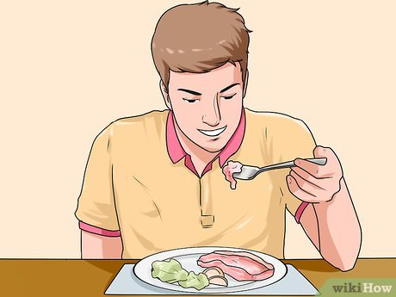
Question 4:
Answer 4:

Question 5:
Answer 5:

Question 6:
Answer 6:
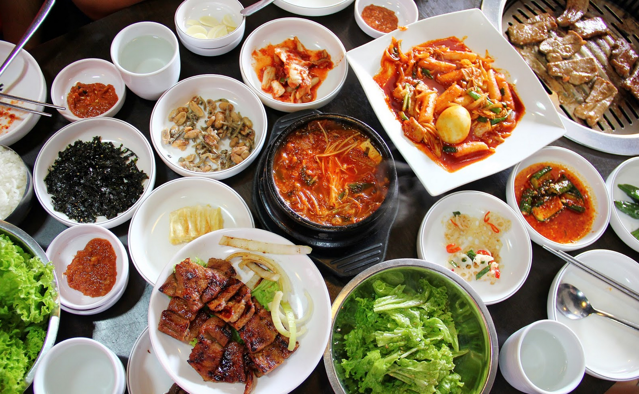

Section 4: What are you doing?
Part A: You run into your friend at the school cafeteria. You greet each other and ask how things are. Translate and practice the following conversation with your partner in Korean, filling in the blanks with your own information.
A:
Speaker 1: Hello, ____________ 씨?
Speaker 2: 어, Hello ____________씨. How are you these days?
Speaker 1: I’m doing well. What about you?
Speaker 2: I’m tired. How is your Korean class?
Speaker 1: It’s fun. What are you doing?
Speaker 2: I am doing my English homework.

Part B: You run into your partner in the library. Ask each other how things are. Then ask what he/she is doing. Make sure you use both an adjective sentence and an SOV sentence. Use the space below to help create the conversation. The conversation should be 30 seconds to 1.5 minutes. You will record this dialogue in the next section. Ask for help if necessary.
B:
Speaker 1:__________________________________________________________
Speaker 2: __________________________________________________________
Speaker 1: __________________________________________________________
Speaker 2: __________________________________________________________
Speaker 1: __________________________________________________________
Speaker 2: __________________________________________________________

Section 5: Record and Save Your Recording
Instructions: Perform the dialogue you created with your partner. Make sure you do not end your Zoom meeting until you have performed your dialogue with your partner.

