KLP03 College Campus
STOP: Before you begin this activity, open and follow recording instructions for online activities or on-campus activities.

Pair # __________

Partner A: ________________________________
Student ID: _______________________________
Instructor: ________________________________
Level: ______________ Date: _________________
Partner B: ________________________________
Student ID: _______________________________
Instructor: ________________________________
Level: ______________ Date: _________________

All links in this activity direct to the KLP Activities page on the LLC website. Find your activity number and click the drop down to find links to videos used in this activity.

Section 1: Vocabulary Mastery
Instructions: Write the translation of the following words and phrases into Korean. Try to use your book and your partner before using other materials or the internet. In the third column, draw a picture, write a note to yourself or put some kind of pronunciation guide for the target language. Use the third column to help remember your target language.
Vocabulary | Translation | Notes/Pictures/Pronunciation Guide (anything to help you)
- Bag
- Classroom
- Library
- School cafeteria
- Back, behind
- Outside
- Inside
- Front
- Bottom, below
- Beside
- Desk
- Clock, watch
- Photo
- Pen / pencil
- Lamp
- Bookstore
- Stuffed animal
- Woman
- Man
- Where is…?

Concept Check: 있다/없다 vs. 이다/아니다
Both 있다/없다and 이다/아니다 are translated into English as “to be/not to be” which can be confusing. Please remember 있다/없다 mean “to be (existence)” and “to not be (non-existence)” whereas 이다/아니다 are “to be (equal to)” and “to not be (not equal to).”
You can watch the Concept Check Video for clarification.
To avoid confusion, remember to use 이다 (to be) / 아니다 (to not be) in N1=N2 and N1≠N2 (Refer to Lesson 1).
For existence 있다/없다, you need to look for the particle 에. If you see the particle 에 in a sentence, you know it means “existence and non-existence.”
Q: 책이 어디에 있어요? (Where is the book?)
A: 책이 책상 위에 있어요. (The book is on top of the desk.)
The sentence structure for location requires the following elements:
Subject 이/가 | Location | Position noun | Location particle 에 | 있어요
1. 의자가 | 책상 | 뒤 | 에 | 있어요
2. 서점이 | 도서관 | 앞 | 에 | 있어요
- The chair is behind the desk.
- The bookstore is in front of the library.
있다/없다 has a second meaning, “to have/to not have” to indicate possession and non-possession. The subject particle 이/가 있어요/없어요is used when you want to say “I have” or “I don’t have.”
책이 있어요. (I have a book.)
스티브는 여자 친구가 있어요. (Steve has a girl friend.)
마이클은 여자 친구가 없어요. (Michael doesn’t have a girlfriend.)
오늘 한국어 수업이 없어요. (I don’t have a Korean class today.)
*Remember to look out for particles 에 있어요/없어요 or 이/가 있어요/없어요 to differentiate between “existence/non existence” and “possession/non possession”.

Section 2: Sentence Translation
Instructions: Take turns translating the following sentences into Korean. Then practice asking and answering the questions with your partner. Write down your partner’s answers in Korean.
- Where is the library?
____________________________________________________________________________
- Where is Mt. San Antonio College?
____________________________________________________________________________
- Do you have a Korean friend?
____________________________________________________________________________
- Do you have your friend’s photo?
____________________________________________________________________________
- Where is the bag?
____________________________________________________________________________
- Are you in the classroom?
____________________________________________________________________________

Section 3: Activity
Instructions: Based on the following picture, choose 8 things and ask where they are. Write down your questions and answers for each item.
Watch the Section 3 Video to help you practice.

- ________________________________________________________________________________________________
________________________________________________________________________________________________
- ________________________________________________________________________________________________
________________________________________________________________________________________________
- ________________________________________________________________________________________________
________________________________________________________________________________________________
- ________________________________________________________________________________________________
________________________________________________________________________________________________
- ________________________________________________________________________________________________
________________________________________________________________________________________________
- ________________________________________________________________________________________________
________________________________________________________________________________________________
- ________________________________________________________________________________________________
________________________________________________________________________________________________
- ________________________________________________________________________________________________
________________________________________________________________________________________________

Section 4: Where is the classroom?
Part A: You run into your friend on campus. Say hello to each other first. Translate and practice the following conversation with your partner in Korean.
A:
Speaker 1: Hello, ____________ 씨.
Speaker 2: 어, Hello ____________씨. Do you have a Korean class today?
Speaker 1: Yes. I have a Korean class today.
Speaker 2: Where is your classroom?
Speaker 1: It’s behind the bookstore.
Speaker 2: Is it next to the library?
Part B: Look at the picture and create a dialogue. You are on the phone with your partner. You can begin your conversation asking where he or she is. Then you can answer where you are. Then you can ask where the place is and carry on the conversation. Use the space below to help create the conversation. The conversation should be 30 seconds to 1.5 minutes. You will record this dialogue in the next section. Ask for help if necessary.
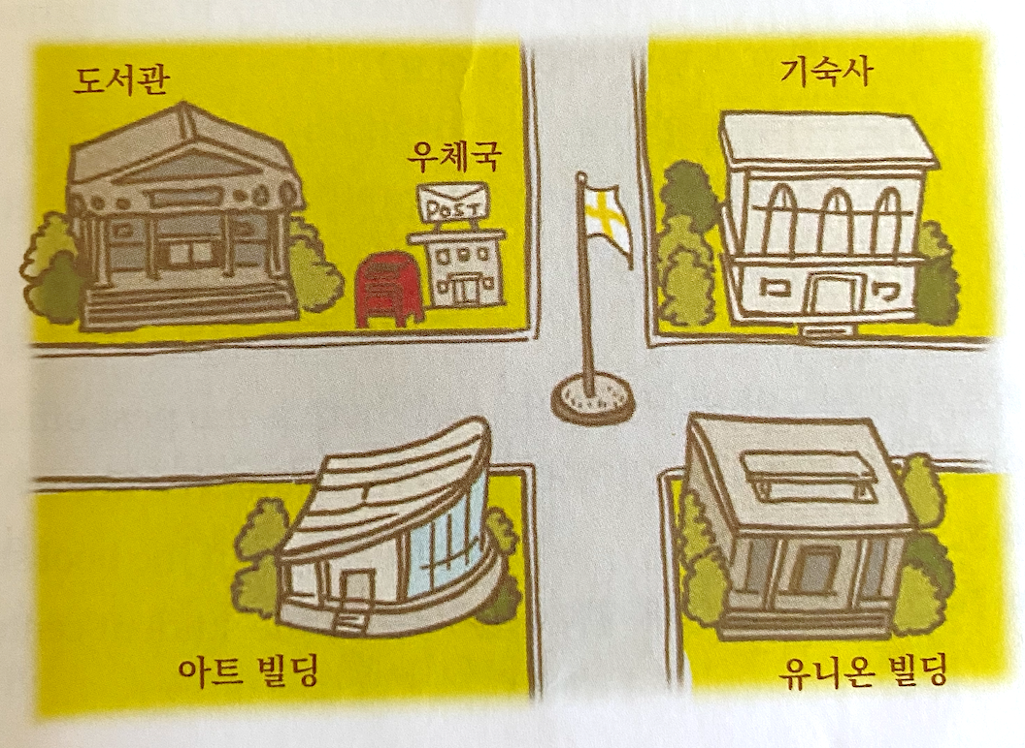
B:
Speaker 1:__________________________________________________________
Speaker 2: __________________________________________________________
Speaker 1: __________________________________________________________
Speaker 2: __________________________________________________________
Speaker 1: __________________________________________________________
Speaker 2: __________________________________________________________
Speaker 1: __________________________________________________________
Speaker 2: __________________________________________________________
Speaker 1: __________________________________________________________
Speaker 2: __________________________________________________________

Section 5: Record and Save Your Recording
Instructions: Perform the dialogue you created with your partner. Make sure you do not end your Zoom meeting until you have performed your dialogue with your partner.

