KLP06 My Day
STOP: Before you begin this activity, open and follow recording instructions for online activities or on-campus activities.

Pair # __________

Partner A: ________________________________
Student ID: _______________________________
Instructor: ________________________________
Level: ______________ Date: _________________
Partner B: ________________________________
Student ID: _______________________________
Instructor: ________________________________
Level: ______________ Date: _________________
All links in this activity direct to the KLP Activities page on the LLC website. Find your activity number and click the drop down to find links to videos used in this activity.

Section 1: Vocabulary Mastery
Instructions: Write the translation of the following words and phrases into Korean. Try to use your book and your partner before using other materials or the internet. In the third column, draw a picture, write a note to yourself or put some kind of pronunciation guide for the target language. Use the third column to help remember your target language.
Vocabulary | Translation | Notes/Pictures/Pronunciation Guide (anything to help you)
- Yesterday
- Weekend
- Past
- Last year
- Koreatown
- Bicycle
- Car
- Subway
- Bus
- To get up
- To shower
- To brush teeth
- To get dressed
- To get undressed
- To surf the Internet
- To play or hang out
- To do dishwashing
- How do you come?
- How long does it take?
- From A (place) to B (place)

Concept Check: Past tense / Particle (으)로
The past tense describes events that took place in the past. In Korean, the past tense is indicated by ~었어요/았어요/ㅆ어요. Pay close attention to the adverbs of time such as “yesterday, past weekend, last year” which clearly mark the past events. You need to use the past tense to agree with the adverbs of time.
The particle (으)로 is used after a mode of transportation to express “by means of” such as “by car” “by subway” “by bus” and “by taxi.” The particle (으)로 is also used with writing instruments or languages to express “by means of” (in) such as write in pen or speak in Korean.
- In almost all textbooks or grammar explanations, the Korean past tense is conjugated in ~었어요/았어요/ㅆ어요. However, one of the easiest ways to conjugate the past tense is by following this rule:
- Make sure you conjugate 어요/아요 properly. As long as you conjugate the present tense properly, you can easily conjugate any into the past tense correctly.
- After you conjugate verbs or adjectives into 어요/아요 form, drop 요 and add ㅆ어요.
먹다 먹어요 (drop 요) 먹어+ㅆ어요 = 먹었어요
마시다 마셔요 ((drop 요) 마셔+ㅆ어요=마셨어요
공부하다 공부해요(drop 요) 공부해+ㅆ어요=공부했어요
알다 알아요(drop 요) 알아+ㅆ어요=알았어요
만나다 만나요(drop 요) 만나+ㅆ어요=만났어요
재미있다 재미있어요(drop 요) 재미있어+ㅆ어요=재미있었어요
바쁘다 바빠요(drop 요) 바빠+ㅆ어요=바빴어요
맛있다 맛있어요(drop 요) 맛있어+ㅆ어요=맛있었어요
- To express “by means of” (으)로 is used before a transportation noun, writing instrument, or languages. 으로 is used after a noun ending in a consonant (except for ㄹ ending) and 로 is used after a noun ending in a vowel.
Mode of transportation
차로
트럭으로
*지하철로 NOT 지하철으로 (X)
Writing instrument
펜으로
*연필로NOT 연필으로 (X)
Language
한국어로
영어로
일본어로
I go to school by car. 저는 차로 학교에 가요.
Steve comes home by bicycle. 스티브가 자전거로 집에 와요.
I write my name in pen. 펜으로 이름을 써요.
Steve and Yumi speak in Korean. 스티브하고 유미가 한국어로 말해요.

Section 2: Sentence Translation
Instructions: Take turns translating the following sentences into Korean. Then practice asking and answering the questions with your partner. Write down your partner’s answers in Korean.
- What did you to yesterday?
_________________________________________________________________________
- What did you eat yesterday?
_________________________________________________________________________
- What time did you get up?
_________________________________________________________________________
- What time did you go to bed?
_________________________________________________________________________
- What did you do on the weekend?
_________________________________________________________________________
- How long did it take you from home to Koreatown?
_________________________________________________________________________
- How did you come to school?
_________________________________________________________________________
- How long did it take from home to school?
_________________________________________________________________________

Section 3: Your daily routine
Instructions: Watch the Section 3 Video to review Korean past tense.
See how a person describes his or her daily routine. Based on the pictures below and on the next page, you and your partner will choose 10 different activities and talk about your daily routine in the past tense. You may find it helpful to talk about the routine things you did yesterday, or another day this past week. Make sure you talk about your routine in chronological order.
My Day
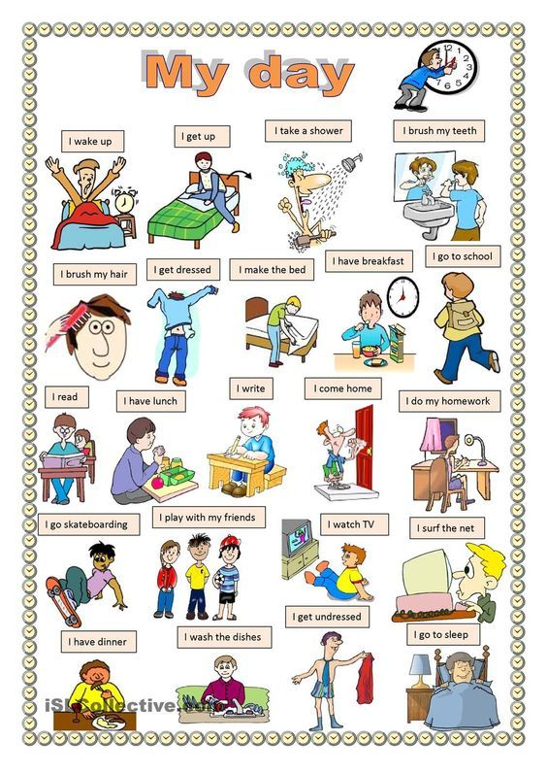
Use the space below if you need to make notes about your daily routines to discuss with your partner:

Section 4: What did you do?
Part A: You and your partner are talking about you did over the weekend. Translate and practice the following conversation with your partner in Korean.
A:
Speaker 1: ____________ 씨, what did you do on the weekend?
Speaker 2: I went to Koreatown.
Speaker 1: Did you eat Korean food?
Speaker 2: Yes, I ate 비빔밥. It was delicious.
Speaker 1: How did you go to Koreatown?
Speaker 2: I went there by car.
Speaker 1: How long did it take from home to Koreatown?
Speaker 2: It took 1 hour.

Part B: You meet your classmate on Monday. You want to ask what he or she did on the weekend. Use the space below to help create the conversation. The conversation should be 30 seconds to 1.5 minutes. You will record this dialogue in the next section. Ask for help if necessary.
B:
Speaker 1:__________________________________________________________
Speaker 2: __________________________________________________________
Speaker 1: __________________________________________________________
Speaker 2: __________________________________________________________
Speaker 1: __________________________________________________________
Speaker 2: __________________________________________________________
Speaker 1: __________________________________________________________
Speaker 2: __________________________________________________________

Section 5: Record and Save Your Recording
Instructions: Perform the dialogue you created with your partner. Make sure you do not end your Zoom meeting until you have performed your dialogue with your partner.

