KLP07 Weekend
STOP: Before you begin this activity, open and follow recording instructions for online activities or on-campus activities.

Pair # __________

Partner A: ________________________________
Student ID: _______________________________
Instructor: ________________________________
Level: ______________ Date: _________________
Partner B: ________________________________
Student ID: _______________________________
Instructor: ________________________________
Level: ______________ Date: _________________

All links in this activity direct to the KLP Activities page on the LLC website. Find your activity number and click the drop down to find links to videos used in this activity.

Section 1: Vocabulary Mastery
Instructions: Write the translation of the following words and phrases into Korean. Try to use your book and your partner before using other materials or the internet. In the third column, draw a picture, write a note to yourself or put some kind of pronunciation guide for the target language. Use the third column to help remember your target language.
Vocabulary | Translation | Notes/Pictures/Pronunciation Guide (anything to help you)
- Newspaper
- Supermarket
- Weekend
- Next
- School vacation
- Movie
- Movie theater
- Summer
- Winter
- Semester
- To do the laundry
- To do the dishes
- To clean
- To buy groceries
- To spend time
- To make
- To prepare
- To travel
- To swim
- To ride

Concept Check: Future tense
(으)ㄹ 거예요is a future tense that conveys the speaker’s or the listener’s intention or plan. For example, I plan to go to Korea. This is not a definite plan but something you intend to do in the future. The form ~을 거예요also expresses probability. For example, 김밥will probably be delicious. You CANNOT say “김밥plans to be delicious.” In English, the meaning is the same without “probably” (김밥will be delicious), so you can leave it out, too. The Korean word for “probably” is 아마 and you can use it together. See example sentences below.
There are other future tenses in Korean. You can think of this future tense as “probable future tense” and translate it as “plan to” or “intend to” or “probably.”
The form ~을 거예요 is used when the verb stem ends in a consonant, and ~ㄹ 거예요is used when the verb stem ends in a vowel.
먹다 (stem먹) ➔ 먹을 거예요
읽다 (stem읽) ➔ 읽을 거예요
없다 (stem없) ➔ 없을 거예요
가다 (stem가) ➔ 갈 거예요
여행하다 (stem여행하) ➔ 여행할 거예요
마시다 (stem마시) ➔ 마실 거예요
It is important to pay attention to irregulars. For example:
만들다 ➔만들 거예요
살다 ➔살 거예요
듣다 ➔들을 거예요
걷다 ➔걸을 거예요
I plan to meet my friend this weekend.
주말에 친구를 만날 거예요.
I probably will eat Korean food in the evening.
저녁에 아마 한국 음식을 먹을 거예요.
I intend to watch Korean dramas.
한국 드라마를 볼 거예요.
I probably will walk in the park.
공원에서 아마 걸을 거예요.
The movie will [probably] be interesting.
영화가 [아마] 재미있을 거예요.
The bag will [probably] be expensive.
가방이 [아마] 비쌀 거예요.

Section 2: Sentence Translation
Instructions A: Take turns translating the following sentences into Korean. Then practice asking and answering. Write down your partner’s answers in Korean.
- What do you plan to do this weekend?
__________________________________________________________________________
- Do you plan to study Korean next semester?
__________________________________________________________________________
- Do you plan to make Korean food?
__________________________________________________________________________
- Do you plan to travel during the summer vacation?
__________________________________________________________________________
- Where do you plan to go this weekend?
__________________________________________________________________________
- Do you plan to clean your room?
__________________________________________________________________________
- Where do you plan to meet your friend?
__________________________________________________________________________

Section 3: To do list
Instructions: You and your partner will each come up with a “To do list” to practice the (으)ㄹ 거예요form. Think about 5 things you plan to do this weekend using the vocabulary words. It can be house chores or doing fun activities or a combination of the two. You can use the pictures below for some ideas.
Then watch the Section 3 Video.
Based on your list of things to do, add at what time you plan to do these things and write them out in full and complete sentences on the next page.
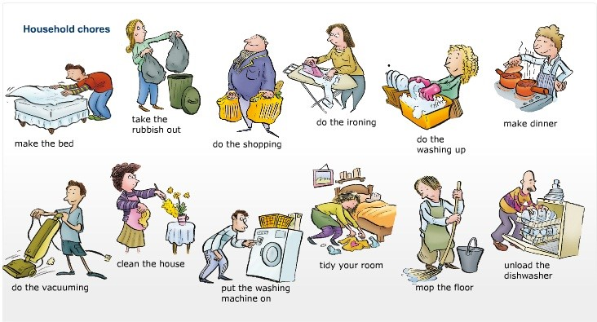

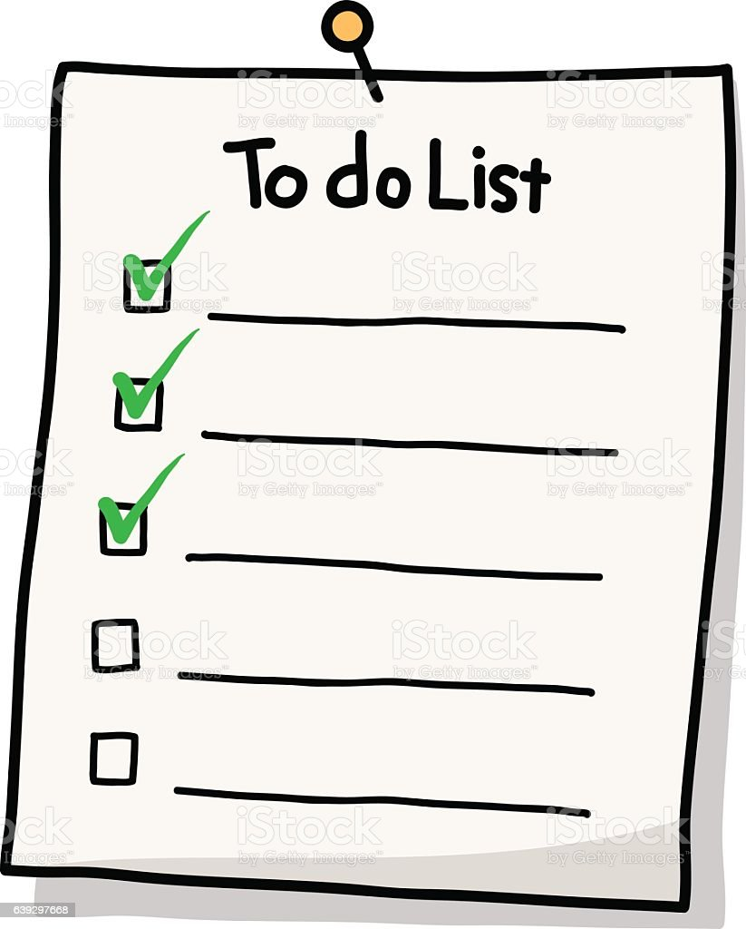
Partner A To Do List
- ___________________________________________________________
- ___________________________________________________________
- ___________________________________________________________
- ___________________________________________________________
- ___________________________________________________________

Partner B To Do List
- ___________________________________________________________
- ___________________________________________________________
- ___________________________________________________________
- ___________________________________________________________
- ___________________________________________________________


Section 4: What do you plan to do?
Part A: You and your partner are talking about each other’s plan to do over the weekend. Translate and practice the following conversation with your partner in Korean.
A:
Speaker 1: ____________ 씨, what do you plan to do this weekend?
Speaker 2: I plan to make Korean food.
Speaker 1: What do you plan to make?
Speaker 2: I plan to make bulgogi. So I am going to buy groceries. Let’s go together.
Speaker 1: Okay. I’ll go with you. Where do you plan to go?
Speaker 2: I plan to go to Koreatown.
Speaker 1: Are you going to drive?
Speaker 2: No, I plan to take a taxi.

Part B: Your school vacation is coming up. You and your partner can talk about what you plan to do during school vacation. Use the space below to help create the conversation. The conversation should be 30 seconds to 1.5 minutes. You will record this dialogue in the next section. Ask for help if necessary.
B:
Speaker 1:__________________________________________________________
Speaker 2: __________________________________________________________
Speaker 1: __________________________________________________________
Speaker 2: __________________________________________________________
Speaker 1: __________________________________________________________
Speaker 2: __________________________________________________________
Speaker 1: __________________________________________________________
Speaker 2: __________________________________________________________

Section 5: Record and Save Your Recording
Instructions: Perform the dialogue you created with your partner. Make sure you do not end your Zoom meeting until you have performed your dialogue with your partner.

