KLP10 What Do You Want?
STOP: Before you begin this activity, open and follow recording instructions for online activities or on-campus activities.

Pair # __________

Partner A: ________________________________
Student ID: _______________________________
Instructor: ________________________________
Level: ______________ Date: _________________
Partner B: ________________________________
Student ID: _______________________________
Instructor: ________________________________
Level: ______________ Date: _________________

All links in this activity direct to the KLP Activities page on the LLC website. Find your activity number and click the drop down to find links to videos used in this activity.

Section 1: Vocabulary Mastery
Instructions: Write the translation of the following words and phrases into Korean. Try to use your book and your partner before using other materials or the Internet. In the third column, draw a picture, write a note to yourself or put some kind of pronunciation guide for the target language. Use the third column to help remember your target language.
Vocabulary | Translation | Notes/Pictures/Pronunciation Guide (anything to help you)
- Culture
- Professor’s office
- Just, without any reason
- Early
- Notebook
- Shoes
- Scholarship
- To take time off (school)
- To transfer (different college)
- To start or set up (a company)
- To apply
- To help
- To do voluntary work
- To travel around the world
- To move
- To play or not work
- To start
- To be sorry
- To come in
- To get employed

Concept Check: Expressing Desire ~고 싶다/~고 싶어하다
If you want to express your desire or ask a listener, you can use ~고 싶다, meaning “I want”. However, to express a desire of a third person, you need to use ~고 싶어하다, meaning “He or she wants.” You can also express this in the past tense form by changing the verbs 싶다and싶어하다into 싶었어요and싶어했어요.
To express your desire, you need to take the verb stem and add~고 싶어요.
먹다 먹 먹고 싶어요. (I want to eat.) 뭐 먹고 싶어요? (What do you want to eat?)
사다 사 사고 싶어요. (I want to buy.) 뭐 사고 싶어요? (What do you want to buy?)
마시다 마시 마시고 싶어요. (I want to drink.) 뭐 마시고 싶어요? (What do you want to drink?)
배우다 배우 배우고 싶어요. (I want to learn.) 뭐 배우고 싶어요? (What do you want to learn?)
To express the third person’s desire, you need to take the verb stem and add ~고 싶어해요.
스티브: 뭐 먹고 싶어요? (What do you want to eat?)
마이클: 피자를 먹고 싶어요. (I want to eat pizza.)
Now Steve is talking to Lisa about what Michael wants to eat, so he needs to say마이클이 피자를 먹고 싶어해요. This means, “Michael wants to eat pizza.”
If you are talking to someone older, use the honorific form by adding ~고 싶으세요to the verb stem to ask a question instead of~고 싶어요. And use ~고 싶어하세요to the verb stem to express what the third person (older and higher social status) wants instead of ~고 싶어해요.
You can also express this in the past tense form by changing the verbs 싶다and싶어하다into 싶었어요and싶어했어요.
For honorific past tense, change 싶으세요to 싶으셨어요 and change 싶어하세요to 싶어하셨어요.

Section 2: Sentence Translation
Instructions: Take turns translating the following sentences into Korean. Then practice asking and answering. Write down your partner’s answers in Korean. When you write your partner’s answers, don’t forget to use the third person’s desire.
*Remember: Do not to translate “you” in Korean. It is understood from the context.
- What do you want to eat?
________________________________________________________________________
- Where do you want to go?
________________________________________________________________________
- What do you want to buy?
________________________________________________________________________
- What kind of present do you want to receive on your birthday?
________________________________________________________________________
- Where do you want to live?
________________________________________________________________________
- What kind of work do you want do?
________________________________________________________________________

Section 3: Ask appropriate questions
Instructions A: Look at the pictures and ask appropriate question as you have just practiced in Section 2. Ask at least 3 times per image group.
Instructions B: Write down your partner’s answers using the third person’s desire.
Example: You: “What do you want to eat?” Your partner is Lisa: “I want to eat pizza.” Then you need to write down “Lisa wants to eat pizza” not “I want to eat pizza.”
Image Group 1:
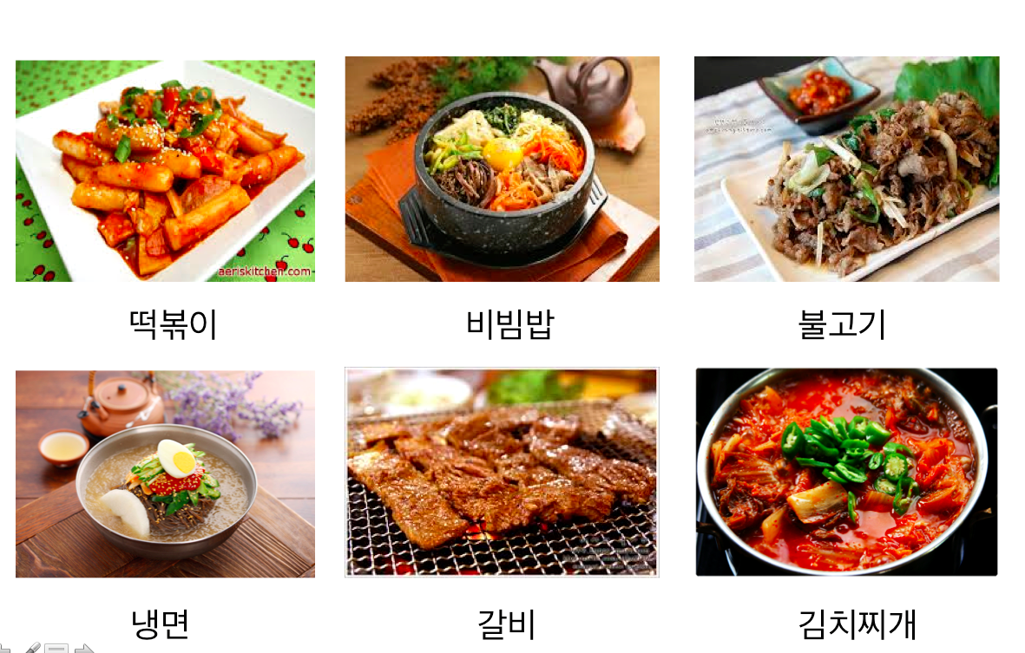
떡볶이
비빔밥
불고기
냉면
갈비
김치찌개

Questions and Answers for Image Group 1:
Image Group 2
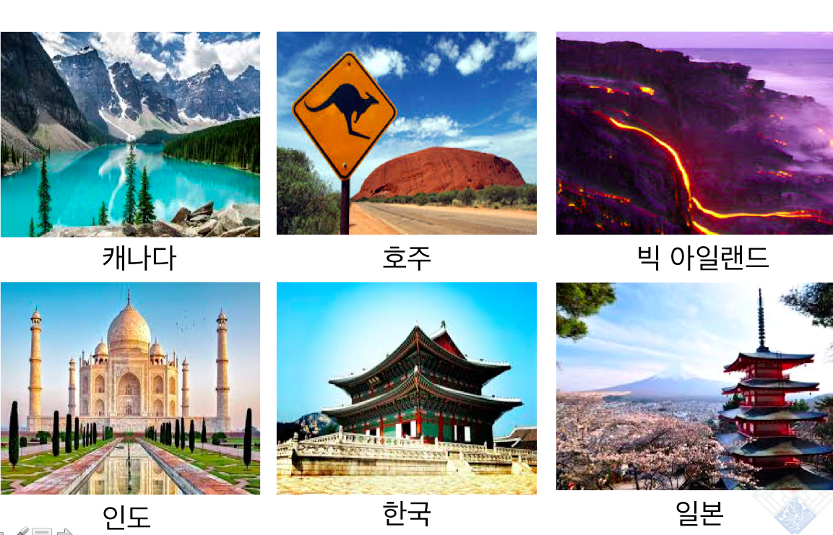
캐나다
인도
호주
한국
빅 아일랜드
일본
Questions and Answers for Image Group 2:
Image Group 3:
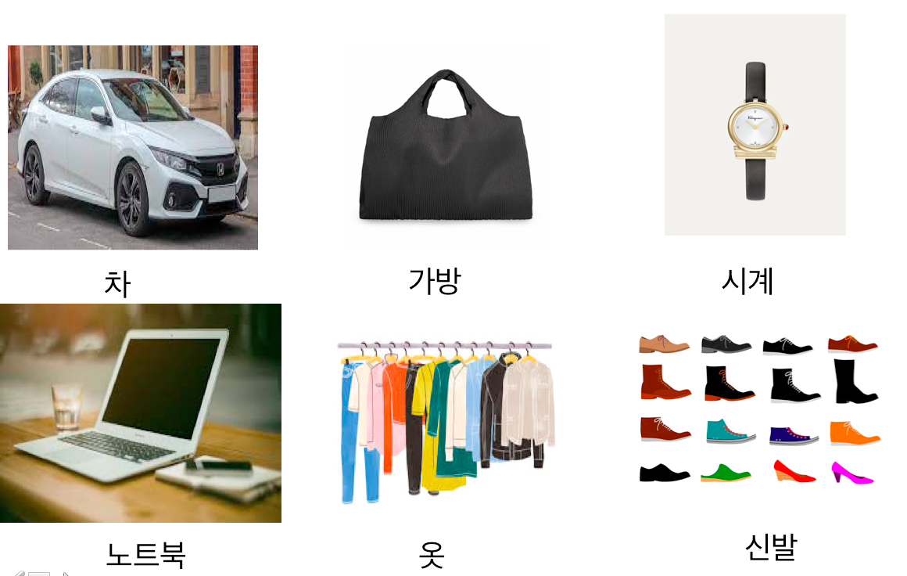
차
노트북
가방
옷
시계
신발
Questions and Answers for Image Group 3:

Section 4: What do you want?
Part A: You and your friend are talking about what you want to do about next year. There are several things you want to do. Translate and practice the following conversation with your partner in Korean, filling in the blanks with your own information.
A:
Speaker 1: ____________ 씨, what do you want to do next year?
Speaker 2: I want to transfer to _______________.
Speaker 1: Really? Steve also wants to transfer to __________________.
Speaker 2: I want to major in Korean. ___________씨는요?
Speaker 1: I want to get a scholarship. So I am studying very hard.
Speaker 2: I want to get a scholarship, too.
Part B: You and your partner are discussing things you want to do during the break. Make sure you use vocabulary words from the list in Section 1. Use the space below to help create the conversation. The conversation should be one to two minutes. You will record this dialogue in the next section. Ask for help if necessary.
B:
Speaker 1:__________________________________________________________
Speaker 2: __________________________________________________________
Speaker 1: __________________________________________________________
Speaker 2: __________________________________________________________
Speaker 1: __________________________________________________________
Speaker 2: __________________________________________________________
Speaker 1: __________________________________________________________
Speaker 2: __________________________________________________________

Section 5: Record and Save Your Recording
Instructions: Perform the dialogue you created with your partner. Make sure you do not end your Zoom meeting until you have performed your dialogue with your partner.

