KLP11 Activities
STOP: Before you begin this activity, open and follow recording instructions for online activities or on-campus activities.

Pair # __________

Partner A: ________________________________
Student ID: _______________________________
Instructor: ________________________________
Level: ______________ Date: _________________
Partner B: ________________________________
Student ID: _______________________________
Instructor: ________________________________
Level: ______________ Date: _________________

All links in this activity direct to the KLP Activities page on the LLC website. Find your activity number and click the drop down to find links to videos used in this activity.

Section 1: Vocabulary Mastery
Instructions: Write the translation of the following words and phrases into Korean. Try to use your book and your partner before using other materials or the Internet. In the third column, draw a picture, write a note to yourself or put some kind of pronunciation guide for the target language. Use the third column to help remember your target language.
Vocabulary | Translation | Notes/Pictures/Pronunciation Guide (anything to help you)
- Last night
- Horse
- Ski
- Classic music
- Green tea
- Swimming
- To eat out
- To play (guitar, piano)
- To take a walk , stroll
- To take a photo
- To ride
- To draw a picture
- To telephone
- To dance
- To rest
- To do origami
- To wait
- To rain
- To do puzzle
- To sing

Concept Check: Present Progressive ~고 있다/~고 계시다
In Korean, you can use a simple present tense to express the ~ing form. For example, 저는 아침을 먹어요 can be translated as “I eat breakfast” or “I am eating breakfast.” Depending on the context of the situation, you can translate it as the progressive form. However, there is a present progressive form in Korean. ~고 있다/ ~고 계시다expresses the continuation or progression of an action. This construction CANNOT be used with adjectives.
There are two forms: one plain and the other honorific. You can also express in the present tense and the past tense. You use the stem of the verb and add either ~고 있다or ~고 계시다. Look at the table on the next page.

Verb | Verb | Plain present | Plain past | Honorific present | Honorific past
Dictionary Form | Stem | ~고 있어요 | ~고 있었어요 | ~고 계세요 | ~고 계셨어요
읽다 | 읽 | 읽고 있어요 | 읽고 있었어요 | 읽고 계세요 | 읽고 계셨어요
앉다 | 앉 | 앉아 있어요 | 앉아 있었어요 | 앉아 계세요 | 앉아 계셨어요
공부하다 | 공부하 | 공부하고 있어요 | 공부하고 있었어요 | 공부하고 계세요 | 공부하고 계셨어요
쓰다 | 쓰 | 쓰고 있어요 | 쓰고 있었어요 | 쓰고 계세요 | 쓰고 계셨어요
찾다 | 찾 | 찾고 있어요 | 찾고 있었어요 | 찾고 계세요 | 찾고 계셨어요
You need to pay attention whether the subject of your sentence requires you to use the honorific form or plain form. If you are talking to your friend, you cannot use the honorific form. When you are talking to or talking about your grandparents, parents, teacher, or your boss, you need to use the honorific form. Look at the examples below:
소피아: 지금 뭐하고 있어요? What are you doing now?
유미: 아침을 먹고 있어요. I’m eating breakfast.
마이클: 어제 전화했어요. 그런데 안 받았어요. 뭐하고 있었어요? I called yesterday. But you didn’t answer (lit. didn’t receive). What were you doing?
스티브: 공부하고 있었어요. I was studying.
리사: 이 선생님 지금 뭐하고 계세요? What is Professor Lee doing now?
빌: 한국어를 가르치고 계세요. Professor Lee is teaching Korean.
마이클: 할아버지가 어제 책을 읽고 계셨어요. Grandfather was reading a book yesterday.

Section 2: Sentence Translation
Instructions: Take turns translating the following sentences into Korean. Then practice asking and answering using the progressive form. Remember to use the honorific form if you are talking about your grandparents, parents, teacher, or your boss.
*Remember: Do not to translate “you” in Korean. It is understood from the context.
- What are you doing now?
________________________________________________________________________
- What were you doing yesterday?
________________________________________________________________________
- What is your mother doing now?
________________________________________________________________________
- What was your father doing yesterday?
________________________________________________________________________
- What is your friend doing?
________________________________________________________________________
- What was your friend doing?
________________________________________________________________________

Section 3: What are you doing?
Instructions A: Look at the pictures and ask questions in the progressive form and reply using the progressive form. Use the plain form for Picture Group 1 and use the honorific form for Picture Group 2. Practice using both the present tense and the past tense.
Instructions B: Write down your 6 questions (3 present & 3 past) and 6 answers (3 present & 3 past) for each picture group below.
Picture Group 1 (Plain form):

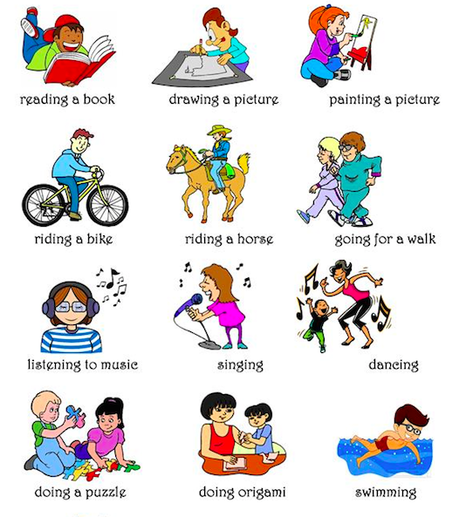
reading a book
drawing a picture
painting a picture
riding a bicycle
riding a horse
going for a walk
listening to music
singing
dancing
doing a puzzle
doing origami
swimming

Picture Group 1 Questions and Answers:
Present:
- Q: _________________________________________________________________________
A: __________________________________________________________________________
- Q: _________________________________________________________________________
A: __________________________________________________________________________
- Q: _________________________________________________________________________
A: __________________________________________________________________________
Past:
- Q: _________________________________________________________________________
A: __________________________________________________________________________
- Q: _________________________________________________________________________
A: __________________________________________________________________________
- Q: _________________________________________________________________________
A: __________________________________________________________________________
Picture Group 2 (Honorific form):
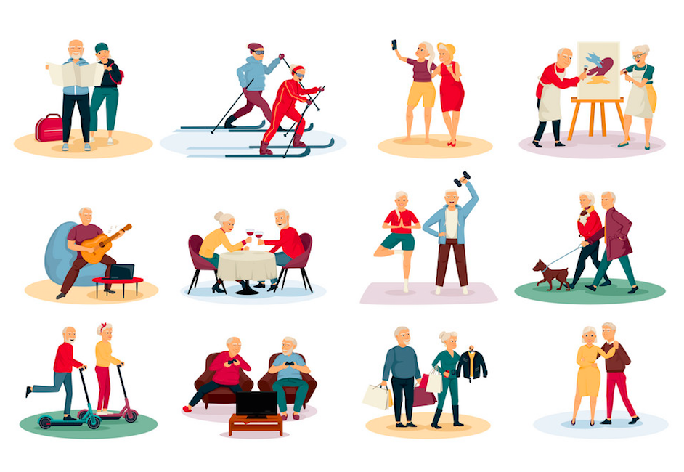
reading a map
skiing
taking a selfie
painting a picture
playing guitar
having a glass of wine
exercising
walking the dog
riding a scooter
playing video games
going shopping
dancing

Picture Group 2 Questions and Answers:
Present:
- Q: _________________________________________________________________________
A: __________________________________________________________________________
- Q: _________________________________________________________________________
A: __________________________________________________________________________
- Q: _________________________________________________________________________
A: __________________________________________________________________________
Past:
- Q: _________________________________________________________________________
A: __________________________________________________________________________
- Q: _________________________________________________________________________
A: __________________________________________________________________________
- Q: _________________________________________________________________________
A: __________________________________________________________________________

Section 4: What are you doing?
Part A: You meet your friend in the school cafeteria. You say hello to each other, ask what each other is doing, and ask about what your friend did on the weekend. Translate and practice the following conversation with your partner in Korean, filling in the blanks with your own information. Use the information in parentheses to guide you.
A:
Speaker 1: Hello, ____________ 씨?
Speaker 2: Hello ____________씨. What are you doing now?
Speaker 1: I’m reading a ______________ (a Korean book, comic book). What about you?
Speaker 2: I’m waiting for _______________(my roommate, boyfriend, girlfriend). I called you last night. But you didn’t answer. What were you doing?
Speaker 1: I was listening to ______________(music, radio). Why did you call?
Speaker 2: I was watching a Korean drama. And I had questions.
Part B: You and your friend are talking about what you did last night. Ask each other what you did using the progressive form. Use the space below to help create the conversation. The conversation should be one to two minutes. You will record this dialogue in the next section. Ask for help if necessary.
B:
Speaker 1:__________________________________________________________
Speaker 2: __________________________________________________________
Speaker 1: __________________________________________________________
Speaker 2: __________________________________________________________
Speaker 1: __________________________________________________________
Speaker 2: __________________________________________________________
Speaker 1: __________________________________________________________
Speaker 2: __________________________________________________________

Section 5: Record and Save Your Recording
Instructions: Perform the dialogue you created with your partner. Make sure you do not end your Zoom meeting until you have performed your dialogue with your partner.

