KLP13 At the Pharmacy
STOP: Before you begin this activity, open and follow recording instructions for online activities or on-campus activities.

Pair # __________

Partner A: ________________________________
Student ID: _______________________________
Instructor: ________________________________
Level: ______________ Date: _________________
Partner B: ________________________________
Student ID: _______________________________
Instructor: ________________________________
Level: ______________ Date: _________________

All links in this activity direct to the KLP Activities page on the LLC website. Find your activity number and click the drop down to find links to videos used in this activity.

Section 1: Vocabulary Mastery
Instructions: Write the translation of the following words and phrases into Korean. Try to use your book and your partner before using other materials or the Internet. In the third column, draw a picture, write a note to yourself or put some kind of pronunciation guide for the target language. Use the third column to help remember your target language.
Vocabulary | Translation | Notes/Pictures/Pronunciation Guide (anything to help you)
- Pharmacist
- Prescription
- Food poisoning
- Allergy
- Runny nose
- Headache
- Stomachache
- Toothache
- Sore throat
- Before meal
- After meal
- To make a phone call
- To break out in a rash
- To catch a cold
- To take medicine
- To cough
- To be hurt
- To have a fever
- To sprain
- To take care

Concept Check: Expression Obligation or Necessity
If you want to express “I must do something” or “I have to do something” you can use the form ~어/아야 되다. This form is used to express obligation or necessity. You can also use ~어/아야 하다, which is slightly more formal than the ~어/아야 되다.
To conjugate into the ~어/아야 되다 and ~어/아야 하다form, conjugate into the polite ~어요/아요form. Then drop 요 and add ~야 돼요 / ~야 해요. As long as you conjugate verbs and adjectives into the correct ~어요/아요form, you will not make mistakes conjugating them into the ~어/아야 되다 and ~어/아야 하다form.

공부하다 공부해요 공부해야 돼요/해요
먹다 먹어요 먹어야 돼요/해요
숙제하다 숙제해요 숙제해야 돼요/해요
읽다 읽어요 읽어야 돼요/해요
보다 봐요 봐야 돼요/해요
쓰다 써요 써야 돼요/해요
전화하다 전화해요 전화해야 돼요/해요
많다 많아요 많아야 돼요/해요
크다 커요 커야 돼요/해요
작다 작아요 작아야 돼요/해요

Note: In Korea, when you go to a pharmacy or hospital or any public offices, you will be greeted and asked “어떻게 오셨어요?” This literally means, “How did you come?” However, this question is not asking how you came but it is an expression “How can I help you?”
Study the body parts to be able to express where it hurts.
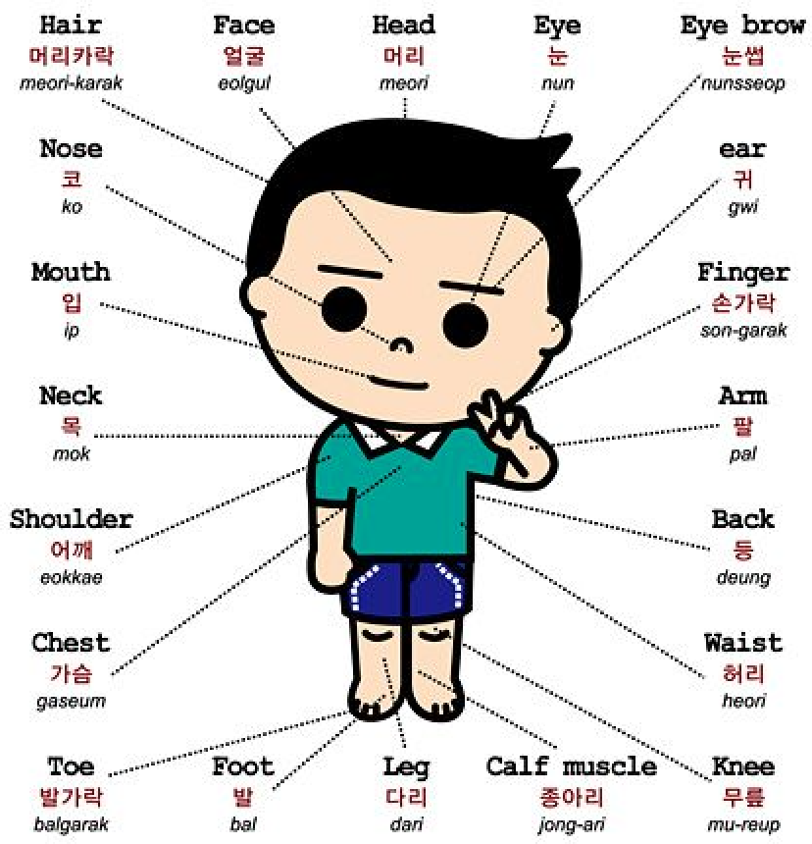
Body Parts in Korean
English | Korean | Pronunciation
head | 머리 | meori
eye | 눈 | nun
eyebrow | 눈썹 | nunsseop
ear | 귀 | gwi
finger | 손가락 | son-garak
arm | 팔 | pal
back | 등 | deung
waist | 허리 | heori
knee | 무릎 | mu-reup
calf muscle | 종아리 | jong-ari
leg | 다리 | dari
foot | 발 | bal
toe | 발가락 | balgarak
chest | 가슴 | gaseum
shoulder | 어깨 | eokkae
neck | 목 | mok
mouth | 입 | ip
nose | 코 | ko
hair | 머리카락 | meori-karak
face | 얼굴 | eolgul

Section 2: Sentence Translation
Instructions: Take turns translating the following sentences into Korean. Then practice asking and answering. Write down your partner’s answers in Korean.
Watch the Section 2 Video first.
*Remember: Do not to translate “you” in Korean. It is understood from the context.
- How can I help you?
_________________________________________________________________________
- Where does it hurt?
_________________________________________________________________________
- When do I take the medication?
_________________________________________________________________________
- How many times do I take the medication?
_________________________________________________________________________
- Do you have a headache?
_________________________________________________________________________
- I want to be healthy. What do I need to do?
_________________________________________________________________________

Section 3: Where does it hurt?
Instructions A: You and your partner will take turns asking “Where does it hurt?” Ask and answer the question for each picture.
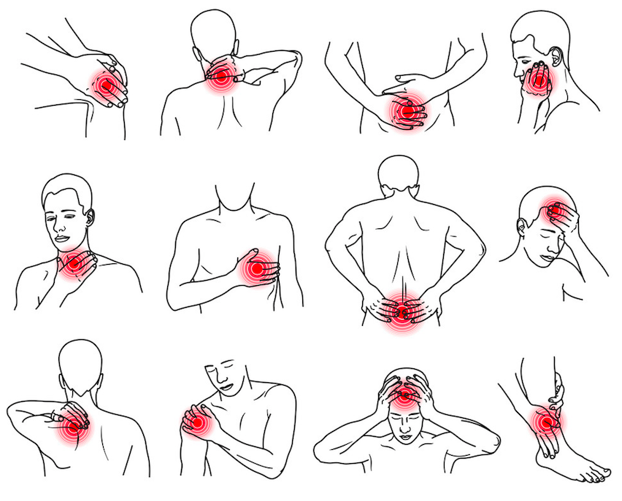
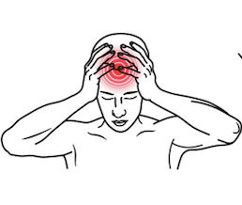

Instructions B: You and your partner will take turns asking “Where does it hurt?” Choose one of the pictures and tell your partner your illness. Your partner will tell you what you need to do. Repeat with at least 4 pictures. Write down your conversations on the next page as shown in the example below.
Example:
A: 어디가 아파요?
B: 목이 아파요.
A: 약을 먹어야 돼요. 그리고 따뜻한 물을 마셔야 돼요.
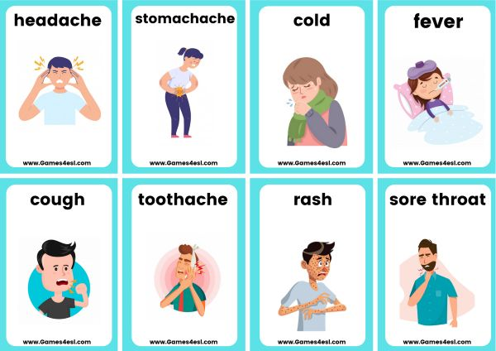

Conversation 1:
A:
B:
A:
Conversation 2:
A:
B:
A:
Conversation 3:
A:
B:
A:
Conversation 4:
A:
B:
A:

Section 4: Take good care of yourself.
Part A: You are not feeling well and you run into your friend on campus. Your friend asks where it hurts and you tell her where. Translate and practice the following conversation with your partner in Korean.
A:
Speaker 1: Are you okay?
Speaker 2: No. I have a headache. I didn’t sleep because I had a test.
Speaker 1: Did you take medication?
Speaker 2: No. I need to go to the pharmacy.
Speaker 1: You need to go home. And you need to sleep.
Speaker 2: I can’t. I need to do my homework. And I need to go to work today.
Speaker 1: You must rest. You need to call your boss. Tell your boss you cannot go to work today.
Speaker 2: You are right. I must rest. I need to be healthy.
Part B: You are not feeling well. You go to a pharmacy and talk to your pharmacist. Use the space below to help create the conversation. The conversation should be one to two minutes. You will record this dialogue in the next section. Ask for help if necessary.
B:
Speaker 1:__________________________________________________________
Speaker 2: __________________________________________________________
Speaker 1: __________________________________________________________
Speaker 2: __________________________________________________________
Speaker 1: __________________________________________________________
Speaker 2: __________________________________________________________
Speaker 1: __________________________________________________________
Speaker 2: __________________________________________________________

Section 5: Record and Save Your Recording
Instructions: Perform the dialogue you created with your partner. Make sure you do not end your Zoom meeting until you have performed your dialogue with your partner.

