KLP14 At the Airport
STOP: Before you begin this activity, open and follow recording instructions for online activities or on-campus activities.

Pair # __________

Partner A: ________________________________
Student ID: _______________________________
Instructor: ________________________________
Level: ______________ Date: _________________
Partner B: ________________________________
Student ID: _______________________________
Instructor: ________________________________
Level: ______________ Date: _________________

All links in this activity direct to the KLP Activities page on the LLC website. Find your activity number and click the drop down to find links to videos used in this activity.

Section 1: Vocabulary Mastery
Instructions: Write the translation of the following words and phrases into Korean. Try to use your book and your partner before using other materials or the Internet. In the third column, draw a picture, write a note to yourself or put some kind of pronunciation guide for the target language. Use the third column to help remember your target language.
Vocabulary | Translation | Notes/Pictures/Pronunciation Guide (anything to help you)
- Taxi fare
- Elevator
- Stairs
- Airport
- Lounge
- To spend money
- To go out to greet someone
- To park
- To offer one’s seat
- To take a photo
- To take off a mask
- To rent (a car)
- To run
- To wear a mask
- To pick up (someone by a car)
- To save (money)
- To throw trash
- To take a photo
- To arrive
- To smoke

Concept Check: Negative Command Form
To politely ask someone to do something as “Please read” you can use the 으세요 form: 읽으세요. In order to ask someone politely not to do something, you need to use ~지 마세요. This form consists of two components: negation suffix ~지 and the verb “말다” to mean “stop doing something.” 마세요 is the honorific form of the verb말다. To use the negative command form, you cannot just use마세요 by itself. You need to use ~지 마세요together.
To use the negative command form, you need to take the stem of the verb and add ~지 마세요.
먹다 먹 먹지 마세요
마시다 마시 마시지 마세요
전화하다 전화하 전화하지 마세요
말하다 말하 말하지 마세요
돈을 쓰다 돈을 쓰 돈을 쓰지 마세요
You can combine both the negative command form and the polite command form to express “Please don’t do X but please do Y” using the construction X~지 말고 Y~(으)세요.
Please do not drive but take a taxi.
운전하지 말고 버스를 타세요.
Please do not take the elevator but walk.
엘리베이터를 타지 말고 걸으세요.
Please do not talk on the phone inside the movie theater but please talk outside.
영화관 안에서 전화하지 말고 밖에서 전화하세요.
~지 못하다 is slightly more formal than못 which means “cannot” or “inability to do something.” The negation suffix 지is combined with 못하다. Add stem to ~지 못하다. To negate using 못, you need to put it before the verb.
못 먹어요 먹지 못해요
못 사요 사지 못해요
못 가요 가지 못해요
못 마셔요 마시지 못해요

Section 2: Sentence Translation
Instructions: Take turns translating the following sentences into Korean. Then practice asking and answering. Write down your partner’s answers in Korean.
*Remember: Do not to translate “you” in Korean. It is understood from the context.
- What time does the plane arrive?
________________________________________________________________________
- Are you going to the airport to greet your parents?
________________________________________________________________________
- Are you going to rent a car?
________________________________________________________________________
- I want to travel next year. How can I save money?
________________________________________________________________________
- I spend too much money. What do I need to do?
________________________________________________________________________
- Taxi fare is too expensive. Do I need to buy a car?
________________________________________________________________________
- Are you planning to rent a car?
________________________________________________________________________

Section 3: Please don’t do that!
Instructions A: Look at each picture and discuss with your partner things that you should not do. Use the vocabulary words from the vocabulary section. Then come up with places were you might see these signs.

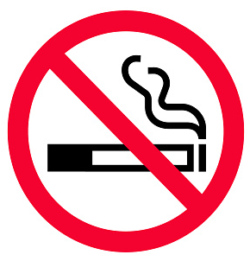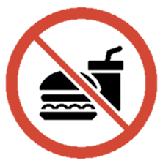
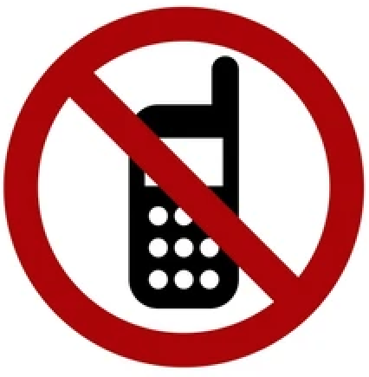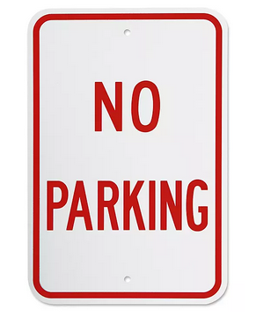

Instructions B: Use “Please don’t do X but do Y” structure for Part B. Write down each sentence next to the picture or pair of pictures.
- 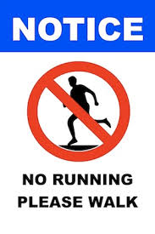 Sentence:
- 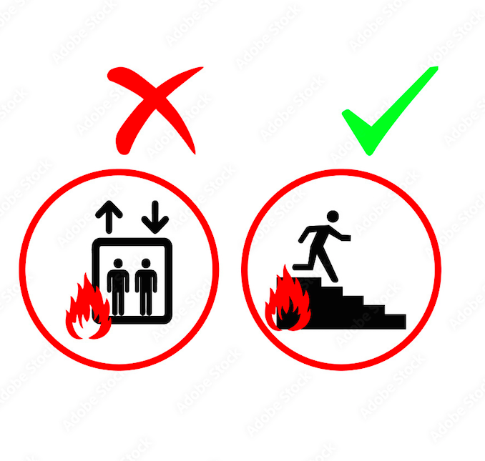 Sentence:
- 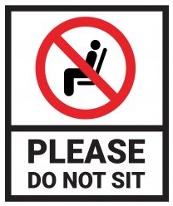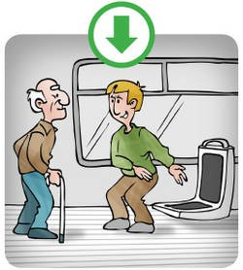 Sentence:
-  Sentence:
- 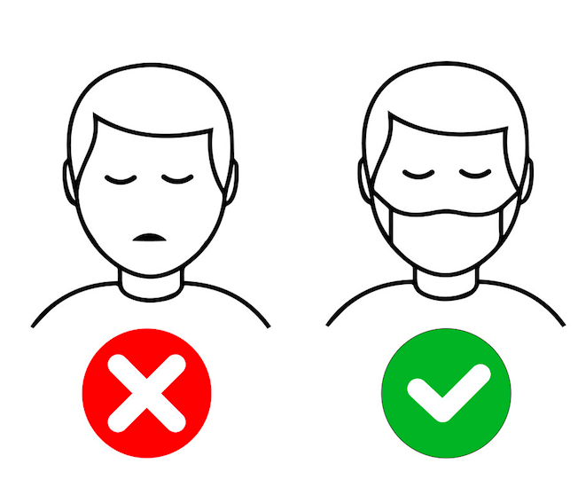 Sentence:
- 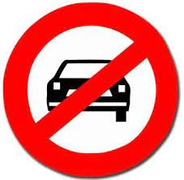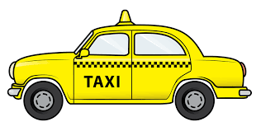Sentence:

Section 4: Going to the airport
Part A: You see your friend on campus and you talk about the upcoming school vacation. You talk about your friend who is coming to visit you during the break. Translate and practice the following conversation with your partner in Korean.
Speaker 1: My friend is coming to LA.
Speaker 2: Are you going to the airport to greet her/him? Are you renting a car?
Speaker 1: Yes, I’m going to the airport. But I cannot drive.
Speaker 2: What time does the plane arrive?
Speaker 1: The plane arrives 10 in the morning. I need to take a taxi.
Speaker 2: Don’t take the taxi. The taxi fare is very expensive.
Speaker 1: I have time. I will pick you up.
Speaker 2: Thank you.
Part B: You and your partner are roommates. You need to discuss about going to the airport to greet one of your parents. Talk about things you shouldn’t do or do or cannot do. Use the space below to help create the conversation. The conversation should be one to two minutes. You will record this dialogue in the next section. Ask for help if necessary.
Speaker 1:__________________________________________________________
Speaker 2: __________________________________________________________
Speaker 1: __________________________________________________________
Speaker 2: __________________________________________________________
Speaker 1: __________________________________________________________
Speaker 2: __________________________________________________________
Speaker 1: __________________________________________________________
Speaker 2: __________________________________________________________

Section 5: Record and Save Your Recording
Instructions: Perform the dialogue you created with your partner. Make sure you do not end your Zoom meeting until you have performed your dialogue with your partner.

