SLP5. Nationalities

Pair #
STOP: Before you begin this activity, open and follow recording instructions here.

Partner A:
Student ID:
Instructor:
Language:
Level: Date:
Partner B:
Student ID:
Instructor:
Language:
Level: Date:

Section 1: Vocabulary Mastery
Instructions: Describe the sign of the following words and phrases using the 5 Parameters of ASL. Try to use your book and your partner before using other materials or the internet. Use the third column to help you remember the sign in your target language (ASL) by drawing a picture or writing a note to yourself.
Vocabulary | 5 Parameters of ASL Description | Notes/Pictures/Sign Guide (anything to help you)
- Italian/Italy
- Spanish/Spain
- French/France
- German/Germany
- English/England
- American/The United States
- Canadian/Canada
- Mexican/México
- Chinese/China
- Korean/Korea
- Colombian/Colombia

Section 2: Signed Expressions
Instructions: Remember there is no to be verb in ASL. Instead we use indexing to refer to people in space. Remember to consider if the pronoun is singular or plural.
Write the following phrases with your partner using ASL syntax (word order).
- I am __________.
- Penélope Cruz is Spanish. __________________________________
- Jacky Chan is Chinese. ___________________________________
- Charlize Therón and Trevor Noah are South African. ____________________________
- Albert Einstein and Immanuel Kant are German. ____________________________
- Germans are from (country name) ___________________________.
- Cantínflas is Mexican. _________________________
- Mexicans are from __________________________.
- J.K. Rowling is ______________________________.
- Gabriel García Márquez is _____________________.
- Jim Carry is _______________________________.
- Canadians are from _________________________.
- Spaniards are from _________________________.


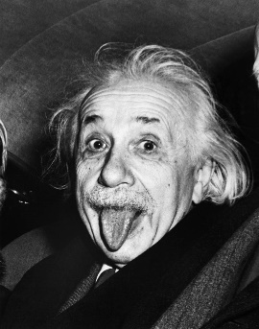


- Varies, f. Germany, h. México, i. British, j. Colombian, k. Canadian, l. Canada, m. Spain

Section 3: International Celebrities
Instructions: Use the internet and your partner’s help to you identify each of the celebrity’s nationalities. Optional Cultural Exchange: If you are not familiar, you and your partner can do some research and talk about their work and role in entertainment (films, music, sports, etc.).


- Emma Watson
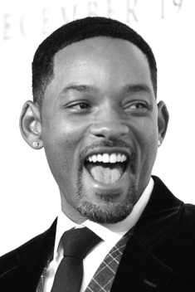
- Will Smith

- Marion Cotillard

- Raoul Bova
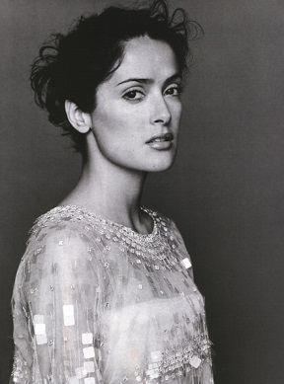
- Salma Hayek
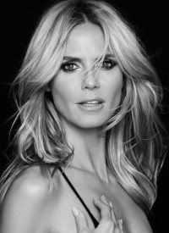
- Heidi Klum

- Fan Bingbing

- Justin Bieber
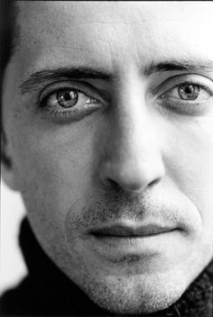
- Gad Elmaleh

- English/British, b. American, c. French, d. Italian, e. Mexican, f. German, g. Chinese, h. Canandian, i. French

Section 4: Dialogue Creation
Instructions: What is your nationality? What is your favorite celebrity’s nationality? Switch roles and then answer your partner’s questions. Attach another piece of paper if you need more space. You will record this dialogue in the next section. Ask for help when necessary.
Signer 1:
Signer 2:
Signer 1:
Signer 2:
Signer 1:
Signer 2:
Signer 1:
Signer 2:

